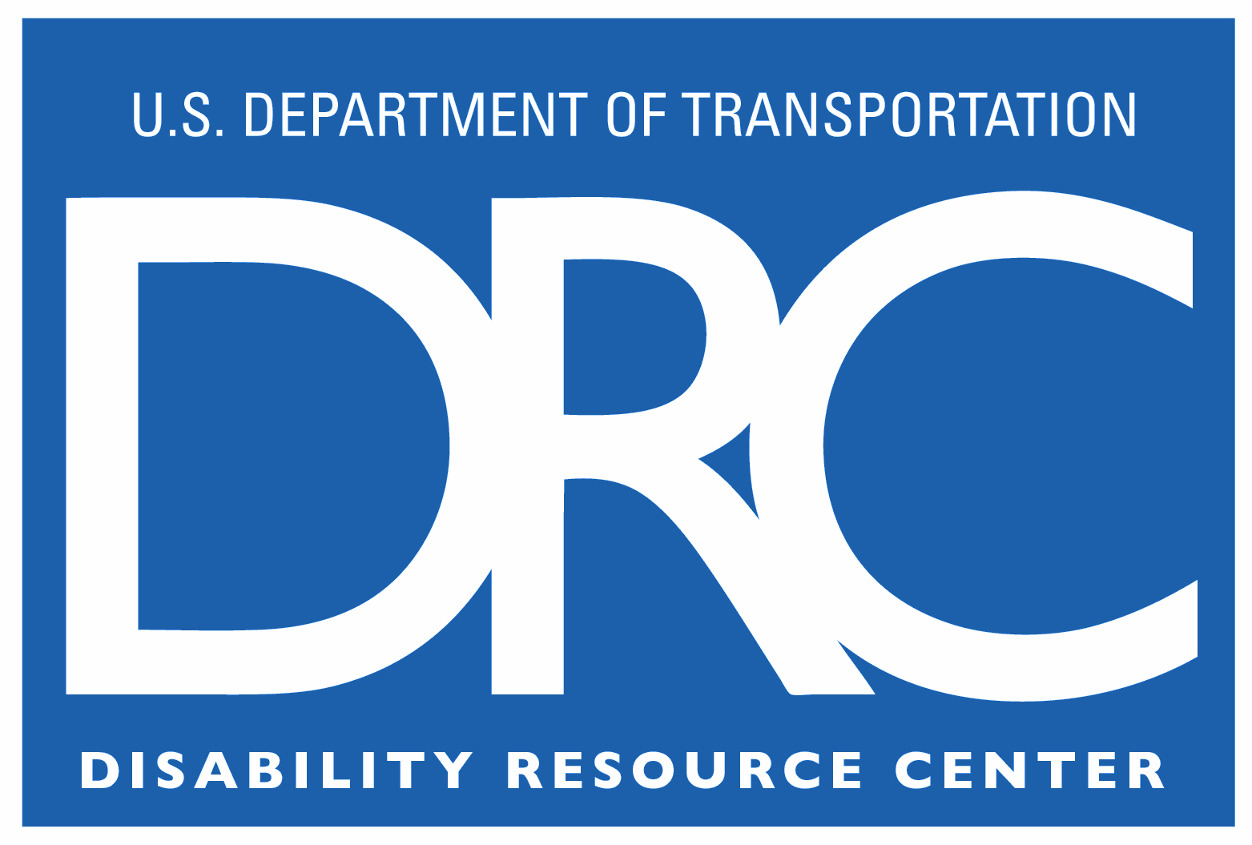
Disability Resource Center
1200 New Jersey Ave, SE W56-403
Washington, DC 20590-0001

Phone: 202-493-0625
Fax: 202-493-2391
drc@dot.gov
Web: https://www.transportation.gov/drc

Documentation for Hidden Medical Conditions

If a Department of Transportation (DOT) employee has a hidden disability and wishes to make a request for reasonable accommodation, documentation is typically requested by the employee’s immediate supervisor, who has been designated the decision maker in the DOT Order on Reasonable Accommodation (i.e., DOT Order 1011.1A, available at https://www.transportation.gov/civil-rights/civil-rights-awareness-enforcement/procedures-processing-reasonable-accommodation). People with hidden disabilities are individuals with impairments that are not visibly apparent, such as clinical depression; certain neurological disorders such as MS, MD, and Lupus; and learning disabilities.

The requested documentation is used to substantiate that the individual meets the following definition of disability under the Rehabilitation Act of 1973, as amended, and is eligible for the provision of reasonable accommodation:

An individual with a disability is:

- A person with a physical or mental impairment(s) that substantially limits one or more major life activities;

- Has a record of such an impairment(s); or

- Is regarded as having such an impairment(s).

A medical doctor or other qualified medical professional, social worker, or a vocational rehabilitation counselor may provide documentation of a hidden disability.

Medical documentation is considered sufficient when it contains the following:

- The name, severity, and the duration or projected duration of the impairment(s)

- The major life activities (e.g., walking, sleeping) that are substantially limited by the impairment(s) and specific examples to support substantial limitation

- How the impairment(s) impacts the completion of job duties

- Recommended workplace accommodations

If a supervisor wishes to seek assistance in making a disability determination after receiving complete medical documentation, he/she can call the DRC at 202-493-0625, and request to speak to an analyst.

