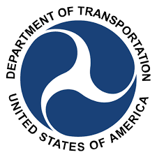

**NATIONAL ADVISORY COMMITTEE ON**

**TRAVEL AND TOURISM INFRASTRUCTURE**

**1200 NEW JERSEY AVENUE, S.E.**

**WASHINGTON, D.C. 20590**

**DOT CONFERENCE CENTER, FIRST FLOOR, WEST BUILDING**

**Rooms 8, 9, & 10**

**MEETING AGENDA**

**December 4, 2018**

**8:45-9:30 a.m. Registration, DOT Main Lobby, New Jersey Ave. Entrance**

**9:30 a.m. DFO Opening Remarks**

**9:35 a.m. Subcommittee #1 Welcome and Roll Call**

*Rosemarie Andolino, Chair of Subcommittee #1*

**9:40 a.m. Subcommittee #1 Working Group**

**11:50 a.m. Public Comment**

**12:00 p.m. Subcommittee #1 Adjournment**

**12:00-1:30 p.m. Lunch**

**1:45 p.m. Subcommittee #2 Welcome and Roll Call**

*David Harvey, Chair of Subcommittee #2*

**1:50 p.m. Subcommittees #1 & #2 Working Group**

**4:15 p.m. Public Comment**

**4:30 p.m. Adjournment**