# Tips for Working with Interpreters

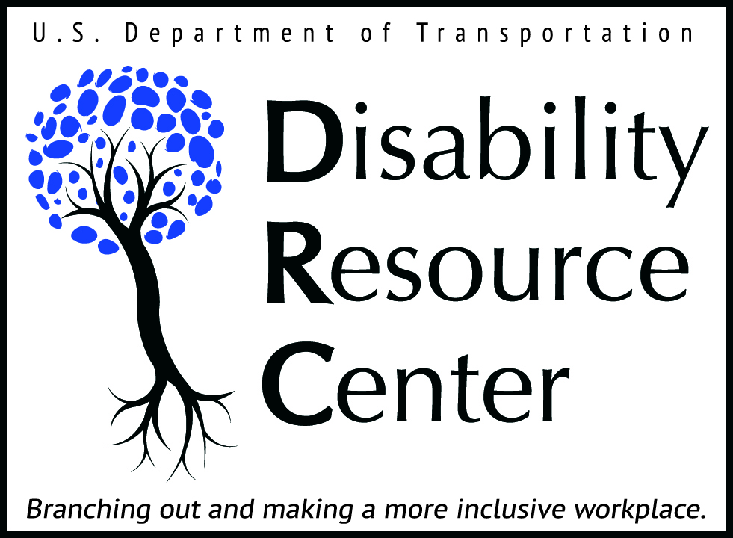

Working with interpreters is a new experience for many people. For some, it can be helpful to review a few tips to ensure that your work with an interpreter flows smoothly and effectively for the deaf employee, the manager, co-workers, and the interpreter.

## Making a Request

When making a request for interpreting services throughout the DOT Headquarters area, please follow the guidelines in Section 4.6 of the DRC Handbook: <https://www.transportation.gov/drc/handbook>. Please allow a minimum of 5 business days’ notice when making your request. While we do accept requests with less than 5 business days’ notice, we cannot guarantee that a short-notice request will be filled.

Be sure to include all the important details about your meeting or event when you make your request:

* What is the date and time of your meeting?
* What is the location? (Please include room number and building information, and if your request is outside of DOT Headquarters, the full address of the assignment.)
* What is the expected duration of your meeting?
* Who are the Deaf/Hard of Hearing participants, and what is their role in the event? (participants, meeting leaders, panel speakers, etc.).
* What is the subject of the meeting?
* Who is the Point of Contact for the meeting? (Please provide at least two points-of-contact, and ensure that at least one will be able to accept the phone call from security when your interpreter arrives.)
* If there are handouts, presentation slides, or technical terms that will be included in the meeting, provide these to the interpreting office as early as possible, so that the interpreters can prepare.

## During a Meeting or Event

* When speaking with a Deaf person, direct your comments to him or her (not to the interpreter). For example, avoid saying, “Tell her I need to meet with her.”
* Speak at a normal pace. If your speech is rapid, the interpreter may ask you to repeat or to slow your pace to make sure that all your comments are being conveyed completely.
* Allow only one person to speak at a time.
* Make sure that there is a clear line of sight between the interpreter, the meeting facilitator, and the Deaf employee, and that traffic in front of the interpreter is kept to a minimum.
* Interpreting is physically demanding. Interpreters may require occasional breaks. Assignments of an hour or more in length that are technical, non-stop or high profile may require a team of interpreters.

## After a Meeting

If you have any questions or comments (positive or negative), please follow up with the Deaf employee, the interpreter, and the DRC.

For more information about DRC Interpreting Services, please contact the CORs for the DRC Nationwide Interpreting Services Contract:

Trina Redmond (Region I, Baltimore-Washington Metropolitan Area), or

MarcusKeith Island (Region II, Outside the Baltimore-Washington Metropolitan Area)

Phone: 202-366-6242

Email: [drc.interpreters@dot.gov](mailto:drc.interpreters@dot.gov) (Region 1)

[drc.interpreters.reg@dot.gov](mailto:drc.interpreters.reg@dot.gov) (Region II)

\****Add a statement of accessibility to your meeting and program announcements. For example, “If you need reasonable accommodations, please contact (name of person) at (number) or via email: (email address here) with your request by close of business (deadline).”***

## U.S. Department of Transportation, Disability Resource Center

**M-14.4, W56-403, 1200 New Jersey Avenue, SE, Washington, DC 20590**

**Voice: (202) 493-0625; Fax: (202) 366-3571**

**Web:** [**https://www.transportation.gov/drc**](https://www.transportation.gov/drc)**; Email:** [**drc@dot.gov**](mailto:drc@ost.dot.gov)