

**TIGER Discretionary Grant Program**

**Performance Measurement Biennial Report**

**2016**

**US Department of Transportation**

**Office of the Undersecretary of Transportation for Policy**

**Table of Contents**

Executive Summary 1

Background 2

Program Inception 2

Performance Measurement Incorporation 2

Program Review Reports and Responses 2

Performance Measurement Challenges an Improvements 3

Lack of Uniform Performance Measures 3

Selecting Appropriate Measures 4

Data Monitoring and Mining 5

Data Collection 5

Target-Setting for Performance Measures 6

Comprehensive Analysis of Performance Measurement Data 6

Current Status of Reported Performance Measures 6

Reported Performance Measures 7

Specific Project Snapshots 8

Next Steps for TIGER Performance Measurement and Assessment 37

Conclusion 37

Appendix A – Performance Measurement Guidance 38

Appendix B – Case Studies 55

**Executive Summary**

Following a Congressional appropriation of $1.5 billion in 2009, the Department of Transportation (DOT) developed the Transportation Investment Generating Economic Recovery (TIGER) Discretionary Grants Program to provide funding for capital investments to improve the nation’s highway, bridge, public transportation, rail, and port infrastructure. Although Congress did not stipulate that TIGER grant recipients should report performance measurements as part of the grant agreement, the Office of the Secretary began to require grant recipients to develop performance plans and measures for each project. Recognizing that the TIGER program enables the Department to award funding to a vast array of projects, performance measures allow the Department the ability to examine the benefits of each project based on concrete data. Over the previous seven rounds and current eighth round of TIGER program administration, performance measurement has been a goal of the program. As performance measurement has been implemented over time, various challenges have been identified including the purpose of performance measures, measure uniformity, selection of measures, data monitoring and mining, and data analysis. As the performance measurement process develops, the Department continually makes improvements to the development, collection, and analysis of performance measures.

Despite the difficulties in the selection of measures, data collection and data analysis, the TIGER grant recipients and the Department have made great strides in using performance measure data to show benefits of TIGER projects. From the inception of the TIGER program through the end of 2015, 96 projects have been reported as substantially complete or closed out. A total of 865 performance measures have been collected among the 96 projects; however, scrutiny of each project and the grant agreement is necessary to examine these performance measures. Overall, 79 percent of the projects have *some* of their baseline data submitted as of December 31, 2015 and 69 percent have *all* baseline data submitted. Overall, submission of *some* post-construction data lies at 49 percent; however, some projects are just beginning post-construction data collection and others are within an acceptable window for collection due to potential time lag, time-intensive data collection, and resource-heavy data organization. This report also contains specific case study information for nine TIGER projects to illustrate both quantitative and qualitative benefits of the projects.

As work continues on previous TIGER projects and as another round of TIGER project applications is currently under evaluation, the Department is continually refining the performance measurement development process. In conjunction with this refinement, the Modal Administrations (modes) will continue to work with grantees to develop appropriate performance measures as well as follow the Performance Measurement Guidance document for collection and reporting of that data. The Department is currently considering ways to make performance measurement data available online and streamline and simplify performance measurement data reporting.

**Background**

Program Inception

Congress appropriated $1.5 billion through the American Recovery and Reinvestment Act (ARRA) of 2009, charging the Department of Transportation (DOT) with implementing a new program to dispense funds for surface transportation improvements. Given one year to develop and implement this new program, DOT developed the Transportation Investment Generating Economic Recovery (TIGER) Discretionary Grants Program to provide funding for capital (and later, planning) investments to improve the nation’s highway, bridge, public transportation, rail, and port infrastructure. Through a highly competitive process, the TIGER program has proven successful in selecting and funding important transportation projects, including some which may have not been achievable through other funding sources. To date, through seven rounds of TIGER grants, the DOT has awarded a total of nearly $4.6 billion towards these transportation projects with an additional $500 million to be made available this year for the eighth round of the program.

Performance Measurement Incorporation

While ARRA did not require TIGER grant recipients to report performance measurements as part of the stipulations of the agreement, the Office of the Secretary implemented a requirement that the grantee develop performance plans and measures for each project.

Recognizing that the TIGER program enables the Department to award funding to a vast array of projects, performance measures allow the Department the ability to examine the benefits of each project based on concrete data specific to that project. Rather than set targets at the onset of an awarded project – which often requires trend data for appropriate target-setting – DOT set forth instructions to develop measures based on data collected both before project construction and for a number of years post project completion. Thus, TIGER grant recipients collaborate with the DOT in the development of a project-specific performance plan, track progress, and report on the effectiveness of each project in achieving the benefits stated in the application. In developing the TIGER program, the focus of performance measures and project outcomes were focused on, but at the time not directly linked to, five Departmental strategic goals (Safety, State of Good Repair, Environmental Sustainability, Quality of Life, and Economic Competitiveness). However, the Department did not direct the recipient towards specific performance measures, instead directing the recipient to hold collaborative discussions with the grant administering mode to choose performance measures for their specific project. As the TIGER program has evolved, so has the process for choosing and developing performance measures and thus the Department’s capabilities to determine if projects achieved their desired outcomes.

Program Review Reports and Responses

The Office of the Inspector General (OIG) and the Government Accountability Office (GAO) reviewed the TIGER program on a number of points, including the designation and use of performance measures.

With respect to the performance measures, the OIG report made recommendations related to measuring the overall performance of the TIGER program based on the project performance measures. The report stated that DOT had not established a process for evaluating the program performance based on the project outcomes. In turn, this would limit the Office of the Secretary’s ability to describe the extent to which projects achieved the anticipated benefits. Specifically, the OIG report noted the absence of a systematic process for developing the performance measures and a lack of alignment with long-term outcomes. However, OIG acknowledged that it could be years before TIGER program evaluation is possible given the time for project completion and data collection.

GAO conducted their research into the TIGER performance measures by reviewing projects and their associated performance measures. They reported that the performance measures did not establish measurable targets. GAO cited that linkage is exhibited when the performance measure is aligned with goals and missions of an organization and that those goals and missions should be communicated throughout the organization. According to GAO, leading practice at federal agencies states that the performance measure, when appropriate, should have a quantifiable, numerical target and agencies could use baselines to set these targets.

OST submitted official responses to the OIG Report and the GAO Report and agreed to develop this Report to address the status of the performance measures methodology and how TIGER performance measurement data can illustrate the success of the TIGER program.

**Performance Measurement Challenges and Improvements**

Over the previous seven rounds and current eighth round of TIGER program administration, various challenges have been identified by the Department or discussed by external sources. As the performance measurement process develops, the Department continually makes improvements to the development, collection, and analysis of performance measures. The following discusses the challenges and respective improvements to the performance measures.

Lack of Uniform Performance Measures

As previously stated, TIGER grant recipients work with the grant-administering mode within the Department to develop a performance measurement plan that involves development of appropriate performance measures and the reporting period and frequency of such reporting. The intention of the performance measures, specific to each project, is to assess the benefits of each individual project specific to the project area. Given this intended purpose, the performance measures developed in the early years of the TIGER program were extremely project-specific. While they had similar focus, the measures often differed in name, units of measurement, data collection periods, frequency of data collection, among other differences. At the time of development, these project-specific performance measures were believed to be the best approach to the development of measures. It has, however, created a challenge in combining the data in aggregate form to assess the overall benefits of the TIGER program.

As the Department and the grant-administering modes have become more aware of various components of the grant awards, teams have worked diligently to refine the system. The modes and the TIGER grant recipients work closely together after awards have taken place. A grant agreement template – which is continually improved as necessary – is used to ensure incorporation of information deemed vital or beneficial to the process. The mode and recipient discuss the project, the desired benefits or improvements, how those improvements can be measured, data collection methods and feasibility. This discussion has been shaped over years of experience with TIGER grant recipients and closer working relationships now exist between modes and recipients.

Through these enhanced relationships between modes and recipients and after receiving feedback regarding existing performance measures, a working group within the Department determined that clarification was necessary for performance measures. The working group reviewed previously developed measures, industry standards, accessible and collectible data as well as the DOT strategic goals. This group of experts narrowed down the options for TIGER performance measures, all of which could be linked directly to a primary Departmental strategic goal. The working group also set forth, for each performance measure, the name of the measure, frequency of measurement, and definition for clarification and uniformity. Providing a set list of performance measures, and distinct units and frequency of measurement, provide for a consistent set of data for greater analysis capability in future years.

Beyond simply recognizing the need for improvements and developing them, the Department aimed to have these improvements incorporated into new grant agreements and have performance measures be adopted at the earliest project stage possible. The Office of the Secretary, in conjunction with the working group of experts, modified and distributed the Performance Measurement Guidance (Appendix A). The Performance Measurement Guidance is most applicable to TIGER 2015 grant recipients who are still working on or recently completed their negotiated grant agreements; however, to standardize data collection, recipients from prior years have been strongly encouraged to use, as appropriate, the Performance Measurement Guidance. TIGER grant recipients from prior rounds may not be able to adopt the new performance measures, depending upon their specific stage of data collection and reporting. Cost of data collection and reporting is an important consideration for recipients.

Selecting Appropriate Measures

Selection of appropriate performance measures involves identification and development of performance measures specific to the project, relevant to the benefits of the project, that have data points that can be collected without overly-increasing burden, and that align with Departmental goals. Given the uniqueness of each project, finding performance measures that satisfied all of these criteria may not be easily achievable.

As TIGER has progressed over the years, the modal administration staff have become familiar with various projects as well as a variety of performance measures. Close discussion between the modal staff responsible for the administration of the TIGER grant and the grant recipient allow for a greater knowledge base and recommendations for potential performance measures. Consistent with the Performance Measurement Guidance, TIGER grant recipients are to select two to four performance measures from the list of agreed-upon measures. This list of measures has been associated with the mode administering the grant and associated with Departmental strategic goals to reflect industry standards. This association will allow for review of the data respective of the different strategic goals. However, if a project is of such a unique quality, the TIGER grant recipient is encouraged to develop additional measures that will most appropriately illustrate the intention of the project work as well as improvements associated with the project.

Of additional note is that the Department does not fund data collection for performance measures nor reimburse TIGER grant recipients for data collection. The intention of the TIGER funding is to maximize the development of transportation projects. Given the lack of funding for data collection, the recipients may be deterred from selecting challenging performance measures if they are resource-intensive even if those are the most appropriate measures.

Data Monitoring and Mining

When setting and collecting for performance measurements for the TIGER Program, grant recipients were instructed to collect baseline data for performance measures prior to the start of the project work. In turn, after completion of the work, the performance measures were to be collected in the same manner at regular intervals. Gathering the reported performance measurement information required manual review of all submitted emails, matching data and identifying reporting periods, and coordination with modal administrations for grant agreements and any pertinent, additional correspondence. This process was identified to be time consuming and inefficient.

In refining the data monitoring and mining processes, the Department is identifying ways to streamline processes for both the collection and reporting of data by TIGER grant recipients as well as the tracking and analysis of the data by Departmental staff.

Data Collection

Data collection is the sole responsibility of the recipient, including funding of data collection which may be an extensive cost. TIGER funds do not cover performance measurement data collection nor does the program reimburse for data collection expenses. The Department identified challenges with respect to actual data collection for some TIGER projects including, but not limited to, resource constraints relative to level of effort, financial burden, and level of grantee experience with performance data collection and reporting. Selection of the appropriate performance measures may seem intuitive; however, the reality of the data collection may exceed a grant recipient’s capabilities.

Modal administrations will continue to assist TIGER grant recipients in data collection on multiple fronts. The modes provide recipients with expertise on industry standards, appropriate data points for collection, means by which to show success or improvements, and knowledge of resources for data collection. With access to the agreed-upon performance measures, the TIGER grant recipients can work towards an understanding of appropriate performance measures as well as explore opportunities for collection of respective data.

Target-Setting for Performance Measures

The GAO Report cited lack of measurable targets as a deficiency in the selection of performance measures for TIGER projects. The Department acknowledges that for many federal agencies (for example, the National Highway Traffic Safety Administration and the Federal Motor Carriers Safety Administration within the Department) that have established performance measures by which to assess effectiveness of agency work, the performance measures are evaluated based on whether they have met a pre-determined target. Using historical trend data to project future data points, agencies make adjustments to the projections to set attainable yet challenging targets for performance measures.

As is done within Departmental agencies, target-setting is typically used on a national or regional level, as the data is more robust at the larger level. The TIGER projects are a much smaller scale, for example short stretches of roadways or bridges, safer pedestrian access, or transit changes within a community, town, or city. Thus the collection of baseline data and post-construction data aptly illustrates the direction of change for which the performance measures were established as well as capitalizing on the data collection abilities of the TIGER grant recipients.

Comprehensive Analysis of Performance Measurement Data

Because of the sheer number and diversity of the reported performance measures, a comprehensive analysis of the TIGER program is extremely difficult. As of December 31, 2015, 96 projects were noted as closed out or substantially complete. For these 96 projects, 865 performance measures are recorded. The data cover four different rounds of TIGER, various lengths of data collection periods, and different statuses in the reporting of post-construction data. We are experiencing missing data components and have reached out through the Modes to the TIGER grant recipients to ensure all data for periods prior to December 31, 2015 has been submitted. The Department is considering different means of reviewing the existing data to better assess the TIGER program on an aggregate level. To that end, the Performance Measurement Guidance has been modified to decrease the number of performance measures for each project, focus the measures on the most appropriate data, and create uniformity among similar projects for better aggregate data analysis.

**Current Status of Reported Performance Measures**

Any TIGER project, regardless of the round, that was closed out or substantially complete as of December 31, 2015 was included in the data collection effort for this report.

Observing the current TIGER projects that have been completed, it is clear that communities, towns, cities and tribal reservations across the nation have improved multi-modal transportation systems that better connect people and provide safe, effective, and efficient transportation solutions. TIGER grant recipients have successfully adopted responsibilities to measure change in the projects through collection and submission of performance measurement data. Efforts to determine the best manner to report benefits of the TIGER program continue as the Department becomes more familiar with the reported data.

Reported Performance Measures

Table 1 details overall reporting of performance measures for the substantially complete or closed out projects. The Department has updated the TIGER Performance Measurement Guidance to recommend using two to four performance measures. The Department expects that this decrease in the number of measures, along with the assistance of the modal experts, will create uniformity among similar projects for better aggregate data analysis.

Table 1. Performance Measure Reporting for Substantially Complete or Closed out TIGER Projects

|  |  |  |  |  |  |  |  |
| --- | --- | --- | --- | --- | --- | --- | --- |
|  | | ***All Rounds*** | **TIGER 2009** | **TIGER 2010** | **TIGER 2011** | **TIGER 2012** | **TIGER 2013** |
| **# Projects** | | *96* | 35 | 28 | 17 | 12 | 4 |
| **# Performance Measures** | | *865* | 354 | 237 | 147 | 115 | 12 |
| **Average # PM per Project** | | *9.01* | 10.11 | 8.46 | 8.65 | 9.58 | 3.00 |
| **Some Baseline Submitted** | **# Projects** | *76* | 29 | 23 | 11 | 11 | 2 |
| **% Projects** | *79%* | 83% | 82% | 65% | 92% | 50% |
| **No Baseline Submitted** | **# Projects** | *20* | 6 | 5 | 6 | 1 | 2 |
| **% Projects** | *21%* | 17% | 18% | 35% | 8% | 50% |
| **All Baseline Submitted** | **# Projects** | *66* | 23 | 22 | 11 | 8 | 2 |
| **% Projects** | *69%* | 66% | 79% | 65% | 67% | 50% |
| **Some Post-Construction** | **# Projects** | *47* | 21 | 17 | 4 | 5 | 0 |
| **% Projects** | *49%* | 60% | 61% | 24% | 42% | 0% |
| **No Post- Construction** | **# Projects** | *49* | 14 | 11 | 13 | 7 | 4 |
| **% Projects** | *51%* | 40% | 39% | 76% | 58% | 100% |

From the inception of the TIGER program through the end of 2015, 96 projects have been reported as substantially complete or closed out. A total of 865 line item performance measures have been reported through the TIGER program’s collection tools and recorded among the 96 projects; however, as some measures may have been intended as a single measure, the reality has been multiple points of collection and this therefore amplifies the number of line item performance measures recorded.

The average number of line-item performance measures for a single project is nine, with little fluctuation in the first four rounds of TIGER projects in this group. TIGER 2013, as shown in the table, has an average of three performance measures, but that is not representative of the cohort of TIGER projects from that year. The average number of performance measures per project may change as the modal administrations work with the TIGER grant recipients and

Baseline Data. The projects accounted for in the table should have all baseline data submitted. Overall, 79 percent of the projects have *some* of their baseline data submitted as of December 31, 2015. And 69 percent have *all* baseline data submitted. Again, the baseline data is necessary in order to assess the improvements of the project. Projects for which the current method of data reporting have shown as having missing baseline data have been contacted.

Post-construction Data. Post-construction data submission has a different pattern than baseline data due to the timing. Few projects would be through their entire period of post-construction data reporting. Overall, submission of *some* post-construction data lies at 49 percent. We have not provided frequency of full reports of post-construction data as we recognize some types of data may have a time lag, collection is time intensive, data organization requires resources, and few projects would be through their entire period of post-construction data reporting. Earlier rounds of TIGER projects would be expected to have higher frequency of post-construction data reporting due to their earlier completion dates. The data reflect such a pattern. While the overall rate was 49 percent, over 60 percent of the substantially completed or closed out projects in TIGER 2009 and 2010 had some post-construction data submitted. The percentages were lower for subsequent rounds of TIGER, as expected. As with baseline data gaps, projects for which the current data reporting method have shown as having missing data have been contacted.

The Department, through its modal administrations, has contacted those TIGER grant recipients that had not completed either the entirety of their baseline data and or any post-construction data. Modal administrations will continue communication with recipients to request data and identify obstacles that may be hindering data collection or reporting. Efforts to collect performance measurement data and lend assistance to TIGER grant recipients will continue. With a compilation of the performance measurement data in its current format and the development of a performance measurement data-reporting tool, the Department has improved resources to monitor data reporting.

Specific Project Snapshots

As discussed earlier, the breadth of performance measure data, uniqueness of projects, and the challenges of missing data make aggregate reporting of improvements difficult. However, looking at individual projects to assess improvements provides valuable information about the project expectations and improvements and the magnitude of those improvements – some of which are difficult to capture in performance measures alone. The following are snapshots of completed TIGER projects that provide information about the project, improvements, performance measures, project-specific considerations, and how each project fits in with Departmental goals. These snapshots illustrate the benefits of the TIGER program in a quantitative, qualitative, and visual manner.

**PROJECT SNAPSHOT #1:AROOSTOOK COUNTY (MAINE) RAILROAD PRESERVATION AND REHABILITATION, TIGER II PROJECT**

## Project Funding:

Total Project: $29,646,436

TIGER Grant Contribution: $10,546,436

Recipient In-Kind Contribution: $19,100,000

## Project Type and Purpose:

Freight Rail – The rail system in northern Maine has been constrained by capacity limits, but the renewal and expansion of rail freight services through a TIGER grant for the Aroostook County Railroad Preservation and Rehabilitation effort is providing relief to the overall transportation network. The long-term outcome of this project is to enable local businesses to manage their transportation costs, allow for greater investments in their workforce, and improve productivity. In addition, the project enhances the economic competitiveness of the region and increases roadway safety by diverting truck traffic from town centers along the major roadway routes of US Route 1 and Maine State Route 11. The overarching purpose of this project was to ensure continuation of essential rail freight services along the main line segment and branches in order to enhance the economic competiveness (and survival) of the region and its communities. This region has already been severely impacted by the national recession, especially the downturn in construction.

Decaying Rail Section Prior to TIGER Grant

*Source: Maine Department of Transportation*

## Additional Project Background:

In February 2010, the Montreal, Maine and Atlantic Railway (MMA) filed for abandonment of over 230 miles of railroad, primarily in Aroostook County in Northern Maine (The Aroostook Lines). At the time of abandonment, more than 22 Maine businesses used the rail line and its existence is a key component to economic success. The State raised $19.1 million to purchase and preserve the line and was awarded up to $10,546,436 in TIGER II funding to support its efforts to put the line in a state of good repair for a new rail operator to continue freight operations on the rail line. The Aroostook County Railroad Preservation and Rehabilitation Project will contribute to the long-term sustainability of the economy and the environment in an economically distressed region by providing cost-effective transportation options to meet current and emerging markets and needed connections to the national rail system.

The project provided for the rehabilitation of 233 miles of railroad to a state of good repair that enhances system reliability, increases velocity and capacity, and enables Maine-based industries to effectively compete in national and global markets. The TIGER II grant funds provided capital for track rehabilitation following the State-financed acquisition of the railroad corridor. The State committed $19.1 million in funding for the acquisition and related project costs. A companion TIGER II planning project (Aroostook County Rail Corridor Planning & Development project) enabled the State and its partners to identify and address community and regional challenges within the rail corridor leading to increased utilization of the railroad line and corresponding improvements in highway safety and reductions in greenhouse gas emissions.

## Project Benefits:

The project was selected to meet the TIGER II objectives of enhancing economic competitiveness, livability, and sustainability; maintaining a state of good repair of facilities; improving safety; and creating jobs. Within the scope of the grant agreement, baseline and post-project data collected shows the project to have:

• Improved rail operations (reduced monthly slow order miles by 67 percent).

• Reduced fuel consumption (increased average weekly rail carloads by 191 percent, thus reducing less fuel   
 efficient truck miles on the road network).

• Increased asset utilization (48 percent increase in average train operating speeds resulting in more efficient   
 and lower cost movement of freight).

**Table 2. Measured Post-Project Benefits: Aroostook County (Maine) Railroad Preservation and Rehabilitation**

|  |  |  |  |  |
| --- | --- | --- | --- | --- |
| **Performance Measure** | **Pre-Project** | **Post- Project** | **Percentage Change** | **Strategic Goal Area** |
| Monthly slow order miles | 136 | 45 | -67% | State of Good Repair, Safety |
| Average weekly rail carloads | 109 | 317 | 191% | Economic Competitiveness, State of Good Repair |
| Average train operation speeds | 13.2 | 19.5 | 48% | Economic Competitiveness, State of Good Repair |

## Other Considerations:

The data collected was limited to readily available rail performance metrics, which demonstrated that the project significantly improved the rail service in the region. The data did not measure the impacts on the business community that depends on continued freight rail along the corridor and the jobs those businesses create. Nor did the data measure the impacts of direct construction employment associated with the rehabilitation of track, the ability of the State to maintain the rehabilitated rail system at a reasonable cost, reductions in fuel consumption and Green House Gas (GHG) emissions associated with freight movement by rail versus truck, or enhanced roadway safety through reductions in truck traffic. These benefits contribute to multiple TIGER Strategic Goal areas, as follows:

**Table 3. Qualitative Project Benefits: Aroostook County (Maine) Railroad Preservation and Rehabilitation**

|  |  |
| --- | --- |
| **Performance Measure** | **Strategic Goal Area** |
| Business Impacts on rail-dependent firms  (Continuation/enhancement of economical rail service) | Economic Competitiveness |
| Direct construction jobs associated with project | Economic Competitiveness, Job creation |
| Reduced rail line maintenance costs  (Improved condition and modernization of facilities) | State of Good Repair |
| Reduced fuel consumption  (Enhanced rail service to region diverting freight from truck) | Environmental Sustainability  Economic Competitiveness |
| Reduced GHG emissions  (Enhanced rail service to region diverting freight from truck) | Environmental Sustainability |
| Reduced roadway accidents  (Enhanced rail service to region diverting freight from truck) | Safety |

**PROJECT SNAPSHOT #2:CITY OF AMERICAN FALLS COMPLETE STREETS, TIGER III PROJECT\***

## Project Funding:

Total Construction Costs: $4,760,913

TIGER Grant Contribution: $2,300,000

Recipient Contributions: $2,460,913

## Project Type and Purpose:

Complete Streets – The Complete Streets Project in City of American Falls, Idaho, upgraded the downtown core’s infrastructure. The project included repaving roads, reconstructing underground waterlines and storm drains, adding streetscapes and diverting freight truck traffic onto designated truck routes. These improvements allowed the downtown core to attract businesses that were previously unable to locate there due to infrastructure concerns. It also led to an increase in pedestrian use and private investment.

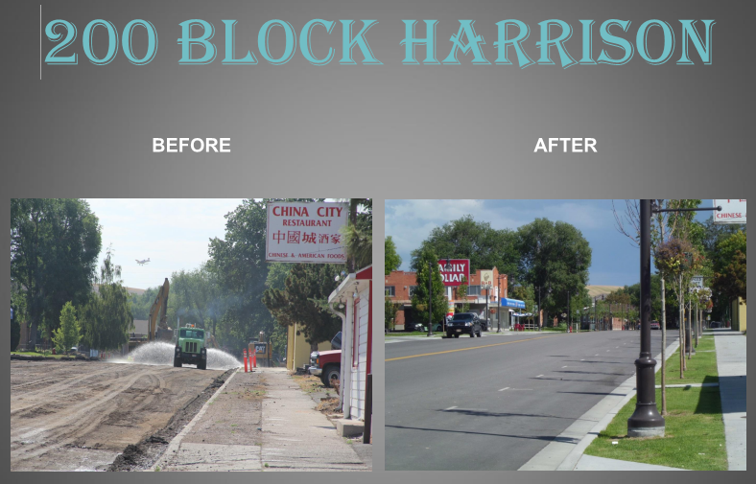

Complete Street Project

Source: City of American Falls, ID

***Additional Project Background:***

The City of American Falls sought TIGER grant funds to aid in the reconstruction of five blocks of its downtown, which also served as a critical transportation corridor. The goal of the project was to transform this area to provide safe, attractive bicycle and pedestrian access into and around the downtown core. The project was envisioned as encouraging alternatives to private cars, improving safety, and reducing speeds by narrowing travel lanes and widening sidewalks. Additional infrastructure improvements such as installing water lines and planting trees, shrubs, and bushes were meant to attract businesses to downtown.

## Project Benefits:

Following project completion, performance metrics for the American Falls Complete Streets project showed a decrease in automobile and truck traffic within the corridor with a corresponding increase in pedestrian trips. The occupancy rate in the neighborhood increased while the average parcel value remained unchanged.

Table 4: Measured Post-Project Benefits: City of American Falls Complete Streets

|  |  |  |  |  |
| --- | --- | --- | --- | --- |
| **Performance Measure** | **Pre-Project**  **08/2011** | **Post-Project**  **Q1 2013–**  **Q4 2015** | **Percentage Change** | **Strategic Goal Area** |
| Annual Average Bike Trips | 10 | 3.99 | -60.10% | Quality of Life |
| Annual Average Pedestrian Trips | 115 | 187 | 62.87% | Quality of Life |
| Annual Average daily traffic | 2040 | 1774.1 | -13.03% | Quality of Life |
| Annual Average daily truck traffic | 261 | 61.9 | -76.28% | Quality of Life |
| Annual parcel occupancy and value in project area | 74% | 82% | 10.81% | Quality of Life |
| Annual parcel value in project area | $89,903 | $89,903 | 0.00% | Quality of Life |

*\*All post-project performance measures are calculated by averaging data collected at quarterly intervals.*

## Other Considerations:

The project has been successful in turning downtown American Falls into an easily navigable, pedestrian-friendly environment. Occupancy rates have started to increase as has interest in vacant parcels. The types of businesses that could potentially be attracted to the sites have also expanded due to the infrastructure upgrades. The infrastructure in place previously was not suitable to support some businesses, such as restaurants. Other qualitative benefits not captured by the data collected as part of the grant agreement requirements include the following:

Table 5: Qualitative Project Benefits: City of American Falls Complete Streets

|  |  |
| --- | --- |
| **Performance Measure** | **Strategic Goal Area** |
| Increased private investment into infrastructure and local businesses | Economic Competitiveness |
| Redirection of trucks onto specified freight routes | Safety, Quality of Life |
| Increased civic pride | Quality of Life |
| Decreased time to find parking in downtown core | Quality of Life |

* A more detailed case study for this TIGER project can be found in Appendix B.

**PROJECT SNAPSHOT #3:I-85 CORRIDOR IMPROVEMENT AND YADKIN RIVER CROSSING,   
TIGER I PROJECT\***

## Project Funding:

Total Project: $136,000,000

TIGER Grant Contribution: $10,000,000

Recipient Contributions: $125,000,000

***Project Type and Purpose:***

Bridge and Highway Improvement: This roadway improvement project featured several bridge replacements, expanded lane capacity, and safety enhancements across a 3.3 mile stretch of interstate I-85, which is a main corridor in NC connecting Greensboro and Charlotte. This project led to decreased travel times and maintenance expenditures as well as increased safety and bridge conditions.

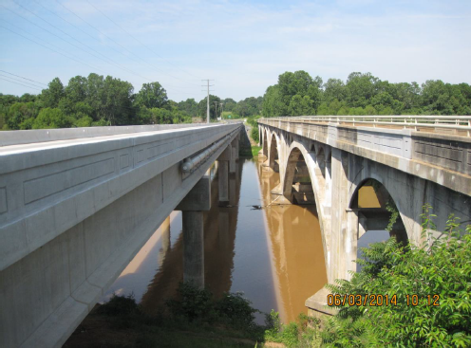

**Yadkin River Bridge Crossing**

*Source:**USDOT FHWA Construction Inspection Report 6/27/14*

***Additional Project Background:***

The project covered roughly 3.3 miles of the corridor and included widening Interstate 85 to eight lanes, replacing existing bridges over the Yadkin River, reconstructing the interchange at NC 150, and potential preservation activities on an historic concrete arch bridge.

Supplemental agreements were provided to further enhance the corridor. These agreements led to the repair of an older bridge, used at first as a detour route, as a new bridge was built and that later became part of a pedestrian and bicycle trail.

## Project Benefits:

Completion of the I-85 Corridor Improvement project resulted in lower average travel times and reduced maintenance costs as well as crash rate ratios, as shown in the table below. The bridge condition sufficiency ratings increased as well.

Table 6: Measured Post-Project Benefits: I-85 Corridor Improvement and Yadkin River Crossing

| **Performance Measure** | **Pre-Project**  **Q4 2010** | **Post-Project\***  **Q3 2013 –**  **Q4 2015** | **Percentage Change** | **Strategic Goal Area** |
| --- | --- | --- | --- | --- |
| Weekday Annual average hourly (or peak and off-peak) buffer index[1] - Northbound | 5.30% | 3.51% | -34% | Economic Competitiveness, Quality of Life |
| Weekday Annual average hourly (or peak and off-peak) buffer index - Southbound | 6.90% | 6.14% | -11% | Economic Competitiveness, Quality of Life |
| Weekday Annual average hourly (or peak and off-peak) vehicle travel time - Northbound | 1.04 | 0.94 | -10% | Economic Competitiveness, Quality of Life |
| Weekday Annual average hourly (or peak and off-peak) vehicle travel time - Southbound | 1.00 | 0.91 | -9% | Economic Competitiveness, Quality of Life |
| Annual maintenance expenditures | $6,000.00 | $2,108.38 | -65% | State of Good Repair |
| Annual or rolling average annual crash rates by type/severity - Total | 129.00 | 37.28 | -71% | Safety |
| Annual or rolling average annual crash rates by type/severity - Fatal | 1.16 | 0.30 | -74% | Safety |
| Annual or rolling average annual crash rates by type/severity - Non-fatal | 34.17 | 6.85 | -74% | Safety |
| Bridge condition (sufficiency rating) | 39.00 | 96.31 | -80% | State of Good Repair, Safety |

| **Performance Measure** | **Pre-Project**  **Q4 2010** | **Post-Project\***  **Q3 2013 –**  **Q4 2015** | **Percentage Change** | **Strategic Goal Area** |
| --- | --- | --- | --- | --- |
| Volume to capacity ratio[2] | 1.23 | 0.60 | 147% | Economic Competitiveness, Quality of Life |

*\*All post-project performance measures are calculated by averaging data collected at quarterly intervals.*

## Other Considerations:

The project was scaled down due to the award being less than was requested in the TIGER grant application. The applicants initially asked for $300 million and received $10 million. The total project cost then changed from $352 million to the $136 million for the first phase of the overall project.

While there are measurable, and notable, impacts from this project, it is part of a larger effort along a major corridor that is not yet complete, including some sections of I-85 that are not yet eight lanes. Once the entire corridor improvement is complete, additional growth and expansion is expected; these benefits will be due at least in part to the earlier improvements, including those funded by TIGER. Additional benefits not captured by the data reported as part of the grant agreement requirements include the following:

**Table 7. Qualitative Project Benefits: I-85 Corridor Improvement and Yadkin River Crossing**

|  |  |
| --- | --- |
| **Performance Measure** | **Strategic Goal Area** |
| Usage of older Route 29 bridge as pedestrian and bicycle trail | Quality of Life |
| Allowed for other improvements to begin | Economic Competitiveness |
| Decreased emissions | Environmental Sustainability |

* A more detailed case study for this TIGER project can be found in Appendix B.

# PROJECT SNAPSHOT #4:Mississippi River Bridges Incident Management, Freight Movement, and Security, TIGER III Project*

## Project Funding:

Total Project: $10,760,658

TIGER Grant Contribution: $9,814,700

Recipient Contribution: $945,958

***Project Type and Purpose:***

Installation of intelligent transportation systems (ITS) improvements on and around four highway bridges – The overarching purpose of this project was to create a highly efficient multi-modal transportation monitoring and management system to detect and support highway and river incident management, improve freight mobility, and enhance security for critical elements of the Nation’s infrastructure. Each of the four bridges serves as a detour route for other bridges along the corridor (via the north/south US 61 and US 65 routes), and this project was intended to help prevent potential closures as well as better manage them when a closure does occur.

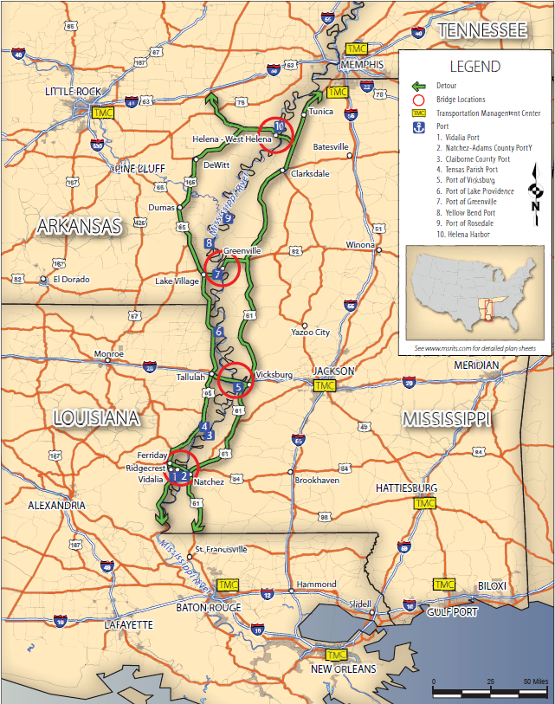

Mississippi River Bridges (red circles)

Detour Routes (green lines with arrows) Transportation Management Centers (yellow boxes)

Source: Mississippi DOT, TIGER Grant Application

***Additional Project Background:***

The Mississippi River Bridges project installed ITS improvements on and around four rural highway bridges that span the Mississippi River across the States of Mississippi, Arkansas, and Louisiana: the Helena Bridge (US-49, MS and AR); the Greenville Bridge (US-82, MS and AR); the Vicksburg Bridge (I-20, MS and LA); and the Natchez-Vidalia Bridge (US-84, MS and LA). The improvements include dynamic messaging signs, vehicle detection systems, road weather information systems, closed circuit television, highway advisory radio, other fiber optic connections that can coordinate communication across the bridges, and real-time river current monitoring systems to provide information for barges traveling beneath the bridges. The project also includes the formation of a tristate Traffic Incident Management (TIM) coalition to operate and manage the system collaboratively.

## Project Benefits:

The project was selected to meet the following TIGER objectives:

* State of good repair (by applying bridge monitoring technology to help bridge owners detect deficiencies caused by damage to the structure).
* Economic competitiveness (by improving highway and waterway operations on four key bridges that support international and national trade).
* Quality of life (by reducing vehicle hours of delay).
* Environmental sustainability (by reducing greenhouse gas emissions and ozone precursor emissions).
* Safety (reduction in potential for traffic crashes, along with faster and more appropriate response to incidents, and improved travel time predictability).

The quantitative performance measure evaluation for this project focused on the safety and quality of life benefits. Specifically, it measured annual vehicle crash rates by severity; river traffic bridge collisions by severity; average crash clearance time by crash severity; average river incident clearance time; and vehicle delayed travel time per incident for all four bridges. Baseline (2012) and post-project (2015) data collected for the project shows:

* A 42 percent reduction in the number of vehicles crashes, from 212 to 103 per year.
* On individual bridges, crashes declined between 25 percent (Greenville Bridge) and 64 percent (Vicksburg).
* There have been no barge-bridge collisions during the evaluation period, either pre-project or post-project.

Table 8: Measured Project Safety Benefits: Mississippi River Bridges Incident Management, Freight Movement, and Security

|  |  |  |  |
| --- | --- | --- | --- |
| Bridge | Crashes | | Percent Change |
| **2012 (Pre-project)** | **2015 (Post-project)** |
| Greenville | 17 | 12 | ‐25% |
| Helena | 8 | 6 | ‐29% |
| Vicksburg | 70 | 25 | ‐64% |
| Natchez | 118 | 61 | ‐48% |
| Average | 213 | 104 | ‐42% |

The data do not show consistent findings about the effectiveness of the ITS improvements in reducing **average crash clearance time**, nor in reducing **bridge delay per incident**. These results may be due to several factors, including the relatively low number of annual crashes, which makes it difficult to assess trends because any single incident can significantly impact the averages.

## Other Considerations:

This project is still in the middle of its post-project evaluation period. The findings from the project are expected to be more robust and potentially more conclusive regarding crash clearance times and vehicle-hours of delay following the final 2017 data collection period.

Although there have been no river-bridge collisions during the pre- or post-project evaluation timeframes, there have been two major river flood events since the river current sensors were installed. It is difficult to determine whether the lack of collisions during these flood events is attributable to the project, but MDOT staff believes it is indicative that the sensors are assisting with navigation during flood events.

This project has also allowed MDOT to provide more robust traffic information to travelers who, in turn, are able to make more informed choices about their route and travel time. MDOT reported that in stakeholder meetings, participants found significant value in this data, which is provided through 511 and changeable message signs.

* A more detailed case study for this TIGER project can be found in Appendix B.

PROJECT SNAPSHOT #5: CRESCENT CORRIDOR INTERMODAL FREIGHT RAIL – MEMPHIS AND BIRMINGHAM INTERMODAL FACILITIES, TIGER 1 PROJECT*

## Project Funding:

Total Project: $224,000,000

TIGER Contribution: $105,000,000

Recipient Contribution: $119,000,000

***Project Type and Purpose:***

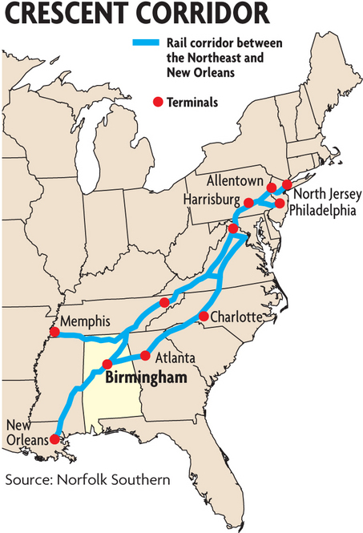

Map of the Crescent Corridor Rail Network

The Birmingham Regional Intermodal Facility (BRIMF) and the Memphis Regional Intermodal Facility (MRIMF) are public-private partnerships to construct the facilities with adjacent infrastructure improvements. The TIGER Grant of $105 million was split evenly and applied toward the cost to construct these facilities. The remaining funding came from a combination of Norfolk Southern, CMAQ funds, and other local sources.

Intermodal Rail/Freight – The Crescent Corridor is a major intermodal freight program centered on the continued development of Norfolk Southern’s rail intermodal route from the Gulf Coast to the Mid-Atlantic. Two TIGER grants totaling $105 million supported construction of two new intermodal facilities in Birmingham (McCalla), AL and Memphis (Rossville), TN—both critical components of the full corridor plan. Construction of these new facilities included pad and support tracks, trailer and container parking areas, lead tracks, roadway access, drainage improvements, and related ancillary buildings and features.

***Additional Project Background:***

The Crescent Corridor freight rail improvement project is a multi-state rail development program undertaken by owner and operator Norfolk Southern Railway in partnership with the U.S. Department of Transportation and the States of Alabama, Pennsylvania, Virginia, Tennessee and Mississippi. The project will connect the existing rail lines with 11 intermodal facilities to enhance freight transportation and distribution services in the Southeast, Gulf Coast and Mid-Atlantic markets. It is intended to provide improved intermodal rail freight services along the Crescent Corridor, which has witnessed drastic growth in interstate freight volumes resulting in traffic congestion and heavy carbon emissions.

The construction of the two intermodal facilities in Alabama and Tennessee funded by TIGER were part of the larger corridor-wide facility improvement program, which, once fully developed, will improve domestic rail intermodal service between the Northeast and Southeast for the terminal host cities of Memphis, Birmingham, Atlanta, Charlotte, Knoxville, Roanoke, Greencastle, Harrisburg, Bethlehem, Philadelphia and the Northern New Jersey region. Connecting this 2,500-mile network of existing rail lines with regional intermodal freight distribution centers will strengthen domestic and international freight distribution in the Southeast, Gulf Coast and Mid-Atlantic markets. The Birmingham, AL and Memphis, TN facilities were fully operational in 2013.

## Project Benefits:

The project was selected to meet the TIGER program objectives of enhancing economic competitiveness, livability, sustainability, state of good repair, safety, and job creation. Within the scope of the grant agreement, baseline and post-project data collected reflect numerous project benefits, including:

* Facility throughput as measured by average daily gross ton-miles originated or destined at facilities, and average daily lifts (containers or trailers, loads only) represented new freight handling capacity, which increased significantly and steadily following completion of the projects.
* Reduced truck vehicle miles traveled via diversion of freight from highway to rail. This results in significant reductions in diesel fuel consumption, truck emissions, and highway accidents involving trucks.
* The benefits have increased significantly at both facilities since opening with average daily lifts increasing 21 percent (Memphis) and 122 percent (Birmingham) between May 2013 and January 2016.

**Table 9. Measured Post-Project Benefits: Crescent Corridor Intermodal Freight Rail – Memphis and Birmingham Intermodal Facilities**

|  |  |  |  |
| --- | --- | --- | --- |
| **Performance Measure** | **MRIMF TIGER Grant #31** | **BRIMF** **TIGER Grant #32** | **Strategic Goal Area** |
| Average Daily Gross Ton-Miles | 3,382,545 | 989,886 | Economic Competitiveness, State of Good Repair |
| Average Daily Lifts (Containers or Trailers, Loads Only) | 201 | 47 | Economic Competitiveness |
| Average Truck Vehicle Miles of Travel Avoided Per Quarter | 17,164,141 | 5,025,161 | Economic Competitiveness, State of Good Repair |
| Average Diesel Fuel Consumption Saved Per Quarter (Gallons) | 2,358,862 | 690,606 | Environmental Sustainability, Economic Competitiveness |
| Average Highway Accidents Avoided Per Quarter | 17 | 5 | Safety |

## Other Considerations:

The measured benefits of the intermodal facilities were developed through operational records of cargo moved as expressed in Gross Ton Miles and number of lifts. The truck and highway related impacts, as expressed by the below performance measures were modeled based on freight flows across likely origin-destination locations which would be diverted from truck to rail as a result of the new facilities.

* Average Truck Vehicle Miles of Travel Avoided Per Quarter
* Average Diesel Fuel Consumption Saved Per Quarter (Gallons)
* Average Highway Accidents Avoided Per Quarter

Other impacts resulting from the new intermodal facilities include the following (see Qualitative Project Benefits table below):

* Significant new freight capacity from the Southeast through the Mid-Atlantic region, an area currently underserved by intermodal rail.
* Provided employment during the construction of each facility and increased business opportunities and job creation in economically distressed Memphis and Birmingham.
* Project combined multiple modes (water, rail, and highway) to gain the capacities, efficiencies, and environmental benefits of each.
* Reduced greenhouse gas emissions; congestion and highway maintenance costs by reducing truck traffic.
* Railroad donated green/recreational spaces improved quality of life for neighboring communities.
* Lessened footprint of facilities through enhanced storm water management on and near facilities; reduced truck idling emissions and fuel consumption due to state of the art Automatic Gate System (AGS) installed at the Memphis facility and with a Leadership in Energy and Environmental Design (LEED) certified Administration Building in the Birmingham facility.

**Table 10. Qualitative Project Benefits: Crescent Corridor Intermodal Freight Rail – Memphis and Birmingham Intermodal Facilities**

|  |  |
| --- | --- |
| **Performance Measure** | **Strategic Goal Area** |
| Business Impacts on freight/rail-dependent firms  (Enabled regional business expansion) | Economic Competitiveness |
| Direct construction jobs and long-term employment opportunities | Economic Competitiveness,  Job creation |
| Reduced highway maintenance costs  (Through reduced truck traffic on highways) | State of Good Repair,  Safety |
| Reduced Greenhouse Gas Emissions  (Through reduced truck traffic on highways) | Environmental Sustainability |
| Lessened footprint of facilities  (Through enhanced storm water management, improved gate management, LEED certified construction, landscaping and other noise/view reduction methods) | Environmental Sustainability |
| Additional green and recreational space donated to neighboring communities | Livability |

* A more detailed case study for this TIGER project can be found in Appendix B.

**PROJECT SNAPSHOT #6: QUONSET WIND ENERGY AND SURFACE TRANSPORTATION, TIGER I PROJECT**

***Project Funding:***

Total Project: $24,501,556.55

TIGER Grant Contribution: $22,293,106.55   
Recipient Contribution: $2,208,450

## Project Type and Purpose:

Port Facility Enhancement – The Quonset Wind Energy and Surface Transportation TIGER Project enabled a series of improvement projects at the Port of Davisville, North Kingstown, RI which included upgrades and repairs to the two docking piers, area paving, road improvements and extensions, mobile harbor crane purchase and crane platform construction, rail improvement and extension, and improved drainage in the port. These improvements not only enable increased throughput of the port, but also allow the on and off loading of wind power equipment supporting off-shore and terrestrial wind projects throughout the region.

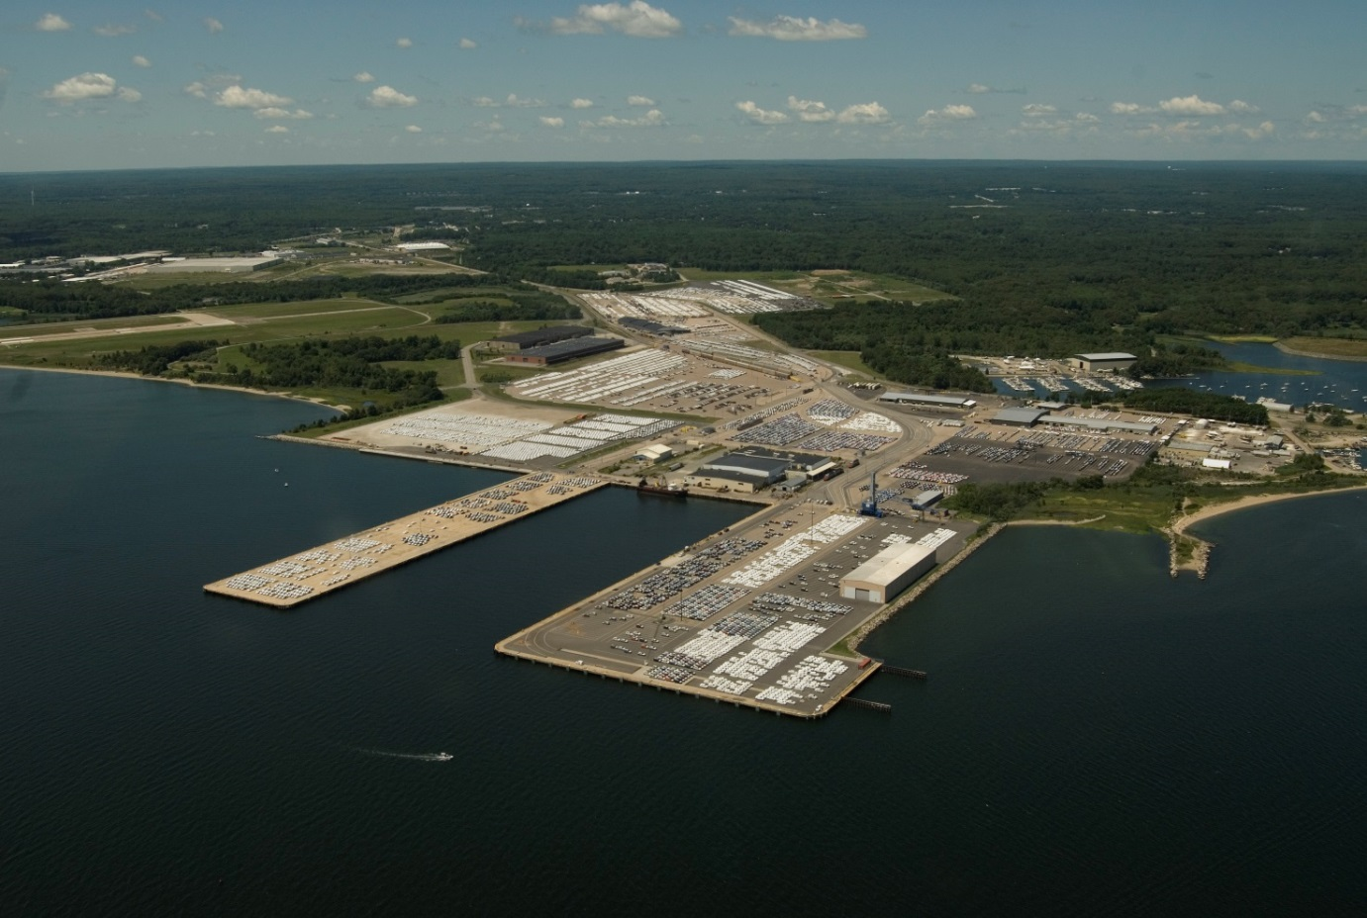

***Port of Davisville, Narragansett Bay, Rhode Island***

*Source: Quonset Development Corporation*

## Additional Project Background:

The Quonset Business Park, located on the west shore of Narragansett Bay, consists of the former Quonset Naval Air Station (surplused in 1974) and the adjacent Davisville Naval Construction Battalion Center (surplused in 1994). Most of the infrastructure was built during base construction in 1939 and 1940. The TIGER funds were used for pier maintenance, rail improvements and road reconstruction, which supports, among other things, a robust auto import business, wind energy projects, and special project cargoes for companies based on Quonset.

The project improved freight transportation at the port, achieved a state of good repair, extended the useful life of former military assets, and increased port capacity. It also improved access to industrial properties being marketed to alternative energy producers (particularly offshore wind), which will help increase energy independence. Quonset is a transportation hub on the northeast corridor and is well situated to divert freight traffic from congested interstate highways to sea and rail, making container barge feeder service viable.

## Project Benefits:

The project was selected to meet the TIGER program objectives of enhancing economic competitiveness, livability, and sustainability; maintaining a state of good repair of facilities; improving safety; and creating jobs. Within the scope of the grant agreement, baseline and post-project data collected shows the project to have:

* Increased port tonnage and port revenues by an average of 55 percent and 98 percent, respectively.
* Increased the number of automobiles moved through the port by 38 percent.
* Enabled new Lift On-Lift Off (LO-LO) cargo (including wind energy equipment) to move through the port through pier improvements and installation of new craning capabilities.

**Table 11. Measured Post-Project Benefits: Quonset Wind Energy and Surface Transportation**

|  |  |  |  |  |
| --- | --- | --- | --- | --- |
| **Performance Measure** | **Pre-Project** | **Post-Project** | **Percentage Change** | **Strategic Goal Area** |
| **Total LO-LO Cargo\*** |  |  |  |  |
| Number of Lifts | 0 | 63 | All New | Economic Competitiveness |
| Tonnage (MT) | 0 | 451 | All New | Economic Competitiveness |
| Gross Revenue | $0 | $2,598 | All New | Economic Competitiveness |

|  |  |  |  |  |
| --- | --- | --- | --- | --- |
| **Performance Measure** | **Pre-Project** | **Post-Project** | **Percentage Change** | **Strategic Goal Area** |
| **Finished Automobiles (RO-RO)** |  |  |  |  |
| Number of Units | 33,662 | 46,314 | 38% | Economic Competitiveness |
| Tonnage (MT) | 49,740 | 76,490 | 54% | Economic Competitiveness |
| Gross Revenue | $163,724 | $321,046 | 96% | Economic Competitiveness |
| **Port Totals** |  |  |  |  |
| Total Tonnage (MT) | 49,740 | 76,941 | 55% | Economic Competitiveness |
| Total Revenue | $163,724 | $323,644 | 98% | Economic Competitiveness |
| * Includes wind and other project cargo. LO-LO = lift on-lift off 🞟 MT = metric tons 🞟 RO-RO = roll on-roll off | | | | |

## Other Considerations:

The data collected demonstrated the project significantly improved the throughput of the port, including the addition of LO-LO cargo, by enhancing and expanding facilities. The table above shows the post-project metrics averaged over the quarters following project completion. Note that port throughput and revenues have grown significantly—total tonnage by 57 percent and total revenue by 94 percent (quarter 12 versus quarter 1 post project). The performance data was limited to readily available port throughput performance metrics and does not measure the impacts of direct construction employment, the impacts on the business community dependent upon the port and the business park and the jobs those businesses create, the ability of the Quonset Development Corporation to maintain the facilities, or reductions in fuel consumption and GHG emissions and reduced roadway accidents resulting from possible diversion of truck to water/rail. These benefits support multiple TIGER Strategic Goal areas, as follows:

**Table 12. Qualitative Project Benefits: Quonset Wind Energy and Surface Transportation**

| **Performance Measure** | **Strategic Goal Area** |
| --- | --- |
| Business Impacts on port and rail-dependent firms (Enabled business expansion at the port/business park) | Economic Competitiveness |
| Direct construction jobs associated with project (35.7 Full Time Equivalent construction jobs) | Economic Competitiveness;  Job creation |
| Long-term employment increases (increase of 408 permanent jobs at the port by 2015) | Economic Competitiveness  Job creation |
| Reduced pier and rail line maintenance costs (Improved condition and modernization of facilities) | State of Good Repair |
| Reduced fuel consumption (Enhanced rail/water service to region diverting freight from truck) | Environmental Sustainability  Economic Competitiveness |
| Reduced GHG emissions (Enhanced rail/water service to region diverting freight from truck. Indirectly be enabling wind farm construction) | Environmental Sustainability |
| Reduced roadway accidents (Enhanced rail/water service to region diverting freight from truck) | Safety |

**PROJECT SNAPSHOT #7: Kansas City Transit Corridor and Green Impact Zone, TIGER I Project**

## Project Funding:

Total project: $50,000,000

TIGER Grant Contribution: $50,000,000

## Project Type and Purpose:

Construction of two transit centers and other transit improvements – The project partners’ goal was to use the construction of transit service infrastructure to support economic development and redevelopment in the Kansas City region. The agencies used the funds to improve facilities linking Kansas City’s revitalized urban core with both new corridor development throughout the region as well as neighborhoods that suffered from disinvestment in past decades, supporting the regional vision for enhanced and expanded transit. This project will enhance access to jobs and support economic development.

***Additional Project Background:***

The project partners, Mid America Regional Council (MARC), Johnson County Transit (JCT), and Kansas City Area Transportation Authority (KCATA) worked together to enhance transit and pedestrian infrastructure throughout the Kansas City region. JCT and KCATA used their funding to invest in transit infrastructure and pedestrian access, while MARC served as the administrator and coordinator for the project. Three transit corridors received significant upgrades including new transit centers, enhanced transit stations, park-and-ride facilities, transit signal priority, and improved pedestrian access, corridors between stations, and infrastructure. In addition, projects in an area called the “Green Impact Zone” included replacing broken sidewalks and curbs, constructing new transit facilities, applying stormwater management projects, improving and synchronizing traffic signals, improving streetscapes, and making improvements to 14 bus stops. To carry out its role coordinating with project stakeholders, MARC developed a project management team that served as a forum for coordinating the 103 improvement projects and dozens of partners that were part of the larger project. MARC also was responsible for the community outreach and put together a video series.

## Project Benefits:

The goals of the project were to increase the state of good repair and to enhance economic competitiveness, livability, sustainability, safety, job creation and economic stimulus, innovation, and regional partnerships. The improvement of transit facilities will provide the public with affordable, clean transportation alternatives and ultimately will better connect neighborhoods to economic opportunities in the region. Four performance measures were used to evaluate the project; the table below provides results for one of the measures, average daily ridership.

Table 13. Measured Post-Project Benefits – Average Daily Ridership: Kansas City Transit Corridor and Green Impact Zone

| **Performance Measure** | **Pre-Project (April 2010)** | **Post-Project (April 2014)** | **Percentage Change** | **Strategic Goal Area** |
| --- | --- | --- | --- | --- |
| Average daily ridership – JCT - Metcalf/Avenue Shawnee Missions Parkway | 189.2 | 359 | +89.7% | Sustainability, Livability |
| Average daily ridership – KCATA – State Avenue corridor | 3,790 | 4,750 | +25.3% | Sustainability, Livability |
| Average daily ridership – KCATA – Missouri Transit Centers | 966 | 1,417 | +46.7% | Sustainability, Livability |
| Average daily ridership – KCATA – All corridors | 58,175 | 61,113 | +5.1% | Sustainability, Livability |

Transit service levels were the second performance measure for the project, although none of the TIGER funding went directly toward service enhancements. JCT implemented a number of span-of-service increases for one of its corridors, while KCATA made a range of service changes to maximize the efficiency of its investments; this included reducing or eliminating service on under-performing routes while increasing it on critical routes. One route in the Green Impact Zone was eliminated altogether, as the area was already well-served by transit. Regarding the third performance measure, traffic counts, the results varied significantly across locations, with no consistent findings. Infrastructure and inventory condition, the fourth performance measure, was largely qualitative, although the project called for the number of improvements to be measured. As a result of the Green Impact Zone component of the project, 3 new transit centers, 30 bus shelters and 49 real-time travel kiosks were constructed, and improvements were made at 84 transit locations. Thirty traffic signals were improved, 14.1 miles of wire interconnect were installed, 22.9 miles of streets were paved, 14 miles of sidewalk and pedestrian trails were paved, and 350 new trees were planted. The picture below provides an example of the improvements.

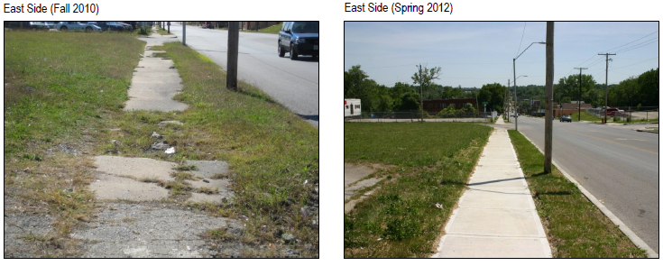

Before and After Photographs Showing Sidewalk Improvement in One Green Impact Zone Location

## Other Considerations:

Transit service levels as a performance measure were informative, but were not directly supported by TIGER funding. Average daily ridership increases, particularly at targeted investment locations, seem indicative of the increased attractiveness of the new facilities.

In order to highlight the qualitative benefits of the project, the grantees developed a series of short (2-4 minute) YouTube videos (example video snapshot below), in which stakeholders and residents discuss and show the pedestrian and transit improvements. With additional resources, MARC and its partners would have conducted a quantitative assessment of the increases in access to jobs and in property values, and the decreases in crime, that could be linked to the project.

MARC staff noted that the project was groundbreaking in terms of the level of regional transit coordination it catalyzed. Since the end of the project, MARC, KCATA, and other partners have formed a regional transit coordinating council that has been successful in winning additional Federal funding for transit, and has developed a mobility management system for the region. Four transit agencies in the region have since branded themselves as a single entity, with one regional website where users can access information about services. Finally, the partners worked together to win an additional TIGER grant to develop a strategy for improved access to jobs, with a goal of doubling the number of jobs accessible to residents by transit within 10 years.

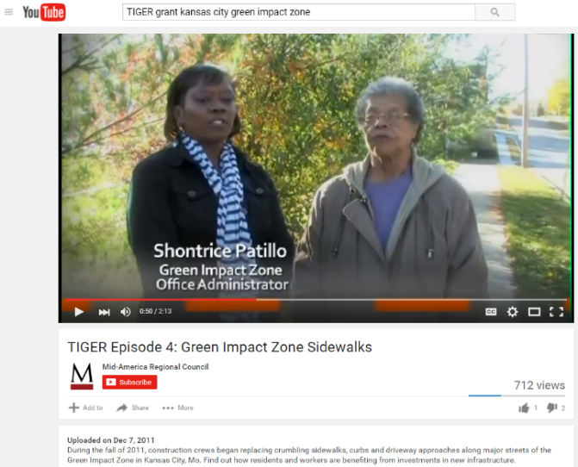

Snapshot of YouTube Video Published by MARC

Table 14. Qualitative Project Benefits: Kansas City Transit Corridor and Green Impact Zone

|  |  |
| --- | --- |
| **Performance Measure** | **Strategic Goal Area** |
| Improved accessibility to jobs | Economic Competitiveness, Quality of Life |
| Economic development and redevelopment | Economic Competitiveness, Quality of Life |
| Enhanced property values | Economic Competitiveness |
| Reduced crime | Safety, Quality of Life |
| Improved accessibility for low-mobility and disabled residents, including transit services | Safety, Quality of Life |
| Improved regional coordination to enhance transit service and consistency across operators | Quality of Life |

**PROJECT SNAPSHOT #8: US-395 North Spokane Corridor - Francis Ave. to Farwell Rd. Southbound TIGER I Project\***

***Project Funding:***

Total Project: $210 million (for the Francis-Farwell component of the corridor[3],[4])

TIGER Grant Contribution: $35 million

Recipient Contribution: $175 million

## Project Type and Purpose:

New highway facility with multimodal components. The North Spokane Corridor project addresses inadequate capacity for north/south traffic, including freight, from the northern part of the metro area to I-90 on the southern end. It also provides park and ride lots, space for future transit, and a bike/pedestrian trail.

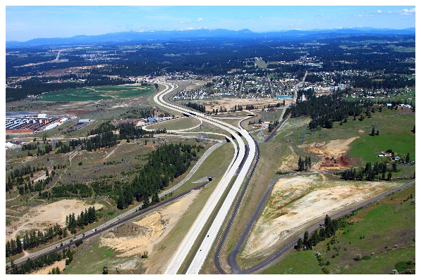

Design visualization for segment of North Spokane Corridor

Source: Washington State DOT

## Additional Project Background:

The TIGER-funded portion of the project included the completion of the 3.7 miles of southbound lanes between Francis Avenue and Farwell Road. Construction began in August 2009 and the southbound lanes opened near the end of 2012. The northbound lanes were previously completed and used for both northbound and southbound traffic (one lane in each direction) prior to the TIGER-funded project.

## Project Benefits:

The purpose of the greater North Spokane Corridor project is to improve mobility, reduce travel time and neighborhood truck traffic, improve safety, and support transportation choices. Trucks currently traveling south to I-90 encounter 29 stoplights. This results in significant idling and contributes to emissions. The project was designed to meet TIGER objectives of Safety (reducing collisions and conflicting movements); Economic Competitiveness (lowering travel times and fuel usage, increasing mobility, improving system efficiency, and creating jobs); Sustainability (reducing emissions and providing alternative travel options); and Quality of Life (lowering travel times and increasing mobility). Baseline and post-project data collected for the project shows:

* Over a doubling in truck traffic and a 235 percent increase in overall annual average daily traffic, suggesting that traffic has shifted to the facility
* A more than doubling of pedestrian and bicycle trips

Results showed an increase in crash rates on the facility itself, associated with the significant increase in traffic volumes. The following table presents before and after data for the project area, with before data taken prior to construction and after data taken in June 2015 after the project had been open to traffic for several months.

Table 15. Measured Project Benefits: I-395 North Spokane Corridor – Francis Ave. to Farwell Rd. Southbound

|  |  |  |  |  |
| --- | --- | --- | --- | --- |
| **Performance Measure** | **Pre-Project** | **Post-Project** | **Percentage Change** | **Strategic Goal Area** |
| Average Annual Daily Traffic (ADT) for southbound lanes | 2000 (8/2009) | 6695 (6/2015) | +234.8% | Economic Competitiveness |
| Average Annual Daily Truck Traffic (ADTT) for the southbound lanes | 280 (8/2009) | 570 (6/2015) | +103.6% | Economic Competitiveness |
| Annual Average Hourly Vehicle Travel Time (AHVTT), in minutes and seconds | 5:18 (10/2010) | 5:35 (6/2015) | +5.3% | Economic Competitiveness, Quality of Life |
| Pavement Condition3, 4 | n/a  (all 99+) (9/2012) | PSC:95  PRC: 91  PPC: 86 (6/2015) | -4.0%  -8.1%  -13.1% | State of Good Repair |
| Bridge Sufficiency Rating (0-100)3 | n/a (average of 99.64) (9/2012) | 99.37 average (6/2015) | <.003% | State of Good Repair |

|  |  |  |  |  |
| --- | --- | --- | --- | --- |
| **Performance Measure** | **Pre-Project** | **Post-Project** | **Percentage Change** | **Strategic Goal Area** |
| Average daily bike trips | 22 (8/2011) | 44 (6/2015) | 100% | Quality of Life |
| Average daily pedestrian trips | 6 (8/2011) | 14 (6/2015) | 133.3% | Quality of Life |
| 3 Pavement condition and bridge sufficiency baseline measures were taken after the new facility was completed. Therefore, the “pre-project” in this case refers to initial data after construction.  4 Pavement Structural Condition (PSC), Pavement Rutting Condition (PRC), and Pavement Profile Condition (PPC) | | | | |

## Other Considerations:

Performance results showed some fluctuation across quarters. In a few cases, these were due to seasonal factors (e.g. bike/pedestrian trips were lower in the winter), while in others (e.g. delay) they were due to temporary construction activities. In yet other cases (e.g. traffic volumes), the fluctuations were the results of changes in methodologies or technologies used for data collection. This project demonstrates challenges associated with measuring performance of a new facility. For most performance metrics, the baseline figures represented conditions during an early stage of the project when only two lanes out of the eventual six were available. Reported changes in traffic, crashes, and pavement and bridge conditions do not address the overall benefits of the project from a regional perspective but represent changes on the road facility itself. Moreover, because the project involved construction of just one segment of what will eventually be a new multimodal corridor providing a critical high-speed, stoplight-free link to I-90, significantly greater benefits are likely to be realized once the full corridor is complete. Additional benefits not captured by the data reported as part of the grant agreement requirements include the following:

Table 16. Qualitative Project Benefits: I-395 North Spokane Corridor – Francis Ave. to Farwell Rd. Southbound

| **Performance Measure** | **Strategic Goal Area** |
| --- | --- |
| Fuel savings | Economic Competitiveness, Quality of Life, Environmental Sustainability |
| Travel time savings | Economic Competitiveness, Quality of Life |
| Jobs created | Economic Competitiveness, Quality of Life |
| Traffic moved from urban arterials to the new highway | Economic Competitiveness, Quality of Life, Environmental Sustainability |

* A more detailed case study for this TIGER project can be found in Appendix B.

**PROJECT SNAPSHOT #9: SADDLE ROAD IMPROVEMENT, TIGER III PROJECT\***

***Project Funding:***

Total Project: $33,500,000

TIGER Contribution: $13,500,000

Recipient Contribution: $20,000,000

***Project Type and Purpose:***

Highway Improvement – The Saddle Road Improvement Project is a rural highway project improving the most direct cross-island route (east-west) on the island of Hawaii and the only paved access road to the U.S. Army’s Pohakuloa Training Area (PTA), Kaumana City, Hawaiian Homelands, Hakalau Forest National Wildlife Refuge, Mauna Kea State Park, and the Mauna Kea & Mauna Loa astronomical observatories. Although Saddle Road is the most direct cross-island route, many drivers avoid it because it is considered one of the State’s most hazardous highways. TIGER funded Section I of the project – building off of work already completed on Sections II and III – repaving and expanding the roadway along with other safety improvements, as well as realigning the western end of the road.

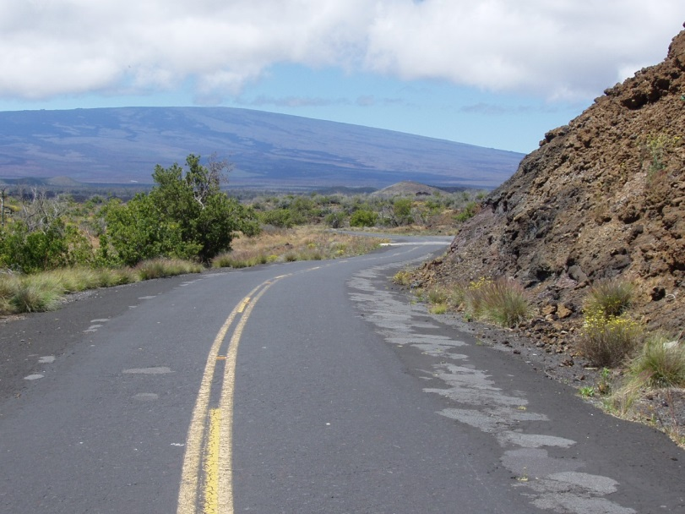

Saddle Rd, Hawaii, before improvements

Source: Federal Highway Administration; Central Federal Lands Highway Division

***Additional Project Background:***

Efforts to improve Saddle Road began in the mid-1990 with a multi-year planning effort between local stakeholders, the U.S. Army, and FHWA. Since that time, two of the four sections have been improved, building on significant investments by the U.S. Army (which had already reconstructed 31 of the original 48 miles). The overarching purpose of this project was to create a highly efficient, cross-island roadway to allow for safer and more efficient travel from the west side of the island to the east. Features of the project include:

* Travel lane width improvements allowing for two-way traffic and improved safety.
* Eight-foot wide shoulder installation, including signage for a shared route that will accommodate bicyclist and pedestrian use.
* Full, adequate clear zone installation and improved guardrails and parapets.
* Sight distance improvements and passing opportunities.
* Passing zones and/or pull-out construction to allow drivers the ability to safely pass slower moving vehicles or convoys.
* Climbing lane construction throughout most of the route.

## TIGER funded work on Section I, which included horizontal and vertical realignments, the addition of uphill passing lanes, truck escape ramps on the 10 miles of Saddle Road (SR200) from approximate MP 52 to MP 42, plus realignment of the western portion, making for a shorter and safer connection to the Mamalahoa Highway Intersection. Work also included construction of a new bridge overpass and associated underpass approaches (MP 43.5) for military vehicles and several highway access approach roads providing connection to adjacent land.

***Project Benefits:***

After completion, the west side of Saddle Road saw significant reductions in crash rates while use of the road (as measured in average daily traffic) increased considerably.

Table 17. Measured Post-Project Benefits: Saddle Road Improvement

|  |  |  |  |  |
| --- | --- | --- | --- | --- |
| **Performance Measure** | **Pre-Project**  **9/31/2012** | **Post-Project** | **Percentage Change** | **Strategic Goal Area** |
| Average Daily Traffic (ADT) | 1,881 | 3,4181 | 82% | Economic Competitiveness, Quality of Life |
| Average Daily Truck Traffic (ADTT) | 58 | 3902 | 572% | Economic Competitiveness, Quality of Life |
| Annual average vehicle travel time | 27 | 163 | -43% | Economic Competitiveness, Quality of Life |
| Annual crash rates measured by severity - Severe | 0.92 | 0.22† | -76% | Safety |
| Annual crash rates measured by severity - Total | 1.29 | 0.56† | -57% | Safety |
| Pavement condition rating (PCR) | 48 | 100‡ | 108.33% | State of Good Repair |
|
| *1Data is average of reports for 1/2014-8/2014.* | | | | |
| *2Data is average of reports for 1/2014-6/2014.* | | | | |
| *3Data is average for June 2014 and June 2015 Reports.* | | | | |
| *†Data is average of Q11 and Q14 reporting results* | | | | |
| *‡Data is only reported once, post project. Please see State of Good Repair discussion for further information* | | | | |

The performance metrics showed significant benefits from the safety improvements, as crash rates decreased considerably. The rate of severe crashes decreased by 57 percent and the total crash rate declined by 76 percent after the improvements. Discussions with local stakeholders indicate that this is much appreciated by the local community, as the completion of this project now allows for a safe route to travel east to west on the island.

The realignment and passing lanes have made traveling this section of Saddle Road faster as well as safer. Connecting Saddle Road to Mamalahoa Hwy in a more efficient manner and bypassing military facilities significantly reduces travel time. Prior to the new bypass, all traffic shared the same road, and passing slow vehicles was impossible at certain locations due to the narrow width of the existing roadway.

Previously, the pavement condition on Saddle Rd was poor. Since the improvements, the road’s pavement condition rating (measured and calculated using the roughness and surface condition of the roadway pavement) has improved significantly.

***Other Considerations:***

Other benefits from the project were measured after project completion. With respect to environmental sustainability benefits, while no specific metrics were selected, data on travel time savings and traffic could be used to determine any emissions reductions. Additionally, the new roadway was built in a context-sensitive manner, with minimal disruption to the native landscape.

Additionally, while no data was collected specifically for Quality of Life, interviews with stakeholders indicate the new road has positively impacted citizens across the island. This has come in the form of family members making more frequent visits to relatives who live on the other side of the island now that a safe travel alternative is available. Additionally, many people live on the East end of the island, while a large number of jobs are located on the West end. The improvements to the roadway have made for an easier and safer commute.

Table 18. Qualitative Project Benefits: Saddle Road Improvement

|  |  |
| --- | --- |
| **Performance Measure** | **Strategic Goal Area** |
| Emissions Reduction | Environmental Sustainability |
| Increased Connectivity | Quality of Life |
| Increased Comfort Level of Drivers | Quality of Life |

From the local community standpoint, the project is considered successful due to a number of factors, including high levels of local stakeholder participation. In interviews, local project stakeholders indicated a community committee to reconstruct Saddle Road had been active for 20 years. Discussion with the FHWA project office indicated a positive working relationship as well. Local funding and military funding were important in demonstrating project readiness, and the project completion appeared to be a joint effort consisting of the community, State, local, and Federal governments as well.

* A more detailed case study for this TIGER project can be found in Appendix B.

**Next Steps for TIGER Performance Measurement and Assessment**

As another round of TIGER project applications is currently under evaluation, previous rounds of TIGER projects undergoing grant agreement development, and still others in data submission phases, the Department is continually refining the performance development process. In conjunction with this refinement, the Modal Administrations will continue to work with grantees to develop appropriate performance measures as well as follow the Guidance document for collection and reporting of that data.

The Department looks to additional actions regarding the reporting and review of performance measurement data.

* The Department is currently considering ways to make TIGER performance measurement data available online. Release of such information would be through the TIGER website.
* Development and implementation of streamlined performance measurement data-reporting approaches for simplifying submission of performance data for TIGER grant recipients.
* The Department is considering ways to better organize data across modes and track submission.

**Conclusion**

The TIGER program is currently in its eighth round of awards and has already seen nearly $4.6 billion put towards improvements to the nation’s transportation systems. To both encourage the TIGER grant recipients to monitor progress and changes associated with the project as well as allow the Department to quantify benefits, each project is responsible for setting up performance measures. Throughout the program, the Department and TIGER grant recipients have experienced various challenges, but with each round, those experiences set forth positive change and improved processes. Overall, reporting of baseline data and post-completion measures has been positive. While aggregating the performance measures to show quantitative program benefits proves to be a continued challenge, individual review of projects shows program successes. The Department will continue efforts to implement improved performance measurement data collection and reporting processes.

1. The buffer index represents the extra time (or time cushion) that travelers must add to their average travel time when planning trips to ensure on-time arrival. <http://ops.fhwa.dot.gov/publications/tt_reliability/brochure/>
2. Referred to as the degree of saturation, this is synonymous with vehicle level of service. This serves as an indication of the operational performance of the facility by representing how sufficient the capacity is to accommodate the vehicular demand. <https://www.fhwa.dot.gov/congestion/index.htm>
3. <http://www.transinfo.state.wa.us/Projects/frmProjectDetail.asp?projectdescid=69242669>
4. $625 million total has been allocated to date ($140 million Federal and $475 million from the State) for the larger North Spokane Corridor project with connection to I-90. The full build-out cost with the completed I-90 connected is estimated at $1.3 billion. <http://www.wsdot.wa.gov/Projects/US395/NorthSpokaneCorridor/>