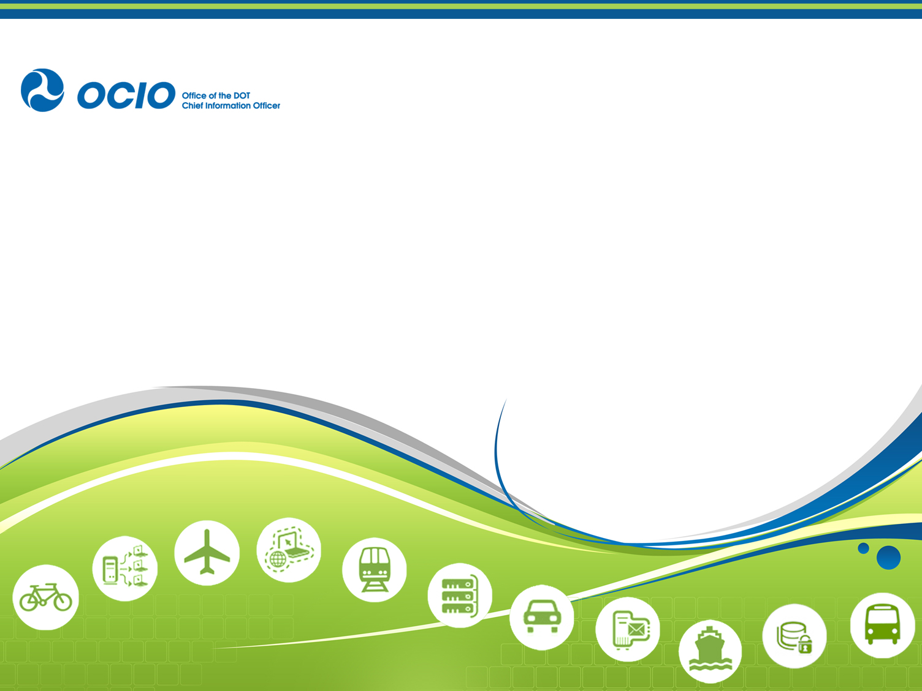

U.S. Department of Transportation

Privacy Impact Assessment (Update)

Federal Motor Carriers Safety Administration (FMCSA)
National Registry of Certified Medical Examiners
(National Registry)

Responsible Official
Elaine Papp
Division of Medical Programs
Federal Motor Carrier Safety Administration
202-366-4001
fmcsamedical@dot.gov

Reviewing Official
Claire W. Barrett
Chief Privacy & Information Asset Officer
Office of the Chief Information Officer
privacy@dot.gov

Executive Summary
The National Registry of Certified Medical Examiners (National Registry) was developed and implemented under the authority of Section 4116(a) of the Safe, Accountable, Flexible, Efficient Transportation Equity Act: A Legacy for Users (SAFETEA-LU) (codified at 49 U.S.C. § 31149). The program is managed and maintained by the Federal Motor Carrier Safety Administration (FMCSA). The Federal Motor Carrier Safety Regulations (FMCSRs) require that commercial motor vehicle (CMV) drivers comply with physical qualification requirements and be examined and certified by a medical examiner (ME) at least once every two years. The National Registry program ensures that MEs who perform DOT driver medical examinations are properly trained and certified by FMCSA to do so. The program will maintain personally identifiable information (PII) for each ME candidate applying for ME certification, MEs’ administrative personnel who are registering on the National Registry, and of CMV drivers examined by a certified ME. FMCSA published a final rule on April 20, 2012 (77 FR 73129), to establish and maintain a National Registry of Certified Medical Examiners. FMCSA posted a Privacy Impact Assessment (PIA) of the final rule on the DOT privacy program website on August 20, 2012.

FMCSA published the Medical Examiner’s Certification Integration Notice of Proposed Rulemaking (NPRM) on May 10, 2013 (78 FR 24104), a follow-on rule to the National Registry final rule. This NPRM proposes to require MEs to use a new Medical Examination Report (MER) Form, MCSA-5875; Medical Examiner’s Certificate (MEC), Form MCSA-5876; more frequent reporting of CMV driver medical examinations; FMCSA to electronically transmit Commercial Driver’s License ( CDL) and Commercial Learner’s Permit (CLP) driver information, from the National Registry system, to the State Driver Licensing Agencies (SDLAs); and electronically transmit medical variance information for all CMV drivers to the SDLAs.

Reason for the PIA Update
This PIA is being published as an update to the previous National Registry PIA (August, 20, 2012) and in support of the Medical Examiner’s Certification Integration NPRM. Any changes that have been made to the previously published National Registry PIA language are for clarification purposes only. In conjunction with this update, FMCSA published the Medical Examiner’s Certification Integration NPRM that proposes changes to require:

- Certified MEs performing medical examinations on CMV drivers to use a newly developed MER Form, MCSA-5875, in place of the current MER Form.
- Certified MEs to use Form MCSA-5876 for the MEC.
- Certified MEs to report results of all completed drivers’ medical examinations (including the results of examinations where the driver was found not to be qualified) to FMCSA by close of business day on the day of the examination. This would include all CMV drivers who are required to be medically certified to operate in interstate commerce, not only those who hold or apply for CDLs or CLPs.
- FMCSA to electronically transmit driver identification, examination results, and restriction information, from the National Registry system, to the SDLAs for holders of CDLs and CLPs. This includes those that have been voided by FMCSA because it finds that an ME has certified a driver who does not meet the physical certification standards.
- FMCSA to electronically transmit medical variance information (exemptions, skills performance evaluation certificates and grandfathered exemptions) for all CMV drivers to the SDLAs.

In connection with this PIA update, the National Registry System of Record Notice (SORN), published on August 20, 2012 (72 FR 24247), will be updated accordingly.

Privacy Impact Assessment
The Privacy Act of 1974 articulates concepts for how the Federal government should treat individuals and their information and imposes duties upon federal agencies regarding the collection, use, dissemination, and maintenance of personally identifiable information (PII). The E-Government Act of 2002, Section 208, establishes the requirement for agencies to conduct privacy impact assessments (PIAs) for electronic information systems and collections. The assessment is a practical method for evaluating privacy in information systems and collections, and documented assurance that privacy issues have been identified and adequately addressed. The PIA is an analysis of how information is handled to—i) ensure handling conforms to applicable legal, regulatory, and policy requirements regarding privacy; ii) determine the risks and effects of collecting, maintaining and disseminating information in identifiable form in an electronic information system; and iii) examine and evaluate protections and alternative processes for handling information to mitigate potential privacy risks.

Conducting a PIA ensures compliance with laws and regulations governing privacy and demonstrates DOT’s commitment to protect the privacy of any personal information we collect, store, retrieve, use and share. It is a comprehensive analysis of how DOT’s electronic information systems and collections handle personally identifiable information (PII). The goals accomplished in completing a PIA include:

Making informed policy and system design or procurement decisions. These decisions must be based on an understanding of privacy risk, and of options available for mitigating that risk;

- Accountability for privacy issues;
- Analyzing both technical and legal compliance with applicable privacy law and regulations, as well as accepted privacy policy; and
- Providing documentation on the flow of personal information and information requirements within DOT systems.

Upon reviewing the PIA, you should have a broad understanding of the risks and potential effects associated with the Department activities, processes, and systems described and approaches taken to mitigate any potential privacy risks.

FMCSA Background Information
The primary mission of FMCSA is to reduce crashes, injuries, and fatalities involving large trucks and buses. This mission is accomplished by developing and enforcing data-driven regulations that balance motor carrier safety with industry efficiency; utilizing Federal and State safety information systems to focus on high-risk carriers and drivers to enforce safety regulations; targeting educational messages to carriers, CMV drivers, and the public; and partnering with stakeholders (e.g., Federal, State, and local enforcement agencies; the motor carrier industry; safety groups; and organized labor) to reduce bus- and truck-related crashes.

With limited exceptions, all drivers who operate CMVs, as defined in 49 CFR 390.5, in interstate commerce must comply with the qualification requirements of 49 CFR Part 391. Each driver subject to the physical qualification requirements must be examined and certified by a medical examiner, as defined in § 390.5, at least once every two years. For certain drivers, such as those with severe cases of hypertension or other acute medical conditions, more frequent medical re-examination by a ME may be required to determine whether the driver can still be certified.

National Registry of Certified Medical Examiners Overview
The National Registry of Certified Medical Examiners Final rule established the framework for the National Registry, which includes a national database of names and contact information for MEs certified by FMCSA to perform CMV driver medical examinations. The National Registry supports the enrollment of trained, certified MEs who fully understand the medical standards in the FMCSRs. The MEs must demonstrate an understanding of the physical qualifications standards in the FMCSRs and how to apply those standards in a uniform and consistent manner when making the determination whether an individual meets the standards. MEs will be required to successfully complete training and pass a certification test before being listed on the National Registry. Data collected will allow FMCSA to determine ME compliance with the FMCSR standards. Beginning May 21, 2014, all interstate CMV drivers are required to obtain their medical certificates from a certified ME listed on the National Registry. Medical certificates issued prior to May 21, 2014, remain valid until the expiration date but all medical certificates issued on or after that date must come from an certified ME listed on the National Registry.

ME Training, Testing, & Certification
FMCSA developed the National Registry to improve highway safety and driver health by requiring that MEs be trained, tested, and certified to determine whether a CMV driver’s health meets FMCSA standards. FMCSA determined that focusing on ME performance is one strategy to improve highway safety and driver health. In support of the National Registry, FMCSA developed core curriculum specifications, guidance, and administrative requirements for ME training and provides this information to private sector training providers. FMCSA requires that all ME candidates complete training conducted by an approved private sector training provider and pass a certification test developed by FMCSA-approved test developers and delivered by a FMCSA authorized test center.

Healthcare professionals that wish to become certified MEs, must be licensed, certified, or registered to perform physical examinations in accordance with applicable State laws and regulations. The first step in the certification process is for ME candidates to register via the National Registry website (https://nationalregistry.fmcsa.dot.gov). Once registered, the ME is assigned a unique identification number (national registry number). ME candidates must then complete the required training and pass the certification test to become certified and listed on the National Registry.

The test centers verify and document the ME candidate’s identity, medical licensing information, and training completion prior to administering the National Registry ME certification test. Test centers administer the National Registry certification test according to FMCSA specifications, and are responsible for submitting the ME certification test results to the National Registry. Testing organizations that offer online testing will provide a means to authenticate the identity of the person taking the test, provide a means for the testing organization to monitor the activity of the person taking the test, and prohibit the person taking the test, from reproducing the contents of the test.

Upon completion of the certification test, the test center uploads the applicant’s results to the National Registry system. FMCSA validates the test results, ME licensing credentials, and training. If the applicant passes the certification test and meets the eligibility criteria, FMCSA notifies the ME that he or she has been awarded FMCSA ME certification credential, that he or she will be listed on the National Registry, and that he or she is authorized to conduct CMV driver medical examinations. FMCSA then posts the certified ME contact information on the National Registry public website.

Conducting CMV Driver Medical Examinations
Once certified, the ME may perform CMV driver examinations on CMV drivers who are required to receive a medical examination. FMCSA uses the CMV driver medical examination information to monitor the ME competence and performance in evaluating the CMV driver health and fitness and to detect irregularities in examination procedures. The National Registry final rule requires certified MEs to electronically transmit the results of each driver medical examination completed during the previous month to FMCSA via their individual password-protected National Registry web account once every calendar month. FMCSA uses this information to request MERs and MECs for a representative sample of driver medical examinations and review them to determine ME performance. Access to MERs and MECs is limited to authorized representatives of FMCSA or authorized Federal, State, or local enforcement agency representatives.

FMCSA allows MEs to designate Administrative Assistants (AAs) to register on the National Registry and perform reporting functions on their behalf. Upon confirmation by a ME, they will become a designated Medical Examiner Administrative Assistant (MEAA) of the ME and their National Registry account will be associated with the National Registry account of the ME. MEs and their designated AAs can view previously submitted CMV driver medical examination results data, submit CMV driver medical examination results data to FMCSA, and edit the ME’s contact information.

Medical Examiner’s Certification Integration Notice of Proposed Rulemaking (NPRM) Overview
The Medical Examiner’s Certification Integration NPRM is a follow-on rule to both the National Registry of Certified Medical Examiners final rule published on April 20, 2012 (77 FR 24104), and the Medical Certification Requirements as Part of the CDL final rule (Med-Cert final rule) published on December 1, 2008 (73 FR 73096). It would also be the third rule of an initiative to improve the driver qualification and ME’s certificate process.

The Medical Examiner’s Certification Integration NPRM proposes requirements for certified MEs performing medical examinations on CMV drivers to use a newly developed MER Form, MCSA-5875, in place of the current MER Form and to use the prescribed Form MCSA-5876 for the MEC. In addition, MEs would be required to report results of all completed CMV drivers’ medical examinations (including the results of examinations where the driver was found not to be qualified) to FMCSA by close of business on the day of the examination rather than every 30 days as required by the National Registry final rule. This would include all CMV drivers who are required to be medically certified to operate in interstate commerce, not only those who hold or apply for CDLs or CLPs. Reporting of this information would be accomplished, by completing a CMV Driver Medical Examination Results Form, MCSA-5850, via their individual password-protected National Registry web account. This NPRM also requires FMCSA to electronically transmit driver identification, examination results, and restriction information from the National Registry system to the SDLAs of holders of CDLs and CLPs. This includes those that have been voided by FMCSA because it finds that an ME has certified a driver who does not meet the physical certification standards. FMCSA would also electronically transmit medical variance information (exemptions, skills performance evaluation certificates and grandfathered exemptions) for all CMV drivers to the SDLAs whenever FMCSA issues, renews, or rescinds a medical variance. SDLAs will be required to update Commercial Driver’s License Information System (CDLIS) driver records each business day with medical variance information transmitted from FMCSA for CDL and CLP drivers. Transmission of this information would allow authorized State and Federal enforcement officials to be able to view the most current and accurate information regarding the medical status of the CDL driver, all information on the MEC (see Medical Certification Forms section for a detailed description), and the medical variance information (exemptions, skills performance evaluation certificates and grandfathered exemptions) to include the issued and expiration dates.

Drivers who are required to have a CDL or CLP would no longer be required to provide either their MEC or any medical variance documents to the SDLA as outlined in the Med-Cert final rule. FMCSA would provide that information to the SDLA electronically. CDL or CLP drivers would no longer be required to carry a valid MEC while operating a CMV, even during the first 15 days after it is issued because the MEC information would be electronically transmitted from the ME to the National Registry system via the CMV Driver Medical Examination Results Form, MCSA-5850, by close of business on the day of the examination. FMCSA would then promptly transmit the information from the National Registry system to the SDLAs electronically for entry into the appropriate CDL driver record. The MEC information would be posted to the driver’s record, by the SDLA, within one business day of receiving the information from FMCSA. The electronic record of the driver’s medical certification would be the only valid evidence that the driver is physically qualified. For physically qualified non-CDL drivers, the ME will continue to issue a paper MEC, Form MCSA-5876. Non-CDL drivers will continue to be required to carry the original, or a copy, of the MEC. All CMV drivers would be required to carry any relevant medical variance documents (exemptions, skills performance evaluation certificates and grandfathered exemptions).

Medical Certification Forms (see Appendix A)

National Registry of Certified Medical Examiners Forms

The CMV Driver Medical Examination Results Form, MCSA-5850
The CMV Driver Medical Examination Results Form, MCSA-5850, was created as part of the National Registry of Certified Medical Examiners final rule. Monthly submission of the CMV Driver Medical Examination Results Form, MCSA-5850, is one of the administrative requirements for being listed on the National Registry. The MCSA-5850 is used to collect and electronically transmit ME certification information to FMCSA for each medical examination of an interstate CMV driver performed during the previous month and is an electronic form that is only available through the certified MEs individual password-protected National Registry web account. The MCSA-5850 includes almost all of the information on the MEC. The information not on the MCSA-5850 includes the ME’s name, address, healthcare profession, state licensing number, state license issued by, national registry number, and the date the MEC was signed. This information is not on the MCSA-5850 because the National Registry system collects this information from MEs as part of the registration process and as a first step in becoming a certified ME. This information is used to establish the ME’s account and to assign and provide the ME with a national registry number that is unique to each ME. The ME then establishes a username and password that allows them to logon to their National Registry web account where their account information is stored. The National Registry system is programmed to link the ME’s PII data elements to each MCSA-5850 submitted in order to capture all information collected on the MEC.

Medical Examiner’s Certification Integration NPRM Forms

The CMV Driver Medical Examination Results Form, MCSA-5850
Under the Medical Examiner’s Certification Integration NPRM, the certified MEs will be required to report results of all completed CMV drivers’ medical examinations to FMCSA by close of business on the day of the examination by completing and electronically transmitting a CMV Driver Medical Examination Results Form, MCSA-5850, via their individual password-protected National Registry web account. As described above, the MCSA-5850 is an electronic form that is only available through the certified MEs individual password-protected National Registry web account and includes almost all of the information on the MEC. Under the Medical Examiner’s Certification Integration NPRM, the “Temporarily Disqualified” option has been replaced with a “Pending Determination” option which would be selected when a ME needs to defer a decision temporarily for up to 45 days, if the ME requires additional information to make a determination of whether or not the driver is qualified. The CMV Driver Medical Examination Results Form, MCSA-5850, found in Appendix A is a representation of the electronic form.

The MER Form, MCSA-5875
The proposed MER Form, MCSA-5875, is an updated version of the MER Form currently being used by MEs and its’ use is a requirement of the Medical Examiner’s Certification Integration NPRM. The current version of the MER Form and the instructions and requirements for its’ use, have evolved over a number of years. The MER Form is used by the ME to record the details and results of a CMV driver’s medical examination. The proposed MER Form, MCSA-5875, would make the information collected on driver’s health history more comprehensive, streamline the format, strengthen the efficiency of frequently used clinical processes and tools for performing driver medical examinations, expand the ME determination section, add a statement for the ME signature, add a place for the MEs national registry number, and add a section for amending the ME determination. The MER Form, MCSA-5875, would no longer include information about the driver’s role, a listing of physical qualification standards for drivers, detailed instructions for performing the examination, and the medical advisory criteria. The MER Form, MCSA-5875, would expand the ME determination section by eliminating the “Temporarily Disqualified” option and adding a “Pending Determination” option to defer a decision temporarily for up to 45 days, if the ME requires additional information to make a determination of whether or not the driver is qualified. The form would also add a place for an ME to amend the certification decision if the driver did not require a completely new examination.

The MEC Form, MCSA-5876
The proposed MEC Form, MCSA-5876, is an updated version of the MEC currently being used by MEs and its’ use is a requirement of the Medical Examiner’s Certification Integration NPRM. The purpose of the MEC Form is to provide the driver with documentation that they have been medically examined and certified, in accordance with §391.43, as physically qualified to operate a CMV in interstate commerce. The proposed MEC Form, MCSA-5876, reflects only minor editorial changes made for clarity and does not change the information collected under the current regulation.

Under the Medical Examiner’s Certification Integration NPRM, drivers who are required to have a CDL or a CLP would no longer be required to provide either their MEC or any medical variance documents to the SDLA as outlined in the Med-Cert final rule. FMCSA would provide that information to the SDLA electronically. In addition, CDL or CLP drivers would no longer be required to carry a valid MEC while operating a CMV, even during the first 15 days after it is issued because the MEC information would be electronically transmitted from the ME to the National Registry system via the CMV Driver Medical Examination Results Form, MCSA-5850, by close of business on the day of the examination. FMCSA would then electronically transmit the information from the National Registry system to the SDLAs for entry into the appropriate CDL driver record. The MEC information would be posted to the driver’s record, by the SDLA, within one business day of receiving the information from FMCSA. The electronic record of the driver’s medical certification would be the only valid evidence that the driver is physically qualified. For physically qualified non-CDL drivers, the ME will continue to issue a paper MEC, Form MCSA-5876. Non-CDL drivers will continue to be required to carry the original, or a copy, of the MEC. All CMV drivers would be required to carry any relevant medical variance documents (exemptions, skills performance evaluation certificates and grandfathered exemptions).

The Medical Exemption Certificate/SPE Certificate
Under the National Registry of Certified Medical Examiners final rule, medical variance information for CMV drivers is neither collected nor transmitted. However, the Medical Examiner’s Certification Integration NPRM requires medical variance information (exemptions, skills performance evaluation certificates and grandfathered exemptions) for all CMV drivers to be electronically transmitted to the SDLAs, resulting in a new collection of information. A medical variance (exemptions, skills performance evaluation certificates and grandfathered exemptions) is issued by FMCSA to a driver who would otherwise not meet the physical qualification standards in 49 CFR 391.41(b). Therefore, the medical variance information originates with FMCSA who would electronically transmit this medical variance information for all CMV drivers to the appropriate SDLAs whenever FMCSA issues, renews, or rescinds a medical variance. FMCSA proposes to require the SDLAs to update CDLIS driver records each business day with medical variance information transmitted from FMCSA for CDL and CLP drivers. This will allow the most current information about the medical status of CDL drivers to be made available promptly and accurately. Transmission of this information will also allow authorized State and Federal enforcement officials to be able to view the most current and accurate information regarding the medical status of the CDL driver, all information on the MEC (see Medical Certification Forms section for a detailed description), and the medical variance information to include the issued and expiration dates.

Collection of PII

The following discussion outlines the PII and business information that is collected and maintained by FMCSA, from MEs, MEAAs, and CMV drivers, in support of the National Registry.

National Registry of Certified Medical Examiners PII

ME PII and Business Information Collection
The National Registry system collects PII and business information from each ME as part of the certification process. The PII collection takes place during the registration, training, and testing phases of the process. In addition, this information is used to establish the ME’s National Registry system web account and to assign the ME with a national registry number that is unique to each ME. The MEs national registry number is used to identify a certified ME and will be included on all MCSA-5875s and MCSA-5876s that the ME completes. After the ME has established their password protected National Registry system web account, they will enter their account to submit required MCSA-5850s for each medical examination they conduct. .The National Registry system links the MEs PII data elements to each CMV Driver Medical Examination Results Form, MCSA-5850 submitted to capture all information collected on the MEC, Form MCSA-5876.

The specific PII and business information collected from MEs during the registration and certification process, during certification training, during certification testing, and during the certification decision process is listed in Appendix B. In addition, five data elements that were discussed in the National Registry final rule PIA dated August 20, 2012 that were no longer needed in support of the implementation of the National Registry final rule and were removed from collection are listed in Appendix B.

MEAA PII Collection to Register with the National Registry System
As previously discussed, FMCSA allows MEs to designate AAs to register on the National Registry and perform reporting functions on their behalf. FMCSA collects PII from MEAAs to provide them secure access to their individual password-protected web account that is associated with the designating MEs National Registry web account.

The specific PII and business information collected from MEAAs during the registration process is listed in Appendix B.

CMV Driver PII Collection for Reporting Medical Examination Results to the National Registry System via the MCSA-5850
FMCSA collects PII from CMV drivers for reporting medical examination results to the National Registry system via the MCSA-5850. This is the same driver information that is collected and recorded on the MEC.

The specific PII collected from CMV drivers that is reported to the National Registry via the MCSA-5850 is listed in Appendix B. In addition, four data elements that were discussed in the National Registry final rule PIA dated August 20, 2012 that were no longer needed in support of the implementation of the National Registry final rule and were removed from collection are listed in Appendix B.

MER and MEC information may be collected for all CMV drivers, not just CDL and CLP holders, once FMCSA establishes the oversight and audit processes for the program as authorized by 49 U.S.C. 31149(c)(2), enacted by section 4116(a) of Safe, Accountable, Flexible, Efficient Transportation Equity Act: A Legacy for Users, Pub. L.109-59, 119 Stat. 1726 (Aug. 10, 2005) (SAFETEA-LU). It is necessary for MEs to provide MERs and MECs, when requested, to an authorized representative, special agent, investigator of FMCSA or an authorized State or local enforcement agency representative in order to determine ME compliance with FMCSA medical standards and guidelines in performing CMV driver medical examinations. FMCSA’s reasoning for including the MEC in the data collection is to verify that the medical certification decision matches that of the MER and that the driver is carrying a MEC that accurately reflects his or her certification status.

Medical Examiner’s Certification Integration PII

Additional CMV Driver PII Collection for Reporting Medical Examination Results to the National Registry System via the MCSA-5850
As previously discussed, in the National Registry of Certified Medical Examiners final rule PIA dated August 20, 2012, a determination was made that four data elements for CMV drivers that had been identified and included in the NRPM PIA for collection were removed. At that time a decision was made that these data elements, one of which being the driver’s mailing address, were not needed in support of the implementation of the National Registry final rule. Under the Medical Examiner’s Certification Integration NPRM, FMCSA has reconsidered the need for the driver’s mailing address and has determined that the driver’s mailing address does need to be collected. Therefore, FMCSA will adjust the collection of National Registry system data elements to once again include the collection of the driver’s mailing address. FMCSA has also decided to include, as an optional collection of information, the driver’s e-mail address. The Agency determined that the driver’s mailing address will be necessary should FMCSA need to contact the driver regarding their certification during the oversight and audit process for the program. The optional collection of the driver’s e-mail address would be used only for general correspondence with the driver.

The specific PII collected from CMV drivers that is reported to the National Registry via the MCSA-5850 is listed in Appendix B.

ME and CMV Driver PII Collection on the MER Form, MCSA-5875
The proposed MER Form, MCSA-5875, is an updated version of the MER Form currently being used by MEs to record the details and results of CMV driver medical examinations. PII from both the ME and CMV driver is collected and recorded on the MER Form, MCSA-5875. The MER has been revised as previously described, has been assigned an Office of Management and Budget (OMB) form number, and MEs will be required to use it to record the details and results of CMV driver medical examinations. This form would remain with the ME and be provided to FMCSA upon request.

The specific PII collected from MEs and CMV drivers that is collected and recorded on the MER Form, MCSA-5875 is listed in Appendix B.

ME and CMV Driver PII Collection on the MEC, Form MCSA-5876
The proposed MEC, Form MCSA-5876 has been revised as previously described, has been assigned an OMB form number and is a requirement of the Medical Examiner’s Certification Integration NPRM. PII from both the ME and CMV driver is collected and recorded on the MEC, Form MCSA-5876.

The specific PII collected from MEs and CMV drivers that is collected and recorded on the MEC, Form MCSA-5876 is listed in Appendix B.

CMV Driver PII Collection on the Medical Exemption Certificate and SPE Certificate
As described above, the Medical Examiner’s Certification Integration NPRM requires medical variance information (exemptions, skills performance evaluation certificates and grandfathered exemptions) for all CMV drivers to be electronically transmitted to the SDLAs. PII from the CMV driver is recorded on both the Medical Exemption Certificate and the SPE Certificate.

The specific PII collected from CMV drivers that is collected and recorded on the Medical Exemption Certificate and SPE Certificate is listed in Appendix B.

As previously discussed above regarding collection of MERs and MECs, under the Medical Examiner’s Certification Integration NPRM, MER information may continue to be collected for all CMV drivers. However, since MEs will no longer be required to provide CDL and CLP drivers with a MEC, CDL and CLP drivers will no longer be required to carry a valid MEC while operating a CMV, and the information will be electronically transmitted to the SDLAs, MEC information may only be collected for CMV drivers.

Transmission of the PII collected

National Registry of Certified Medical Examiners
One of the administrative requirements for being listed on the National Registry is for the certified ME to submit a CMV Driver Medical Examination Results Form, MCSA-5850, to FMCSA for every medical examination conducted on CMV drivers. Beginning on May 21, 2014, the National Registry final rule will require MEs to electronically transmit this information monthly via their individual password-protected National Registry web account. Therefore, the PII collected above on the MCSA-5850 and the information captured by the National Registry system upon the ME signing in via their individual password-protected National Registry web account will be combined and forwarded to the National Registry system.

Medical Examiner’s Certification Integration NPRM
As part of the Medical Examiner’s Certification Integration NPRM, certified MEs will be required to report results of all completed CMV driver’s medical examinations to FMCSA, by close of business on the day of the examination, by completing and electronically transmitting a CMV Driver Medical Examination Results Form, MCSA-5850, for each examination conducted, via their individual password-protected National Registry web account. The MCSA-5850 includes almost all of the information on the MEC. The information not on the MCSA-5850 includes the ME’s name, address, healthcare profession, state licensing number, state license issued by, national registry number, and the date the MEC was signed. This information is not on the MCSA-5850 because the National Registry system collects this information from MEs as part of the registration process and as a first step in becoming a certified ME. When an ME submits a MCSA-5850, the information on the MCSA-5850 is merged with the MEs account information and becomes part of the MCSA-5850 submission and represents all of the information captured on the MEC. FMCSA will electronically transmit driver identification, examination results, and restriction information for CDL and CLP holders from the National Registry system to the SDLAs. FMCSA will also electronically transmit medical variance information (exemptions, skills performance evaluation certificates and grandfathered exemptions) for all CMV drivers to the SDLAs. Transmission of this information will allow authorized State and Federal enforcement officials to be able to view the most current and accurate information regarding the medical status of the CDL driver, all information on the MEC (see Medical Certification Forms section for a detailed description), and the medical variance information (exemptions, skills performance evaluation certificates and grandfathered exemptions) to include the issued and expiration dates.

Fair Information Practice Principles (FIPPs) Analysis
The Fair Information Practice Principles are rooted in the tenets of the Privacy Act and are mirrored in the laws of many U.S. states, as well as many foreign nations and international organizations. The FIPPs are common across many privacy laws and provide a framework that will support DOT efforts to appropriately identify and mitigate privacy risk. The FIPPs-based analysis DOT conducts is predicated on the privacy control families articulated in the Federal Enterprise Architecture Security and Privacy Profile v.3, which is sponsored by the National Institute of Standards and Technology (NIST), OMB, and the Federal Chief Information Officers Council.

Transparency
Sections 522a(e)(3) and (e)(4) of the Privacy Act and Section 208 of the E-Government Act require public notice of an organization’s information practices and the privacy impact of government programs and activities. Accordingly, DOT is open and transparent about policies, procedures, and technologies that directly affect individuals and/or their PII. Additionally, the Department should not maintain any system of records the existence of which is not known to the public.

Transparency Overview
FMCSA does not secretly collect or store PII and clearly discloses its’ policies and practices concerning the PII collected and held associated with the implementation of all rules discussed in this PIA. FMCSA provides notice to individuals through several different ways including the National Registry of Certified Medical Examiners final rule, the FMCSA website (www.fmcsa.dot.gov), the National Registry website (www.nationalregistry.fmcsa.dot.gov), the Medical Examiner’s Certification Integration NPRM, Medical Examiners Certification Integration NPRM PIA , and the update of the SORN that will be published on the DOT Privacy Program website and in the Federal Register for public comment.

National Registry of Certified Medical Examiners
During the comment phase of the National Registry NPRM, comments were submitted by the public that indicated the belief that the Health Insurance Portability and Accountability Act (HIPAA) regulations apply to FMCSA and/or drivers’ employers. In response to this comment, in the National Registry final rule, FMCSA determined that that they were not a covered entity, which is defined in the HIPAA rules as (1) health plans, (2) health care clearinghouses, and (3) health care providers who electronically transmit any health information. Further, FMCSA disagreed that there were possible conflicts with HIPAA that would be encountered by employers because the National Registry final rule did not require employers to access private health information.

As required by the Privacy Act, DOT/FMCSA provides direct notice to individuals via Privacy Act Statements on the paper and electronic forms it uses to collect PII. Under the National Registry final rule, effective notice is given to the ME by requiring the ME, prior to taking the FMCSA certification test, to provide several statements. Statements include that the ME is capable and willing to comply with FMCSA requirements and agrees to the statement regarding the National Registry/FMCSA Terms of Use and Privacy Act.

Medical Examiner’s Certification Integration NPRM
As discussed above, effective notice of the Privacy Act is given to the ME prior to taking the certification test. In addition, notice of the Privacy Act Statement is available at the bottom of every webpage on the National Registry website including the webpages that the ME/MEAA uses while logged into his or her account. As required by the Privacy Act, DOT/FMCSA will provide direct notice to individuals via Privacy Act Statements on all paper and electronic forms it uses to collect PII. The Privacy Act Statement will be added to the new MER Form, MCSA-5875, and the MEC, Form, MCSA-5876. All CMV drivers will be required to acknowledge, by providing their signature, that they have been provided with and understand the provisions of the Privacy Act as it applies to them through the Privacy Act Statement on the MER Form, MCSA-5875.

Federal Medical Exemption Programs
Under the National Registry of Certified Medical Examiners final rule, medical variance information for CMV drivers is neither collected nor transmitted. However, the Medical Examiner’s Certification Integration NPRM requires medical variance information (exemptions, skills performance evaluation certificates and grandfathered exemptions) for all CMV drivers to be electronically transmitted to the SDLAs, resulting in a new collection of information. FMCSA established the Medical Exemption Program to support the paper-based Federal Vision Exemption Program and Federal Diabetes Exemption Program which are managed by the FMCSA Medical Programs Division. These programs were established to process requests from CMV drivers to allow them to operate CMVs in interstate commerce if they do not meet the requirements of one of the medical standards in 49 CFR 391.41(b). In accordance with the Privacy Act of 1974, FMCSA published in the Federal Register a SORN for the Medical Exemption Program (http://www.gpo.gov/fdsys/pkg/FR-2011-02-22/pdf/2011-3825.pdf). Additionally, FMCSA published a Privacy Impact Assessment (PIA) for the Medical Exemption Program to coincide with the publication of the Medical Exemption Program SORN (http://www.dot.gov/individuals/privacy/pia-medical-exemption-program).

Individual Participation and Redress
DOT should provide a reasonable opportunity and capability for individuals to make informed decisions about the collection, use, and disclosure of their PII. As required by the Privacy Act, individuals should be active participants in the decision making process regarding the collection and use of their PII and be provided reasonable access to their PII and the opportunity to have their PII corrected, amended, or deleted, as appropriate.

Participation in the National Registry by MEs is voluntary. However, an individual who refuses to provide such information will not be able to obtain a national registry number, ME certification, or MEAA Number. MEs and MEAAs have the ability to update and change basic demographic and professional data through the National Registry website. CMV drivers give consent to the collection of their PII when they obtain a medical examination by a FMCSA-certified ME that is listed on the National Registry.

FMCSA ensures that an individual has the right to (a) obtain confirmation of whether FMCSA has PII relating to him or her; (b) access the PII related to him or her within a reasonable time, cost, and manner and in a form that is readily intelligible to the individual; (c) obtain an explanation if a request made under (a) and (b) is denied and challenge such denial; and (d) challenge PII relating to him or her and, if the challenge is successful, have the data erased, rectified, completed, or amended. Individuals may request access to their own records that are maintained in a system of records in the possession or under the control of DOT by complying with DOT Privacy Act regulations found in 49 CFR Part 10. Privacy Act requests for access to an individual’s record must be in writing (either handwritten or typed), and may be mailed, faxed, or e-mailed. DOT regulations require that the request include a description of the records sought, the requester’s full name, current address, and date and place of birth. The request must be signed and either notarized or submitted under penalty of perjury. Additional information and guidance regarding DOT’s FOIA/PA program may be found on the DOT website. Privacy Act requests concerning information in the National Registry may be addressed to:

Elaine Papp, Chief, Division of Medical Programs,
Office of Carrier, Driver and Vehicle Safety Standards,
Federal Motor Carrier Safety Administration,
U.S. Department of Transportation,
1200 New Jersey Avenue SE,
Washington, DC 20590.
Phone number 202-366-4001
Fax number 202-366-1265
fmcsamedical@dot.gov

National Registry of Certified Medical Examiners
FMCSA provides an appeals process for MEs who have been proposed to be removed from the National Registry to correct an identified deficiency or request review by FMCSA. This process provides an additional layer of redress for individuals to challenge and seek correction of information about them in the National Registry. An ME who receives a notice of proposed removal has 30 days to submit a response in writing explaining the error committed in being proposed to be removed from the National Registry. Alternatively, the ME may submit a written response indicating that he or she will come into compliance, if possible, and complete the corrective actions identified in the notice of proposed removal. An individual who has been removed from the National Registry may request an Administrative Review by FMCSA. FMCSA published further information about the appeals process in the “Complete Guide to Medical Examiner Certification” on the National Registry website.

FMCSA will use the CMV driver medical examination information to monitor the ME competence and performance in evaluating the CMV driver health and fitness and to detect irregularities in examination procedures. Under the authority granted by 49 U.S.C. 31149(c)(2), FMCSA may void a MEC issued to a CMV driver if it finds either that an ME has issued a certificate to a driver “who fails to meet the applicable standards at the time of the examination” or “that a ME has falsely claimed to have completed training in physical and medical examination standards.” Some examples of circumstances in which the driver does not meet the applicable standards that might trigger such action by the Agency could include, but would not be limited to, when a driver has falsified or omitted disclosing potentially disqualifying medical information to the ME at the time of the examination or when a ME has not applied correctly the physical qualification standards in deciding that the driver was physically qualified.

Medical Examiner’s Certification Integration NPRM
The update to this PIA based on the Medical Certification Integration Project NPRM proposes that the Agency will develop internal processes for evaluating the validity of certificates in the wide variety of possible situations where such review appears to be appropriate under the statutory standard. This will include review of the data submitted by MEs to the National Registry system, as well as complaints, field investigations, crash reports and other sources. The update to this PIA also requires FMCSA to provide the affected driver a notice of the proposed action and an opportunity either to obtain a new MEC, if appropriate, or to provide the Agency with any legal or factual reasons why the action should not be taken before voiding the MEC. If the decision is made to void the driver’s certificate, FMCSA would notify the driver. If the driver holds a CDL or CLP, notification would be electronically transmitted by FMCSA to the driver’s SDLA through the National Registry, and the SDLA would change the CDL or CLP driver’s medical status to “not certified” and notify the driver of the action taken.

In addition, the Medical Examiner’s Certification Integration NPRM proposes that MEs allow and encourage all drivers to review their information that will be collected for reporting to FMCSA via the CMV Driver Medical Examination Results Form, MCSA-5850. This review, if conducted, will not include an actual review of the data entry information submitted into the National Registry system. This review would reduce data errors that will be transmitted to the National Registry and then to the States potentially hindering delivery of the MEC information to the intended CDLIS driver record. If a driver finds that there is an error in his or her MEC information, the driver should contact the SDLA to see if the information that was transmitted to the SDLA is accurate. If the SDLA is unable to correct the information, the driver should contact the ME that conducted the examination. Although, FMCSA has the responsibility to ensure that the data is transmitted appropriately, the Agency relies on the accuracy of the data submitted by the ME. Therefore, if a driver finds that inaccurate information was transmitted to the SDLA, the driver should contact the ME that conducted the examination, review the information that was submitted by the ME, correct the information, and have the ME resubmit the MCSA-5850 to the National Registry.

Statutory Authority and Purpose Specification
DOT should (i) identify the legal bases that authorize a particular PII collection, activity, or technology that impacts privacy; and (ii) specify the purpose(s) for which its collects, uses, maintains, or disseminates PII.

National Registry of Certified Medical Examiners
Congress recognized in the Safe, Accountable, Flexible, Efficient Transportation Equity Act: A Legacy for Users, Pub. L. 109-59, 119 Stat. 1726 (Aug. 10, 2005) (SAFETEA-LU) that a number of steps would be needed to improve the quality of the medical certification of drivers. The primary legal basis for the National Registry Program comes from Section 4116(a) of SAFETEA-LU (codified at 49 U.S.C. § 31149). Paragraph (d) of section 31149 provides that:

The Secretary, acting through the Federal Motor Carrier Safety Administration −
- shall establish and maintain a current national registry of medical examiners who are certified to perform examinations and issue medical certificates;
- shall remove from the registry the name of any medical examiner that fails to meet or maintain the qualifications established by the Secretary for being listed in the registry or otherwise does not meet the requirements of this section or regulation issued under this section;
- shall accept as valid only CMV drivers’ medical certificates issued by persons on the national registry of medical examiners; and
- may make participation of medical examiners in the national registry voluntary if such a change will enhance the safety of operators of CMVs.

FMCSA will use ME contact information, medical credentials, training certificate, certification test, and identification information to evaluate his or her eligibility for certification. MEs may be required to provide supporting documentation of eligibility for certification. FMCSA will compare ME contact and medical licensing information provided by the ME during registration to the state’s medical licensing data in order to ensure the data provided by the ME is valid. FMCSA will review ME test responses in order to validate the test grade and score provided by the test center, and to ensure that the test center properly graded and scored the test. FMCSA will use ME contact and employer information to list certified MEs on the publicly available National Registry website for the general public to search for certified MEs.

FMCSA will use ME and MEAA contact and employer information to communicate with the ME and MEAA regarding their information in the National Registry. FMCSA will use the CMV driver contact information and CMV license information to analyze the relationship between driver ME examination results and public safety. FMCSA will use the CMV driver medical examination information to monitor the ME competence and performance in evaluating the CMV driver’s health and to uncover instances of fraud.

The test centers use ME identification, contact, medical credential, employer contact, and training information to verify ME identity and eligibility to take the ME certification test, to make changes to ME information (at the direction of the ME) in the National Registry at the time of the certification test, and to transfer certification test information to the National Registry.

The test developer contractors uses the ME certification test results, ME profession, and ME geographic location to perform analysis of the certification test results to identify future improvements and modifications to the test questions and to identify potential patterns of fraud and abuse in the testing process by individual ME candidates, testing organizations, test centers, or proctors.

Medical Examiner’s Certification Integration NPRM
The purpose of the principal requirements proposed in the Medical Examiner’s Certification Integration NPRM is to modify the requirements adopted in two earlier final rules issued by FMCSA, the National Registry of Certified Medical Examiners final rule published on April 20, 2012 (77 FR 2410), and the Medical Certification Requirements as Part of the CDL final rule (Med-Cert final rule) published on December 1, 2008 (73 FR 73096), so that the information from the MEC transmitted to FMCSA, by close of business on the day of the examination by MEs for drivers required to have a CDL, would then be promptly and accurately transmitted to the SDLAs electronically for entry into the appropriate CDL driver record within one business day of receipt from FMCSA. In view of this purpose, the legal bases of the two previous final rules also serve as the legal basis for this proposed rule. The primary legal basis for the 2008 final rule, Medical Certification Requirements as Part of the CDL, is section 215 of Motor Carrier Safety Improvement Act [Pub. L. 106-159, 113 Stat. 1767 (Dec. 9, 1999)] (set out as a note to 49 U.S.C. 31305). The primary legal basis for the 2012 final rule, National Registry of Certified Medical Examiners, is 49 U.S.C. 31149, enacted by section 4116(a) of Safe, Accountable, Flexible, Efficient Transportation Equity Act: A Legacy for Users, Public Law 109–59, 119 Stat. 1726 (Aug. 10, 2005) (SAFETEA–LU).

FMCSA has authority under 49 U.S.C. 31133(a)(8) and 31149(c)(1)(E) to require MEs on the National Registry to record and retain the results of the medical examinations of CMV drivers and to require frequent reporting of the information contained on all MECs they issue. Section 31133(a)(8) gives the Agency broad administrative powers (specifically “to prescribe recordkeeping and reporting requirements”) to assist in ensuring motor carrier safety. [Sen. Report No. 98-424 at 9 (May 2, 1984)]. Section 31149(c)(1)(E) authorizes a requirement for electronic reporting of certain specific information by MEs, including applicant names and numerical identifiers as determined by the FMCSA Administrator. Section 31149(c)(1)(E) sets minimum monthly reporting requirements for MEs and does not preclude the exercise by the Agency of its broad authority under § 31133(a)(8) to require more frequent and more inclusive reports. In addition to the general rulemaking authority in 49 U.S.C. 31136(a), the Secretary of Transportation is specifically authorized by section 31149(e) to “issue such regulations as may be necessary to carry out this section.” Authority to implement these various statutory provisions has been delegated to the Administrator of FMCSA [49 CFR 1.87(f)].

The update to this PIA based on the Medical Examiner’s Certification Integration NPRM requires medical variance information (exemptions, skills performance evaluation certificates and grandfathered exemptions) for all CMV drivers to be electronically transmitted to the SDLAs. Under 49 U.S.C. 31136(e) and 31315, FMCSA may grant an exemption from the Federal Motor Carrier Safety Regulations for a 2-year period if it finds “such exemption would likely achieve a level of safety that is equivalent to or greater than the level that would be achieved absent such exemption.” A medical variance (exemptions, skills performance evaluation certificates and grandfathered exemptions) is issued by FMCSA to a driver who would otherwise not meet the physical qualification standards in 49 CFR 391.41(b). Therefore, the medical variance information originates with FMCSA and would be electronically transmitted for all CMV drivers to the appropriate SDLAs whenever FMCSA issues, renews, or rescinds a medical variance. FMCSA proposes to require the SDLAs to update CDLIS driver records each business day with medical variance information transmitted from FMCSA for CDL and CLP drivers. This will allow the most current information about the medical status of CDL drivers to be made available promptly and accurately. Transmission of this information will also allow authorized State and Federal enforcement officials to be able to view the most current and accurate information regarding the medical status of the CDL driver, all information on the MEC (see Medical Certification Forms section for a detailed explanation), and the medical variance information to include the issued and expiration dates.

Data Minimization & Retention
DOT should collect, use, and retain only PII that is relevant and necessary for the specified purpose for which it was originally collected. DOT should retain PII for only as long as necessary to fulfill the specified purpose(s) and in accordance with a National Archives and Records Administration (NARA)-approved record disposition schedule. Forms used for the purposes of collecting PII shall be authorized by (OMB).

The DOT/FMCSA records schedule for the National Registry records is currently pending approval at NARA under Job Number N1-557-11-2. All records maintained in this system of records will be treated as permanent records until the schedule is approved by NARA. The proposed schedule includes the following retention periods for records containing PII. National Registry identity information for all MEs granted National Registry certification status shall be retained for 60 years from the date that certification was granted because FMCSA will assign a unique identifier to each ME candidate who registers in the National Registry. To maintain data quality assurance, FMCSA will maintain one account for each ME candidate. Records other than National Registry identity information of MEs who are certified will be retained for 16 years; this duration is the certificate’s lifetime, which is 10 years, plus an additional 6 years to allow employers and investigators to verify the validity of CMV drivers’ medical certification and to allow FMCSA to process ME removals and Administrative Reviews of removals. National Registry applications of MEs who do not complete the certification process will be maintained for one year from initial application submission. National Registry applications of MEs who fail the certification test or are deemed ineligible for certification by DOT will be maintained for one year from the date of the certification decision. Records of MEs who voluntarily request removal from the National Registry will be maintained for three years from the date the removal is finalized by DOT. National Registry identity information for all MEs involuntarily removed from the National Registry shall be retained for 60 years from the date that certification was granted. All other records related to these MEs shall be retained for 16 years; the duration of the certificate’s lifetime, which is 10 years, plus an additional 6 years to allow employers and investigators to verify the validity of CMV drivers’ medical certification and to allow FMCSA to process ME removals and Administrative Reviews of removals. Records of individual CMV drivers will be maintained concurrent with the records of the ME who performed the driver’s medical examination. Records of the ME’s administrative personnel will be maintained concurrent with the records of the ME for whom they provide services or for one year from the date that the Department is notified that the individual is no longer authorized to perform duties in the system on behalf the ME, whichever is shorter.

Under the National Registry final rule, MEs are required to retain the original (paper or electronic) MER and a copy or electronic version of the MEC for each medical examination they conduct of CMV drivers for at least 3 years from the date of the examination.

As previously discussed, in the National Registry of Certified Medical Examiners final rule PIA dated August 20, 2012, five data elements for MEs and four data elements for CMV drivers that had been previously identified and included in the NPRM PIA for collection were removed.

The update to this PIA based on the Medical Examiner’s Certification Integration NPRM expands the ME determination section by eliminating the “Temporarily Disqualified” option and adding a “Pending Determination” option on the MER Form, MCSA-5875 to defer a decision temporarily for up to 45 days, if the ME requires additional information to make a determination of whether or not the driver is qualified. The form would also add a place for an ME to amend the certification decision if the driver did not require a completely new examination. FMCSA would consider any CMV Driver Medical Examination Results Form, MCSA-5850, displaying a “Pending Determination” status as an incomplete examination. This information will be submitted and stored only in the National Registry system. If the disposition of the pending examination is not updated by the ME before the 45 day expiration date, FMCSA would notify the ME and the driver in writing that the examination is no longer valid and that the driver is required to be re-examined. FMCSA will retain the invalidated examination information in the National Registry System consistent with the current DOT/FMCSA record schedule for the National Registry. Therefore, this information will be retained, as explained above, for 16 years.

The update to this PIA based on the Medical Examiner’s Certification Integration NPRM would still require MEs to retain the original (paper or electronic) MER and a copy or electronic version of the MEC for each medical examination they conduct of CMV drivers for at least 3 years from the date of the examination. In addition, the SDLA would be required to retain an electronic record of the MEC, Form MCSA-5876 information for 3 years.

Use Limitation
DOT shall limit the scope of its PII use to ensure that the Department does not use PII in any manner that is not specified in notices, incompatible with the specified purposes for which the information was collected, or for any purpose not otherwise permitted by law.

Disclosure of PII is limited to the purposes and uses originally specified in the National Registry final rule, except (a) with the express consent of the individual, or (b) as authorized by law. This includes limiting disclosure of PII for the purposes and uses specified in the National Registry final rule and the DOT/FMCSA 009 National Registry SORN, April 23, 2012 (77 FR 24247).

FMCSA does not require the disclosure of any personal information to third parties outside FMCSA and FMCSA test development contractors, except to validate the identity and eligibility of the ME candidate, facilitate the transmission of application data and test results to FMCSA by test centers, or as authorized by law. If appropriate, additional information regarding the use and disclosure of information collected may be made in accordance with the U.S. Department of Transportation Prefatory Statement of General Routine Uses published in the Federal Register on July 20, 2012 (77 FR 42796), under ‘‘Prefatory Statement of General Routine Uses’’ (available at http://www.dot.gov/privacy).

The sharing practices related to the National Registry shall meet applicable legal, regulatory, programmatic, and oversight obligations. Access to National Registry or to individual data elements within National Registry must be linked to a user’s lawfully defined duties that directly support the Agency’s mission.

The update to this PIA based on the Medical Examiner’s Certification Integration NPRM includes the transfer of results from medical examinations of CDL and CLP driver’s from the National Registry system to the SDLAs. This includes those that have been voided by FMCSA because it finds that an ME has certified a driver who does not meet the physical qualification standards. The Agency would also electronically transmit medical variance information (exemptions, skills performance evaluation certificates and grandfathered exemptions) for all CMV drivers from the National Registry system to the SDLAs. The transfer of this information would allow authorized State and Federal enforcement officials to be able to view the most current and accurate information regarding the medical status of the CDL driver, all information on the MEC (see Medical Certification Forms section for detailed description), and the medical variance information to include the issued and expiration dates. This and any other new routine use will be added to the National Registry SORN that will be updated and published on the DOT Privacy Program website and in the Federal Register for public comment. The National Registry SORN will be updated consistent with the publication date for the Medical Examiner’s Certification Integration final rule.

Data Quality and Integrity
In accordance with Section 552a(e)(2) of the Privacy Act of 1974, DOT should ensure that any PII collected and maintained by the organization is accurate, relevant, timely, and complete for the purpose for which it is to be used, as specified in the Department’s public notice(s).

FMCSA ensures that the collection, use, and maintenance of PII for implementing the National Registry final rule is relevant to the purposes for which it is to be used and, to the extent necessary for those purposes, it is accurate, complete, and up to date.

FMCSA has taken reasonable steps to confirm the accuracy of PII in the National Registry. This is accomplished by having a screen displayed for the ME to verify and confirm the accuracy of the information that he or she has entered. When an ME candidate reports for his or her certification test, the ME must provide an acceptable form of photo ID (e.g. State Driver’s license, passport, etc.) and the test center notes the type of documentation presented. The ME must also show to the test center his or her current State medical license and provide proof of completing the required training program. The test center confirms the ME’s medical license information against information maintained in the National Registry. In addition, FMCSA verifies the ME’s medical license with the appropriate State systems.

MEs will enter their national registry number on the MECs and when drivers present their MECs to their employers, the employers will use the national registry number to confirm that the drivers were examined by a ME on the National Registry, as required by 49 CFR § 391.23(m)(1). MEs will submit a CMV Driver Medical Examination Results Form, MCSA-5850, for each medical exam they conduct through their individual password-protected web account on the National Registry system. The National Registry system will merge the ME’s PII data elements to each MCSA-5850 submitted in order to capture all information collected on the MEC.

The update to this PIA based on the Medical Examiner’s Certification Integration NPRM proposes that MEs allow and encourage all drivers to review their information that will be collected for reporting to FMCSA via the CMV Driver Medical Examination Results Form, MCSA-5850, prior to data entry and submission to the National Registry system. This review would reduce data entry errors that will be transmitted to the National Registry and then to the States potentially hindering delivery of the MEC information to the intended CDLIS driver record.

Security
DOT shall implement administrative, technical, and physical measures to protect PII collected or maintained by the Department against loss, unauthorized access, or disclosure, as required by the Privacy Act, and to ensure that organizational planning and responses to privacy incidents comply with OMB policies and guidance.

PII will be protected by reasonable security safeguards against loss or unauthorized access, destruction, usage, modification, or disclosure. These safeguards incorporate standards and practices required for Federal information systems under the Federal Information System Management Act and are detailed in Federal Information Processing Standards Publication 200, Minimum Security Requirements for Federal Information and Information Systems, dated March 2006, NIST Special Publication 800-53 Rev. 3, and Recommended Security Controls for Federal Information Systems and Organizations, dated August 2009. FMCSA has a comprehensive information security program that contains management, operational, and technical safeguards that are appropriate for the protection of PII. These safeguards are designed to achieve the following objectives:

- Ensure the security, integrity, and confidentiality of PII
- Protect against any reasonably anticipated threats or hazards to the security or integrity of PII
- Protect against unauthorized access to or use of PII

Records in the National Registry system are safeguarded in accordance with applicable rules and policies, including all applicable DOT automated systems security and access policies. Strict controls have been imposed to minimize the risk of compromising the information that is being stored. Access to the computer system containing the records in the registry is limited to those individuals who have a need to know the information for the performance of their official duties and who have appropriate clearances and permissions. All records in the National Registry system at DOT’s Volpe Center and data at FMCSA contractor sites are protected from unauthorized access through appropriate administrative, physical, and technical safeguards. All access to the National Registry system is logged and monitored.

FMCSA has developed secure processes for the transmission of information, records control and repository, and the ability to retrieve and search records. A secure information system and web interface is being used, by which each ME registered in the National Registry will receive a unique login ID and password upon his or her acceptance into the National Registry. MEs and ME-designated administrative personnel will be able to access this information system but limited to only view, edit, and change the ME’s own identification, contact, medical credential, employer contact, and training information; request voluntary removal from the National Registry; and to securely submit the required monthly CMV driver medical examination results data.

Testing organizations/test centers will also have password-protected access to the secure information system and web interface, limited to view and verify the ME’s eligibility to take the certification test. Testing organizations/test centers will have the ability to enter information into and edit the following ME data fields: type of photo ID used, photo ID expiration date, and ME training information. Testing organizations will store test results and ME candidate identification information. Testing organizations that offer online testing will provide a means to authenticate the identity of the person taking the test, to monitor the activity of the person taking the test, and to prevent the person taking the test from reproducing the contents of the test, as required by § 390.107(b). Testing organizations must develop policies and procedures when using automated monitoring online systems. These policies and procedures must be presented to each candidate taking the test. Testing organizations are required to submit their procedures to FMCSA as part of their application to become an approved testing organization. FMCSA will conduct security assessments of testing organizations’ data systems, including site visits, to ensure protection of PII before approving them to administer the certification test.

Logical access controls restrict users of the National Registry. These controls are guided by the principles of least privilege and need to know. Role-based user accounts are created with specific job functions allowing only authorized accesses, which are necessary to accomplish assigned tasks in accordance with compelling operational needs and business functions of the National Registry. Any changes to user roles required approval of the System Manager. MEs, MEAAs, and testing organizations will be able to create their own accounts via an option within the National Registry website. Those accounts have system access privileges pre-limited to specific job functions and those accounts are only granted the necessary access to perform their roles.

The National Registry maintains an auditing function that tracks all user activities in relation to data, including access and modification. Through technical controls including firewalls, intrusion detection, encryption, access control lists, and other security methods, FMCSA prevents unauthorized access to data stored in the National Registry. These controls meet federally mandated information assurance and privacy requirements.

FMCSA personnel and FMCSA contractors are required to attend security and privacy awareness training and role-based training offered by DOT/FMCSA. This will allow individuals with varying roles to understand and retain knowledge of how to properly and securely act in situations where they may use PII in the course of performing their duties. No access will be allowed to the National Registry prior to receiving the necessary clearances and security and privacy training as required by DOT/FMCSA.

The National Registry system is approved through the Security Authorization Process under the National Institute of Standards and Technology. The National Registry system was last authorized in April 2012.

The update to this PIA based on the Medical Examiner’s Certification Integration NPRM does not change any of the information described above in this section. However, there may be changes identified during the drafting of the Medical Examiner’s Certification Integration final rule when the Agency determines the means in which the information will be transmitted to the SDLAs. An update to this PIA will be published with the final rule and would describe any such changes.

Accountability and Auditing
DOT shall implement effective governance controls, monitoring controls, risk management, and assessment controls to demonstrate that the Department is complying with all applicable privacy protection requirements and minimizing the privacy risk to individuals.

FMCSA is responsible for identifying, training, and holding FMCSA employees and contractors accountable for adhering to FMCSA privacy and security policies and regulations. FMCSA follows the Fair Information Practice Principles as best practices for the protection of PII associated with the implementation of the National Registry. In addition to these practices, additional policies and procedures are consistently applied, especially as they relate to protection, retention, and destruction of records. Federal and contract employees are given clear guidance in their duties as they relate to collecting, using, processing, and securing privacy data. Guidance is provided in the form of mandatory annual security and privacy awareness training as well as the DOT/FMCSA Rules of Behavior. The FMCSA Information System Security Officer and FMCSA Privacy Officer conduct periodic security and privacy compliance reviews of the National Registry System consistent with the requirements of the Office of Management and Budget (OMB) Circular A-130, Section 8b(3), Securing Agency Information Systems.

Responsible Official

Elaine Papp
Division of Medical Programs
Federal Motor Carrier Safety Administration

Approval and Signature

Original signed and on file with the DOT Privacy Office

Claire W. Barrett
Chief Privacy & Information Asset Officer
Office of the Chief Information Officer

U.S. Department of Transportation

Appendix A

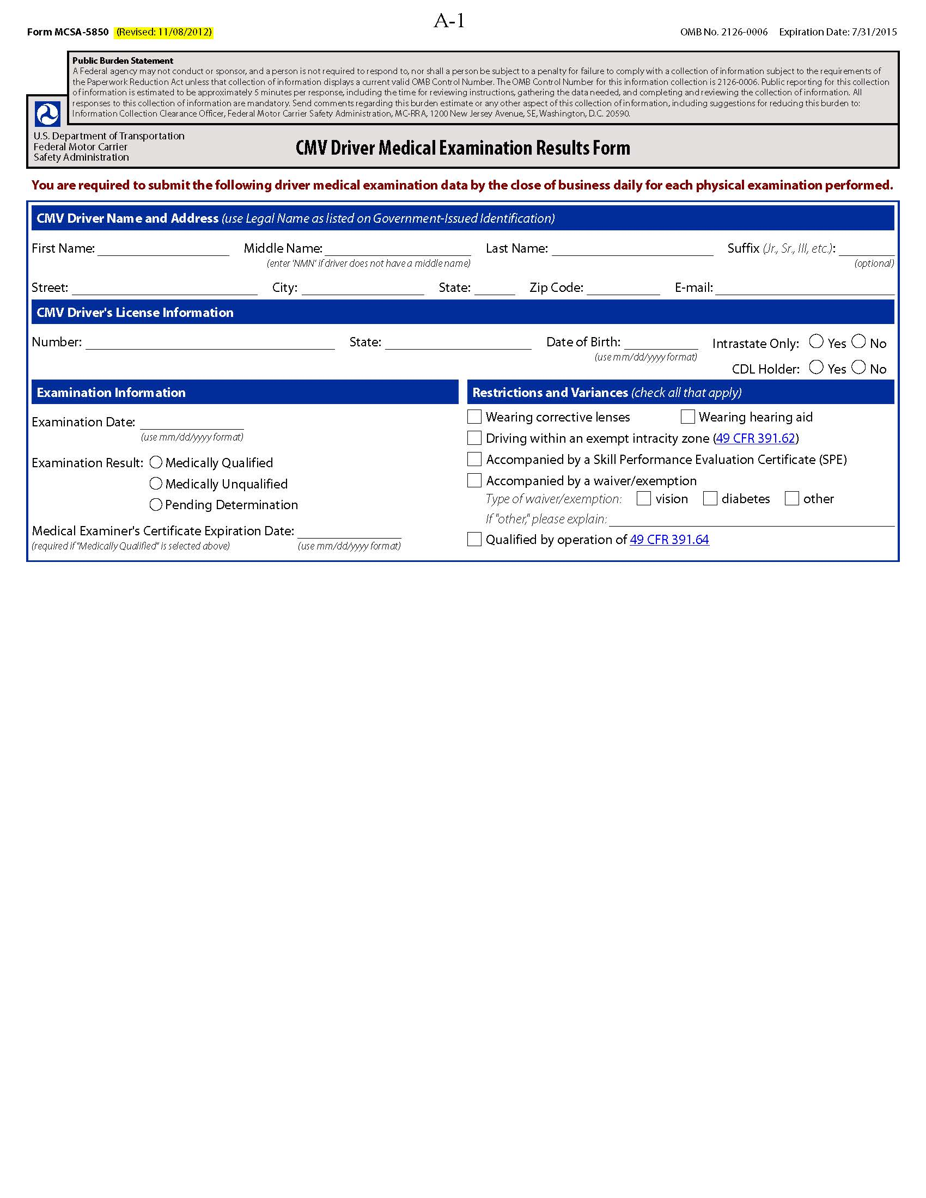
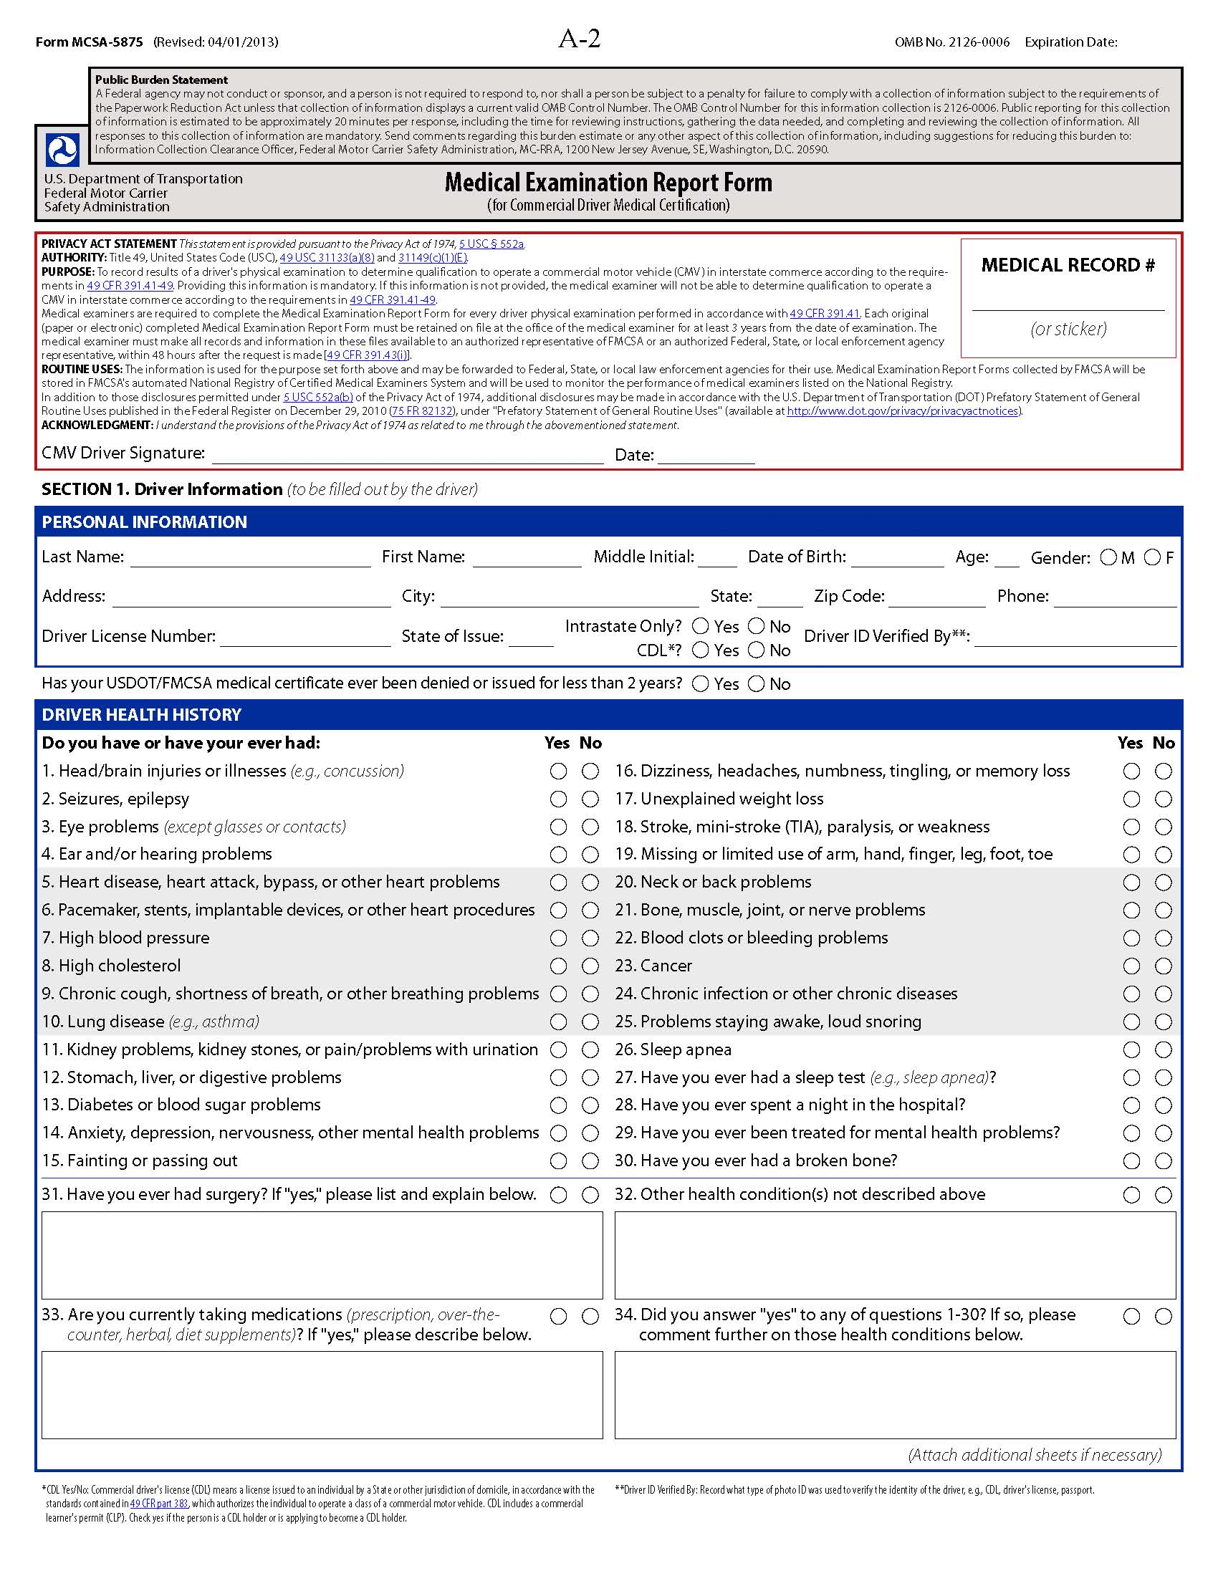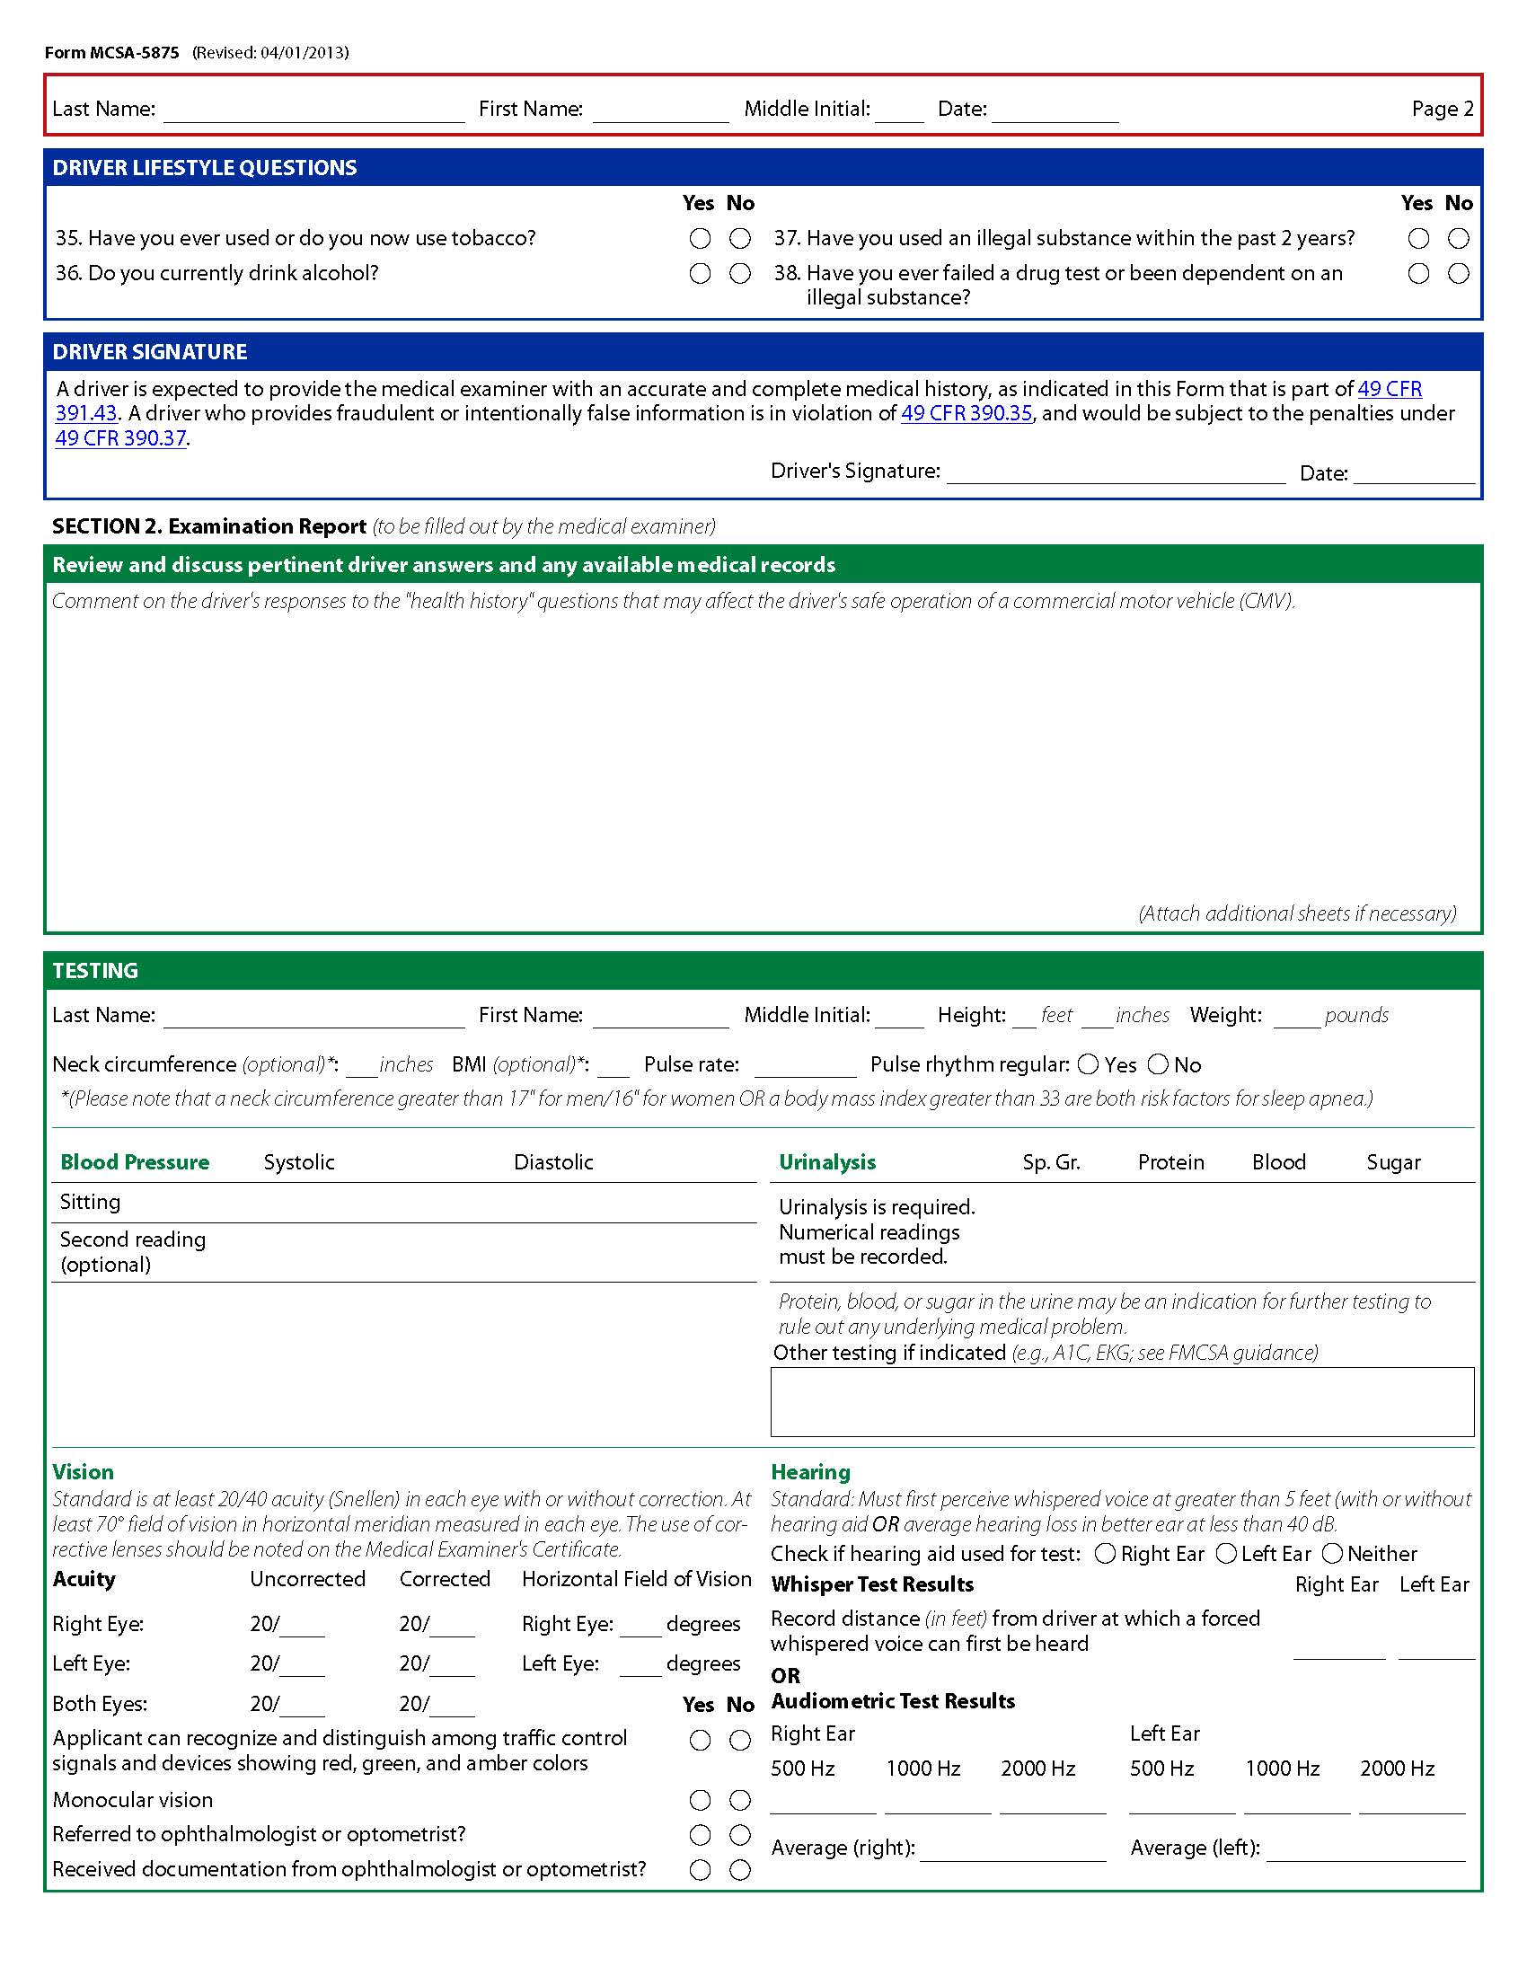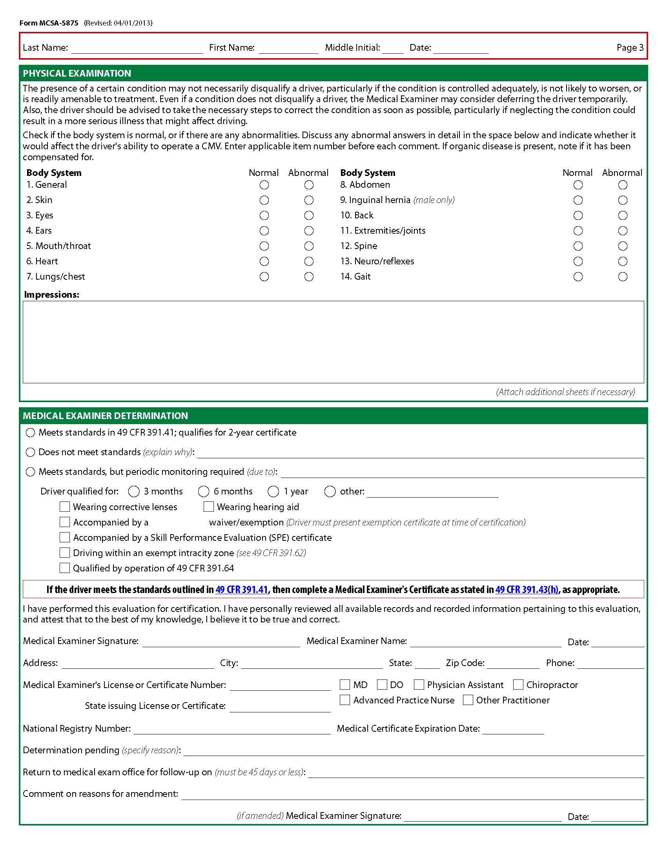
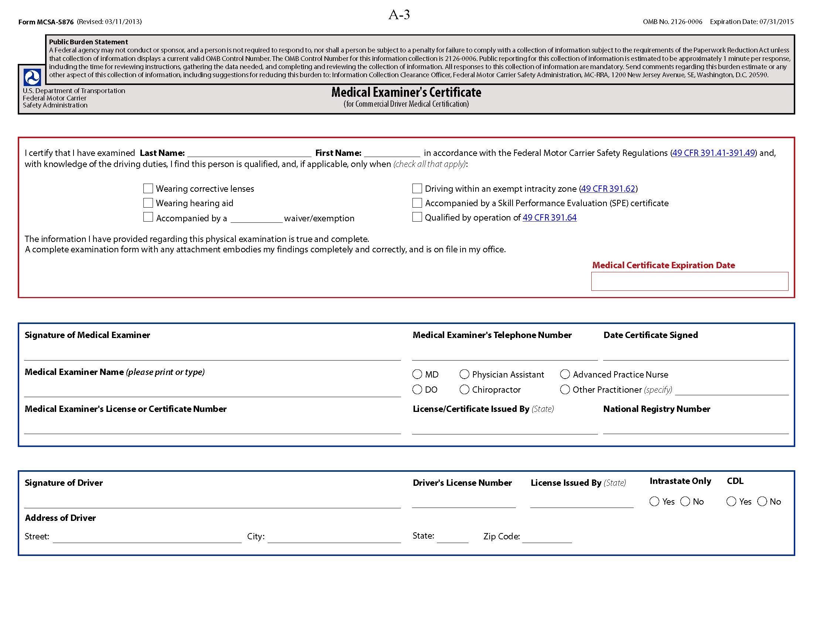

Appendix B

B-1
ME PII Collection
National Registry of Certified Medical Examiners PII

The following ME PII and business information is collected and maintained by FMCSA in support of the National Registry:

ME PII Collection for Registration and Certification Process
- Contact Information/Place of Business (physical location where ME will perform licensed CMV driver medical examinations)
  - Full name (first, last, middle initial)
  - Business name
  - Business address
  - Business telephone number
  - Business facsimile number
  - Business e-mail address
  - Business website address
  - Business hours of operation
- Employer Information
  - Employer name
  - Employer address
  - Employer telephone number
  - Employer facsimile number
  - Employer e-mail address
- Medical Licensing Information (used to validate medical credentials)
  - Medical profession
  - Job title
  - License, certificate or registration number
  - Medical license State of issue
  - Medical license expiration date
ME PII Collection for Certification Training
- Training Information
  - Provider name
  - Training provider address or website
  - Date training completed
  - Training expiration date
  - Organization that accredited the training
  - Type of training
ME PII Collection for Certification Testing
- Identity verification
  - Type of ME photo ID
  - Expiration date of ME photo ID
  - National registry number issued by FMCSA
  - Medical credential or license
- Training Certification Test Information
  - Testing organization name
  - Testing organization ID
  - Test center name
  - Test center ID
  - Test type
  - Test ID
  - Date of certification test
  - Certification test questions
  - Certification test answers
  - Test center grade (pass fail)
  - Test center score (numeric)
ME PII Collection Regarding Certification Decision/Status
  - FMCSA test grade (pass/fail)
  - FMCSA test score (numeric)

As discussed in the National Registry final rule PIA dated August 20, 2012, during the final stage of the National Registry rulemaking process, a decision was made that the following ME PII elements previously discussed in the National Registry NPRM PIA were not needed in support of the implementation of the National Registry final rule. Therefore, the following data elements were removed:

- Information on MEs
  - Date of application
  - Job title, if applicable
  - Employer facsimile number
  - Business facsimile number
  - Type of certification (initial, recertification, or reinstatement)

Medical Examiner’s Certification Integration PII

ME PII Collection on the MER Form, MCSA-5875

The following ME PII is collected and recorded on the MER Form, MCSA-5875 in support of the National Registry:

ME PII Collection
- ME Information
- Full Name (first, last, middle initial)
- Address
- Telephone number
- License or certificate number
- State issuing license or certificate
- Healthcare profession
- National registry number
- Expiration of certification

ME PII Collection on the MEC, Form MCSA-5876

The following ME PII is collected and recorded on the MEC, Form MCSA-5876 in support of the National Registry:

ME PII Collection
- Identify Verification
  - Full name (first, last, middle initial)
  - Address
  - Healthcare profession
  - Medical license, certificate or registration number
  - State of issue for medical license
  - National registry number
  - Date MEC is signed

B-2
MEAA PII Collection
National Registry of Certified Medical Examiners PII

The National Registry system collects and maintains the following PII and business information from MEAAs in support of the National Registry:

MEAAs PII Collection to Register with the National Registry System
- Identity Information
  - Full name (first, last, middle initial)
- ME Business Relationship
  - Business address
  - Business telephone number
  - Business e-mail address
  - Business website link information
  - Name of certified ME that designated the AA
  - National registry number of certified ME that designated the AA

B-3
CMV Driver PII Collection
National Registry of Certified Medical Examiners PII

The following CMV driver PII is collected and maintained by FMCSA in support of the National Registry:

CMV Drivers PII Collection for Reporting Medical Examination Results to the National Registry System via the MCSA-5850
- Identity Verification
  - Full name (first, last, middle initial)
  - Date of birth
- State Driver’s License
  - License number
  - License issuing State
  - CDL status
  - CDL interstate status
- Medical Examination
  - Date of examination
  - Examination Result (medically qualified, medically unqualified, temporarily disqualified)
  - Certificate expiration date
  - Driver restrictions/variances
  - Driver waiver/exemption type

As discussed in the National Registry final rule PIA dated August 20, 2012, during the final stage of the National Registry rulemaking process, a decision was made that the following CMV driver PII previously discussed in the National Registry NPRM PIA were not needed in support of the implementation of the National Registry final rule. Therefore, the following data elements were removed:

- Information on Commercial Motor Vehicle Drivers
  - Medical examination
  - Additional driver information on the MER and MEC
  - Social Security Number
  - Driver’s address

Medical Examiner’s Certification Integration PII

Additional CMV Drivers PII Collection for Reporting Medical Examination Results to the National Registry System via the MCSA-5850

In addition to the driver data elements listed above under the heading “National Registry of Certified Medical Examiners PII” the Medical Examiner’s Certification Integration NPRM will require the collection of the following additional CMV driver information in support of the National Registry:

- Driver’s mailing address
- Driver’s e-mail address (optional)

CMV Driver PII Collection on the MER Form, MCSA-5875

The following CMV driver PII drivers is collected and recorded on the MER Form, MCSA-5875 in support of the National Registry:

Information on the CMV Driver Examined
- Identity Verification
- Full name (first, last, middle initial)
- Date of Birth
- Age
- Gender
- Address
- Contact telephone number(s)
- Type of photo ID used to verify identity of driver
- State Driver’s License
- License number
- License state of issue
- CDL status
- CDL interstate status
Information on the Medical Examination of the CMV Driver
- Medical Examination Information
- Driver health history
- Driver lifestyle information (tobacco, alcohol, drug use, etc.)
- Test results (blood pressure, urinalysis, vision, hearing, etc.)
- Examination results of body systems (skin, eyes, ears, heart, etc.)
- ME Determination
- Medical qualification decision (medically qualified, medically unqualified, pending determination)
- Driver restrictions/variances

CMV Driver PII Collection on the MEC, Form MCSA-5876

The following CMV driver PII is collected and recorded on the MEC, Form MCSA-5876 in support of the National Registry:

CMV Driver PII Collection
- Identity Verification
- Full name (first, last, middle initial)
  - Date of birth
- State Driver’s License
  - License number
  - License issuing State
  - CDL status
  - CDL interstate status
- Medical Examination
  - Date of examination
  - Examination Result (medically qualified)
  - Certificate expiration date
  - Driver restrictions/variances
  - Driver waiver/exemption type

§ 390.5 Commercial motor vehicle means any self-propelled or towed motor vehicle used on a highway in interstate commerce to transport passengers or property when the vehicle: (1) Has a gross vehicle weight rating or gross combination weight rating, or gross vehicle weight or gross combination weight, of 4,536 kg (10,001 pounds) or more, whichever is greater; or (2) Is designed or used to transport more than 8 passengers (including the driver) for compensation; or (3) Is designed or used to transport more than 15 passengers, including the driver, and is not used to transport passengers for compensation; or (4) Is used in transporting material found by the Secretary of Transportation to be hazardous under 49 U.S.C. 5103 and transported in a quantity requiring placarding under regulations prescribed by the Secretary under 49 CFR, subtitle B, chapter I, subchapter C.
http://www.dot.gov/individuals/privacy/pia-national-registry-certified-medical-examiners-national-registry
§ 383.5 Commercial driver's license (CDL) means a license issued to an individual by a State or other jurisdiction of domicile, in accordance with the standards contained in this part, which authorizes the individual to operate a class of a CMV.
§ 383.5 Commercial learner’s permit (CLP) means a permit issued to an individual by a State or other jurisdiction of domicile, in accordance with the standards contained in this part, which, when carried with a valid driver's license issued by the same State or jurisdiction, authorizes the individual to operate a class of a commercial motor vehicle when accompanied by a holder of a valid CDL for purposes of behind-the-wheel training. When issued to a CDL holder, a CLP serves as authorization for accompanied behind-the-wheel training in a CMV for which the holder's current CDL is not valid.
Office of Management and Budget’s (OMB) definition of the PIA taken from guidance on implementing the privacy provisions of the E-Government Act of 2002 (see OMB memo of M-03-22 dated September 26, 2003).
http://www.cio.gov/documents/FEA-Security-Privacy-Profile-v3-09-30-2010.pdf
http://www.regulations.gov/#!docketDetail;D=FMCSA-2008-0363
https://nationalregistry.fmcsa.dot.gov/NRPublicUI/home.seam
http://www.regulations.gov/#!docketDetail;D=FMCSA-2012-0178
http://www.regulations.gov/#!docketDetail;dct=FR%252BPR%252BN%252BO%252BSR;rpp=25;po=0;D=FMCSA-2008- 0363 (Docket FMCSA-2008-0363-0003)
DOT/FMCSA 009 - National Registry of Certified Medical Examiners (National Registry)
http://www.gpo.gov/fdsys/pkg/FR-2011-02-22/pdf/2011-3825.pdf
http://www.dot.gov/individuals/privacy/pia-medical-exemption-program
https://nationalregistry.fmcsa.dot.gov
The provisions of § 31149(c)(1)(E) have been amended by § 32302(c)(1)(A) of Moving Ahead for Progress in the 21st Century, Pub. L. 112-141, 126 Stat. 405 (July 6, 2012) (“MAP-21”).

