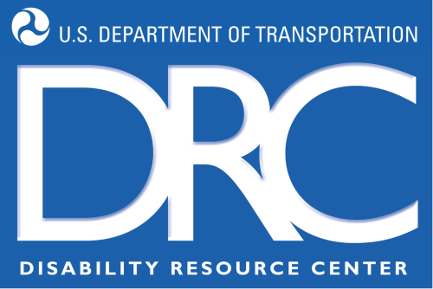
U.S. Department of Transportation
Tips for Applicants in Using Schedule A

This document outlines some suggestions for applicants with severe disabilities who are interested in employment with the U.S. Department of Transportation (DOT).

The U.S. Department of Transportation Secretary has issued a goal that 3% of the DOT workforce will be persons with targeted disabilities. Most people with severe disabilities fall into this category. To help with this hiring initiative, managers are encouraged to hire people with severe disabilities using the “Schedule A Hiring Authority”. This authority allows managers to hire qualified persons with severe disabilities into Federal jobs without advertising vacancies and without competition. Applicants with severe disabilities, who meet the qualifications required for the job, may apply through the “Schedule A” process by providing the necessary documentation along with the Federal resume.

If you are interested in working for DOT, and have the required qualifications for specific jobs, please first follow the suggestions listed in this handout to complete your application. Our Selective Placement Program Team can then help explore opportunities with you.

- At the top of your resume, include the job titles or occupations and the pay grade for which you are interested and qualified. Research job occupations and titles using the career exploration portion of the Federal government's job site: http://www.usajobs.gov/careers/index.asp?ic=1. Information about the General Schedule (GS) or Salary tables is available at the Office of Personnel Management's site: http://www.opm.gov/flsa/oca/09tables/indexGS.asp to help determine the pay grade (and salary) for which you are able to work. Adding these two elements to your resume will greatly help Human Resource staff consider your qualifications and refer your resume to hiring managers more quickly.

- Revise your resume to include key points listed in the DOT handout, “Federal Resume Tips” (http://www.drc.dot.gov/spcdocs/infoforapplicants/FEDERAL%20RESUME%20TIPs.doc). Don’t include your social security number!

- Obtain a current Schedule A letter from a State Vocational Rehabilitation Counselor or any licensed medical practitioner. (http://www.drc.dot.gov/spcdocs/infoforapplicants/SampleSchedAletters.doc.)

- When you see a job opportunity at www.usajobs.gov, apply for DOT jobs on-line and follow the process as directed. In addition, send a copy of your resume and Schedule A letter to the DOT Selective Placement Coordinator where the job is located. For example, when applying to Federal Railroad Administration (FRA) jobs, send your resume and Schedule A letter to the FRA Selective Placement Coordinator. Refer to the following list (http://www.drc.dot.gov/spc.html#spclist).

- Apply for DOT non-competitive vacancy announcements posted here: http://www.drc.dot.gov/vacancies.html. These are opportunities available only to applicants with severe or targeted disabilities. Documentation such as the Schedule A letter will be required prior to hire.

- Ask for reasonable accommodations if you need them throughout your application, hiring, and employment experience at DOT. DOT has a centralized fund to support the provision of reasonable accommodations for all applicants and employees located throughout the U.S. The DOT Disability Resource Center supports, located at headquarters in Washington, DC supports this effort.

- Send thank you notes following every interview. You can also re-emphasize or add a brief paragraph on an important skill or work experience that relates to the job.

