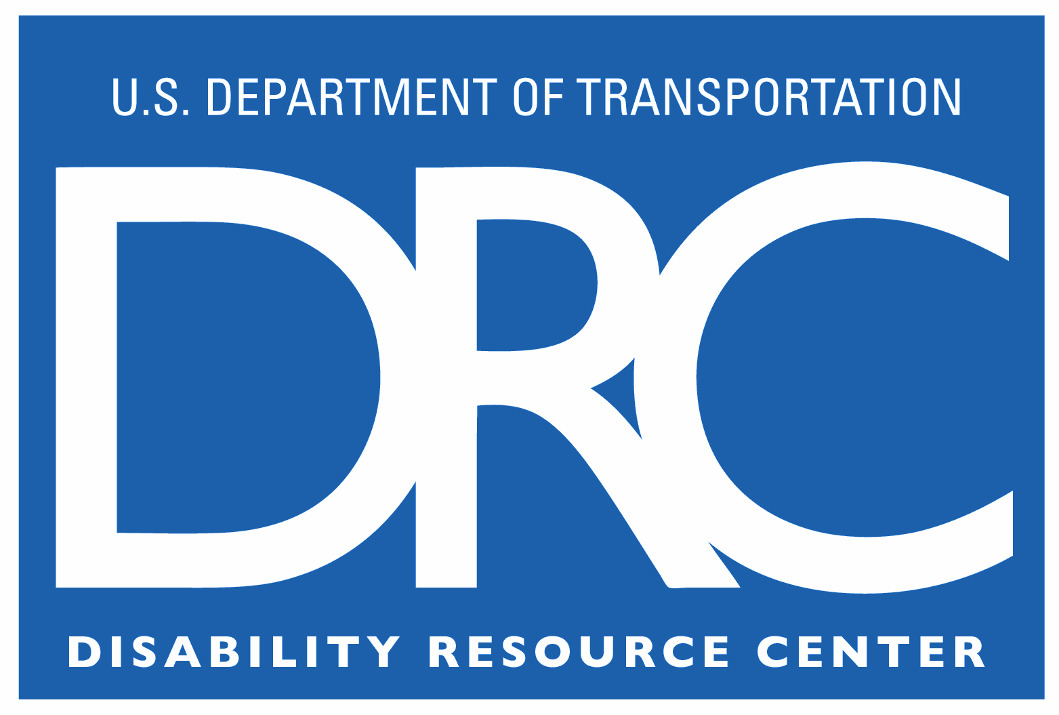

DOT Disability Resource Center  M-14.4, W56-403  1200 New Jersey Ave., SE  Washington, DC 20590 | Phone: (202) 493-0625  Fax: (202) 366-3571  E-Mail: drc@dot.gov

Property agreement

Date:
Employee:
Phone:
Location:
Operating Administration:
Supervisor:
Product:

The DRC provides equipment as part of the fulfillment of a request for reasonable accommodation. When a piece of equipment or assistive technology is provided to an employee by the Disability Resource Center, it will be provided at no additional cost to the Operating Administration (OA) or program office of the requesting individual.

Property and Maintenance Agreements

- Upon delivery, all equipment becomes property of the OA where the employee is employed. The OA will accept the item(s) into its inventory, and is responsible for following all of the OA’s inventory procedures and policies in place with in that OA.

- The OA will be responsible for maintaining the item in good working order. This includes peripherals (i.e., batteries, paper, bulbs, accessory items, etc.), on-going service fees, (i.e., line charges, service agreements, etc.) routine maintenance and repairs. The DRC can provide information to the OA to support the accommodation.

- In the event the employee leaves the OA or Department for another Federal position, the OA is free to transfer the equipment to the employing agency if mutually agreed. The DRC does not receive property back into inventory; however, we may be able to assist the OA with finding an appropriate recipient, if desired. If the employee separates from Federal service, the equipment will remain in the inventory of the OA.

Statement of Supervisor’s and Employee’s Responsibility

The undersigned supervisor/employee has received the item(s) listed above and accepts responsibility for this property. As an employee of the government to whom public property is entrusted, I clearly understand that:
- I am responsible for the proper custody, care, and safeguarding of this property;
- I am authorized to use the property only for the purposes set forth in this agreement;
- If the property is lost, damaged or destroyed, I may be held financially liable and/or subject to discipline if the loss, damage or destruction resulted from my negligence, misuse, dishonesty or willful destruction;
- I will inform appropriate property and budget officials within my organization of this commitment; and by signing this I acknowledge I have received the above items from the Disability Resource Center (DRC). Per the Action Plan these items will now become part of my department’s inventory, and I will notify my property custodian as such.

Supervisor _____________________________________________________________
Signature Date Telephone Number

Employee _____________________________________________________________
Signature Date

