***CITY OF AMERICAN FALLS, IDAHO, COMPLETE STREETS***

***TIGER III PROJECT—CASE STUDY***

## Project Funding:

Total Construction Costs: $4,760,913

TIGER Grant Contribution: $2,300,000

## Recipient Contribution (Combined Community Development Block Grant Program (CDBG), Transportation, Community, and System Preservation (TCSP) and Federal Lands Highway Program (FLHP) grants to expand the project area): $2,460,913

## Location:

## American Falls, Idaho

## Project Type and Purpose:

Complete Streets – The Complete Streets Project in the City of American Falls, Idaho, upgraded the downtown core’s infrastructure. The project included repaving roads, reconstructing underground waterlines and storm drains, adding streetscapes and diverting freight truck traffic onto designated truck routes. These improvements allowed the downtown core to attract businesses that were previously unable to locate there due to infrastructure concerns. It also led to an increase in pedestrian use and private investment.

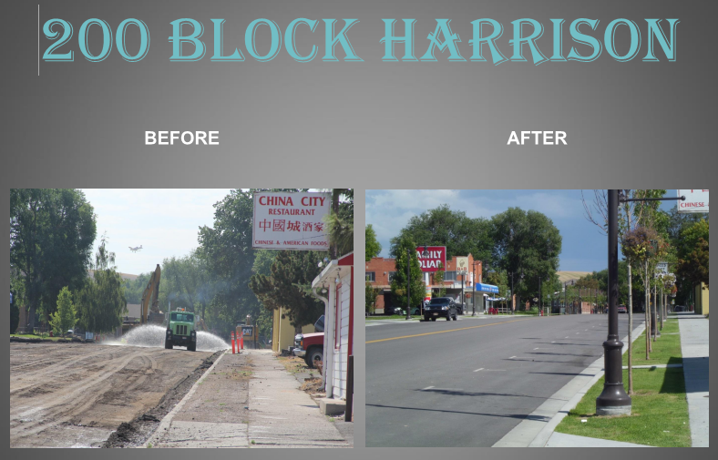

Figure 1: 200 Block of Harrison St, City of American Falls, ID

***Additional Project Background:***

The City of American Falls sought TIGER grant funds to aid in the reconstruction of five blocks of its downtown, which also served as a critical transportation corridor. The goal of the project was to transform this area to provide safe, attractive bicycle and pedestrian access into and around the downtown core. The project was envisioned as encouraging alternatives to private cars, improving safety, and reducing speeds by narrowing travel lanes and widening sidewalks. Additional infrastructure improvements such as installing water lines and planting trees, shrubs, and bushes were meant to attract businesses to downtown.

## Anticipated Benefits:

The project anticipated benefits in all five TIGER categories: state of good repair, economic competitiveness, livability, environmental sustainability, and safety. Though benefits were expected in each category, performance metrics were only collected for economic competitiveness and livability.

**State of Good Repair**

To improve the downtown transportation infrastructure’s state of good repair, the project focused on system maintenance and preservation. Aging, deteriorating infrastructure was to be rehabilitated, reconstructed or replaced (see illustrations of Harrison Street and Roosevelt Street). Roads were projected to be repaved, sidewalks widened, water lines widened and repaired and streetscape was added with trees, shrubs and bushes. It was expected that maintenance cost savings would equal $1 million over the 20 year analysis period, discounted 7% (as per TIGER guidance, to reflect the opportunity cost of money net of the rate of inflation).

**Economic Competitiveness**

Economic competitiveness was to be addressed by making downtown a more attractive location for businesses to locate. Creating a positive image and increasing pedestrian traffic in the corridor was expected to strengthen existing businesses and promote public participation in supporting downtown activity. It was believed that many workers in the American Falls region chose to live 25 miles away in Pocatello due to a negative image of downtown and the city in general. The reconstruction of the downtown area was thought to attract patrons, residents and businesses. By making the area more attractive to potential development, it also led to an expectation that parcel value would increase. The increased property values were expected to equal $3.4 million discounted 7% over the analysis period. Fuel savings from less automobile traffic was expected equal $4.2 million over the same period and discount rate.

**Livability**

The project was also expected to enhance livability by improving mobility and increasing mode choice. Increasing the walkability of the downtown is expected to encourage more pedestrian and bicycle use along the corridor. Upgrading sidewalks to become compliant with Americans with Disabilities Act (ADA) requirements would help the disabled residents of American Falls navigate what would otherwise be a dangerous corridor.

**Environmental Sustainability**

Diverted trips to and from Pocatello were expected to save nearly 627,000 hours of travel time over the analysis period, resulting in $3 million worth of travel time savings when monetized and discounted 7%. It was anticipated that decreased auto trips would reduce emissions by over 17,000 tons of carbon dioxide. Monetized and discounted by 7% over the analysis period equaled $238,421.

**Safety**

Accidents were expected to decrease due to decreased auto and truck traffic resulting in over $300,000 during the analysis period (7% discount).

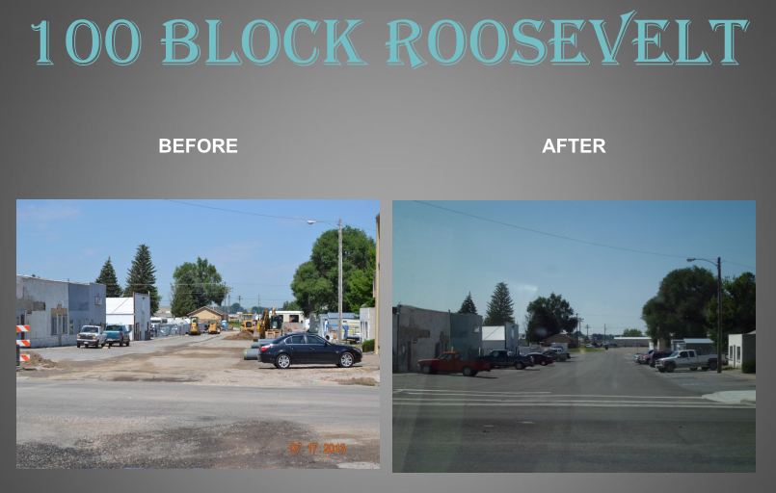

Figure 2: 100 Block of Roosevelt St, City of American Falls, ID

## Analyzed Benefits:

Following project completion, performance metrics for the American Falls Complete Streets project showed a decrease in automobile and truck traffic within the corridor and an increase in pedestrian trips. The occupancy rate in the neighborhood increased, while the average parcel value remained relatively unchanged. The impacts of the projects by strategic goal area are shown in the table below.

Measured Post-Project Benefits

|  |  |  |  |  |
| --- | --- | --- | --- | --- |
| **Performance Measure** | **Pre-Project**  **08/2011** | **Post-Project**  **Q1 2013–**  **Q4 2015** | **Percentage Change** | **Strategic Goal Area** |
| Annual Average Bike Trips | 10 | 3.99 | -60.10% | Livability |
| Annual Average Pedestrian Trips | 115 | 187.2954545 | 62.87% | Livability |
| Annual Average daily traffic | 2040 | 1774.1 | -13.03% | Livability |
| Annual Average daily truck traffic | 261 | 61.9 | -76.28% | Livability |
| Annual parcel occupancy and value in project area | 74% | 82% | 10.81% | Economic Competitiveness |
| Annual parcel value in project area | $89,903 | $89,903 | 0.00% | Economic Competitiveness |

**Safety**

Safety, while being a stated goal of the project, was not assessed and performance measures were not collected. Accident impacts are expected to include fewer truck accidents as trucks are redirected to the designated freight route. A complete assessment of changes in accident rates would incorporate changes in accident rates along the designated freight route.

**Economic Competitiveness**

The parcel occupancy rate was collected on an annual basis and is the occupancy rate for parcels located within the project area. The rate of occupancy has increased post project showing there may be more interest in the area from commercial or residential developers. One parcel was converted into a park while others have been either developed or have had developers show interest in them.

All parcels in the county are assessed every 4 years, the City of American Falls checks for updates on the 53 parcels in the project area for updates every year in January to collect up to date information. Parcel value has remained unchanged post project completion.

**State of Good Repair**

State of good repair, while being a goal of the project, was not assessed and performance measures were not collected. Nevertheless, overall roadway conditions have significantly improved and the sidewalk improvements, together with the public water upgrades, have enhanced overall state of the downtown infrastructure.

**Environmental Sustainability**

Environmental sustainability, while being a goal of the project, was not assessed and performance measures were not collected. Environmental benefits were projected due to anticipated trips diverted from Pocatello to Idaho Falls, which would reduce emissions, but estimating these impacts would require additional research beyond that specified in the grant agreement.

**Quality of Life**

Post-project average bike trips, pedestrian trips, Average Daily Traffic (ADT) and truck traffic were all tracked for the City of American Falls Complete Streets project. These performance measures were collected on a monthly and averaged into quarterly figures. ADT and truck traffic are average daily counts, while bike and pedestrian trips are average counts during two, two- hour windows (10 AM – Noon and 3 PM – 5 PM).

Though bike trips have decreased on average since the project was completed, in the last few quarters they have begun to increase again. Pedestrian traffic increased significantly and has continued to climb. Both truck and auto traffic decreased within the project area post project. This decrease was by design as traffic calming measures were put in place to encourage non-vehicular mode choices and divert freight traffic onto designated truck routes. In addition, project sponsors noted the possibility that motorized vehicle counts on the streets collected before the project included cars circling to find parking.

## Success Factors, Lessons Learned, and Other Considerations:

The project has been successful in turning the project area into an easily navigable, pedestrian friendly environment. Occupancy rates have started to increase as has interest in vacant parcels. The types of businesses that could potentially be attracted to the sites have increased as old infrastructure was not suitable for specific businesses such as restaurants.

Private investment from existing businesses and residences has also increased. Project sponsors noted that some businesses took advantage of the infrastructure work being done on the waterlines and upgraded their own water connections, and others have repaved walkways and driveways to give them a newer appearance in order to match the new wider sidewalks being implemented.

One of the lessons learned from undertaking the project was that involving the community up front and getting their feedback will help projects go smoother. There were some issues with access to businesses during construction that was dealt with through the creation of a Technical Advisory Committee comprised of citizens. The committee helped with communication between citizens and work forces and is viewed as a success. Advice to other grant recipients is to start planning several years in advance.

***I-85 CORRIDOR IMPROVEMENT AND YADKIN RIVER CROSSING TIGER 1 PROJECT—CASE STUDY***

***Project Funding:***

Total Project: $136,000,000

TIGER Grant Contribution: $10,000,000

Recipient Contributions (Grant Anticipation Revenue Vehicle (GARVEE bonds) and state contributions): $125,000,000

## Location:

Salisbury, North Carolina

***Project Type and Purpose:***

Bridge and Highway Improvement: This roadway improvement project featured several bridge replacements, expanded lane capacity, and safety enhancements across a 3.3 mile stretch of interstate I-85, which is a main corridor in NC connecting Greensboro and Charlotte. This project led to decreased travel times and maintenance expenditures as well as increased safety and improved bridge condition ratings.

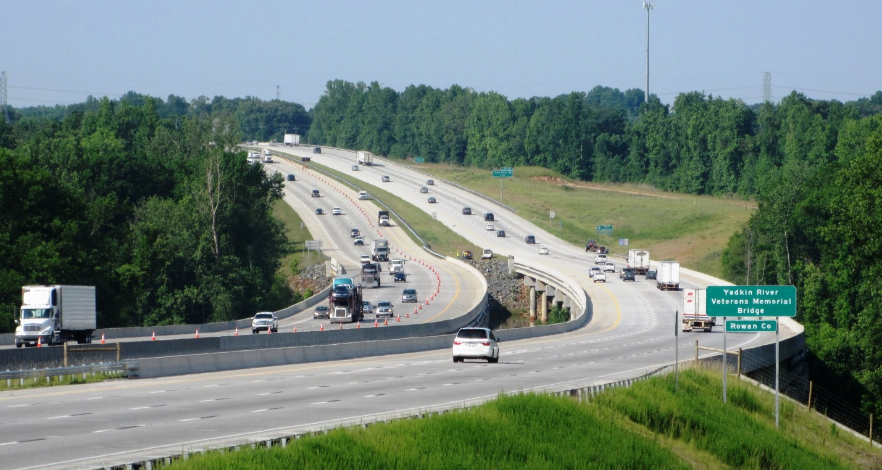

Figure 1: Yadkin River Crossing

***Additional Project Background:***

The North Carolina State DOT applied for $300 million in TIGER funding to improve this corridor (total project costs of $352 million), but was awarded $10 million. Therefore, the project’s scope was scaled down to $136 million, covering smaller components of the larger project. Supplemental agreements were provided to further enhance the corridor. These agreements led to the repair of an older bridge used at first as a detour route as a new bridge was built and that later became part of a pedestrian and bicycle trail.

The I-85 Corridor Improvement sought TIGER grant funds to aid in the replacement of nine bridges, widening a part of the interstate to eight lanes, realigning freight rail tracks and adding enhanced lighting, draining and signage features to a 6.8 mile section of interstate 85 between Greensboro and Charlotte. This project anticipated benefits through relieving congestion, improving safety, replacing deficient and functionally obsolete bridges as well as providing improved military and evacuation routes and enhancing connectivity for area residents and businesses.

The project was envisioned to have a positive impact on the region of more than 300,000 residents, where it was viewed as a means of counteracting job losses. The two counties of Davidson and Rowan, where the project was situated, had unemployment rates higher than the national average (12.7% and 12.5% respectively in April 2009, compared to 9.0% for the nation as a whole).

The project was later scaled to two phases during the grant agreement. Phase I (which was the TIGER funded portion), a $136 million project, was the larger of two Design-Build contracts that were awarded to complete the project corridor. The project covered roughly 3.3 miles of the 6.8 mile corridor and included the widening of Interstate 85 to eight lanes, replacement of existing bridges over the Yadkin River, reconstruction of the interchange at NC-150 and preservation activities on an old concrete arch bridge. Supplemental agreements were provided to further enhance the corridor. These agreements led to the repair of an older bridge used at first as a detour route during construction as a new bridge on I-85 was built and later becoming part of a pedestrian and bicycle trail.

Phase II of the project involves rail improvements for the creation of the Southeast High Speed Rail Corridor (SEHSR). These track improvements will increase freight and passenger train speeds in the region. Also included in Phase II, is the lengthening of a bridge span to accommodate future options for the SEHSR corridor.

## Anticipated Benefits:

The project anticipated benefits in the categories of state of good repair, economic competitiveness, livability, sustainability and safety. Though benefits were expected in each category, performance metrics were not used to measure sustainability benefits. The benefits noted in this section are those reported in the original TIGER funding application for the larger project; anticipated benefits were not presented separately for Phase I of the larger project in the application narrative. Performance targets were, however, presented for Phase I of the project in the Performance Measurement Addendum.

Under state of good repair, the project was planned to replace several functionally obsolete bridges as well as improve roadway conditions as much of the pavement was 50-70 years old. The average bridge rating for bridges within the project scope was anticipated to increase as older, structurally deficient and functionally obsolete bridges were replaced with newer structures. The performance target for bridge condition was a rating of at least 90 on a scale of 0 to 100 (in which 100 represents an entirely sufficient bridge). The performance target for annual maintenance expenditures was less than $1,700 per lane mile.

The project was considered to be vital for the economic competitiveness of the region. The corridor is a main artery for industries concentrated in the region and the project is expected to improve transportation options and efficiency. If the entire project was funded, the applicants have estimated that $972 million worth of output was expected to occur due to this project, as well as a $256 million increase in household income over the 20 year analysis period; it is not clear how much of this benefit was expected from the portion that was funded. The expected decrease in travel times would allow freight to reach its destination sooner making the area more desirable for businesses. Performance targets for operations included volume to capacity reduction of at least 60%.

The project was expected to enhance livability in the region for the nearby population of over 300,000. It was anticipated that commuting time would be reduced. The project was also expected to create a viable and safe pedestrian and bicycle crossing above the Yadkin River.

Sustainability was expected to be impacted by increasing traffic flow and decreasing the travel time for vehicles, leading to less idling, shorter travel times, and reduced congestion In addition, the expanded roadway capacity will lessen the negative impacts of incidents on the highway.

There were operational deficiencies viewed as hazardous to the safety of travelers across the interstate. Limited sight distance through vertical alignment, substandard horizontal curvature, atypical left hand exits and entrance ramps as well as the proximity of multiple interchanges were compounded by a bottleneck on the interstate due to the facilities limited 4 lane capacity. The project aimed to decrease all crash rates by 75%. Monetized, the accident damage was expected to be reduced by $123 million over the analysis period (using a more conservative 43% reduction in crash rates).

## Analyzed Benefits:

Performance metrics were developed for Phase I of the project in order to measure benefits associated with the project corridor’s improvement. Following completion of Phase I of the project, the I-85 Corridor Improvement project resulted in lower average travel times, maintenance costs, crashes and volume to capacity ratios, as seen in table below. The bridge condition sufficiency rating increased threefold. The project has led to safer roadways conditions, decreased travel times, and lower maintenance costs.

As per the grant agreement, several metrics for traffic, safety and level of service were collected, reflecting several project benefits. These are presented in the following text and summarized in the below table. The impacts of the projects by strategic goal area are as follows:

Measured Post-Project Benefits

|  |  |  |  |  |
| --- | --- | --- | --- | --- |
| **Performance Measure** | **Pre-Project**  **Q4 2010** | **Post-Project\***  **Q3 2013 –**  **Q4 2015** | **Percentage Change** | **Strategic Goal Area** |
| Weekday Annual average hourly (or peak and off-peak) buffer index[1] - Northbound | 5.30% | 3.51% | -33.77% | Economic Competitiveness, Quality of Life |
| Weekday Annual average hourly (or peak and off-peak) buffer index - Southbound | 6.90% | 6.14% | -11.01% | Economic Competitiveness, Quality of Life |
| Weekday Annual average hourly (or peak and off-peak) vehicle travel time - Northbound | 1.04 | 0.94 | -9.81% | Economic Competitiveness, Quality of Life |
| Weekday Annual average hourly (or peak and off-peak) vehicle travel time - Southbound | 1.00 | 0.91 | -8.60% | Economic Competitiveness, Quality of Life |
| Annual maintenance expenditures | $6,000.00 | $2,108.38 | -64.86% | State of Good Repair |
| Annual or rolling average annual crash rates by type/severity - Total | 129.00 | 37.28 | -71.10% | Safety |
| Annual or rolling average annual crash rates by type/severity - Fatal | 1.16 | 0.30 | -73.88% | Safety |
| Annual or rolling average annual crash rates by type/severity - Non-fatal | 34.17 | 6.85 | -79.97% | Safety |
| Bridge condition (sufficiency rating) | 39.00 | 96.31 | 146.95% | State of Good Repair, Safety |
| Volume to capacity ratio[2] | 1.23 | 0.60 | -50.89% | Economic Competitiveness, Quality of Life |

*All post-project performance measures are calculated by averaging data collected at quarterly intervals.

**Safety**

Annual crash rate by type/severity (on a rolling annual average) was selected as a performance metric due to the enhanced safety features being added to the corridor. Data was collected quarterly with the rate calculated using a running total of crashes. The reporting agency for accidents was typically the State Highway Patrol.

The total crash rate decreased significantly, as fatal and non-fatal crash rates both decreased by over 70% post project completion. The performance target for safety was to reduce crash rates by 75%.

Since crash data can sometimes take weeks to be entered into the system it is possible that some data from accidents that happened a few weeks prior to data collection may be missing from the analysis. Since the roadway is an interstate with data generally coming from the State Highway Patrol, this was seen as an unlikely occurrence.

**Economic Competitiveness**

Data on the weekday annual average hourly travel times were used as a performance metric for the economic competitiveness category. Average hourly vehicle travel time was estimated during a 16 hour period of the day (6 AM-10 PM) and was averaged over each quarter.

Travel time for northbound traffic decreased by an average of nearly 10% post project while southbound vehicle travel time decreased by 8.6%. Post project, the average travel time has remained fairly consistent for northbound traffic while southbound traffic has seen some fluctuation in travel times, rising above baseline estimates for some quarters while falling far below in others.

It is also important to note that the speed limit increased from 55 MPH to 65 MPH on September 30, 2013. Travel time in the third quarter of 2013 was calculated using 55 MPH while travel time in subsequent quarters were calculated using 65 MPH. With only one data point available using 55 MPH it is difficult to tell whether this had a significant impact on average travel times.

**State of Good Repair**

Annual maintenance expenditures were selected as a performance metric for state of good repair. As older pavement costs more to maintain than newer pavement and as such this project hoped to decrease the annual cost of maintenance. Data was collected in 2010 for the baseline and in years 2014 and 2015 for post project completion.

Maintenance costs initially declined nearly 58% from 2010 to 2014 ($6,000 to $2,523), followed by an additional 33% decrease from 2014 to 2015 ($2,523 to $1,692).

Bridge condition sufficiency rating was also used as a performance metric. This rating measures the structural adequacy, functional obsolescence, level of service and essentiality of the bridge using National Bridge Inventory Standards (NBIS). The NBIS is a requirement of the Federal Highway Administration (FHWA). The average bridge condition sufficiency rating of the bridges replaced increased from 39 to 96 after project completion.

**Environmental Sustainability**

Environmental sustainability, while being a goal of the project, was not assessed and performance measurement data was not collected.

**Quality of Life**

Quality of life was measured through the use of annual average hourly buffer indices for both northbound and southbound traffic as well as a ratio of volume to capacity. These metrics were chosen as they attempt to measure how well the facility accommodates the average volume of traffic.

The buffer index represents the additional travel time a traveler must plan for in order to ensure on time arrival at their destination. It was calculated quarterly and based on a 16 hour day (6 AM – 10 PM). Volume to capacity ratio was calculated on an annual basis.

The buffer index decreased for both northbound and southbound traffic with an average post project value 33% and 11% below the baseline respectively. The volume to capacity ratio is roughly half of its pre-project value allowing more vehicles to travel with safer distance between them.

Volume to capacity ratios in 2015 were calculated using 2014 Average Annual Daily Traffic (AADT) data. AADT was not listed among the performance measures reported by the agency awarded the funding.

## Success Factors, Lessons Learned, and Other Considerations:

The TIGER funded I-85 Corridor Improvement and Yadkin River Crossing had notable measureable impacts. The project replaced several bridges and increased capacity along I-85, leading to a notable decrease in vehicle accidents, lower maintenance costs, and lowered travel times.

In addition, the project laid the foundation for subsequent projects to get underway. This project is part of a larger improvement effort for a major corridor in the state. Subsequent phases will address additional capacity bottlenecks south of Salisbury, North Carolina, increasing many four lane segments to eight lanes. These improvements are envisioned to continue down to Charlotte. The project also widened the highway over a rail line allowing for double tracking in the future.

The original project scope was scaled down since the amount of TIGER funding awarded was less than requested. The initial request from TIGER was for $300 million; the amount awarded was $10 million. The project changed from a $352 million project to a $136 million project with $8 million worth of supplemental agreements. The ability to find independent elements which could be completed with amount awarded was critical for this project’s success.

An important issue regarding measuring the project’s impact is that while there are measurable, and notable, impacts from this project, it is part of a larger effort along a major corridor which is not yet complete, including some sections of I-85 which have not yet been expanded to eight lanes. Once the entire corridor’s improvement are complete, additional growth and expansion is expected; benefits which will be at least partly due to the earlier segments of improvements such as those funded by TIGER. For large projects completed in phases, it is difficult to assign a portion of future benefits to those sections completed earlier. The original application did not include a discussion of individual components of the project which could be completed if only partial funding was received. The I-85 Corridor Improvement and Yadkin River Crossing was awarded funds under TIGER 1; subsequent rounds of TIGER have strongly suggested to applicants that they provide information on parts of their proposed project which could be completed if full funding is not received.

Project sponsors noted that the importance of having experienced personnel on the team and that the collection of data for the performance metrics may require collecting data beyond what the agency might normally collect.

With respect to the performance data collected, the I-85 Corridor Improvement and Yadkin River Crossing had a range of metrics across all of the five strategic goals. This data makes a strong case for the project’s success. One possible addition to the data would have been to report Average Annual Daily Traffic (AADT) separately. AADT can add context for other performance measures such as travel time, the buffer index and maintenance expenditures.

**Mississippi River Bridges Incident Management, Freight Movement, and Security TIGER III Project—CASE STUDY**

## Project Funding:

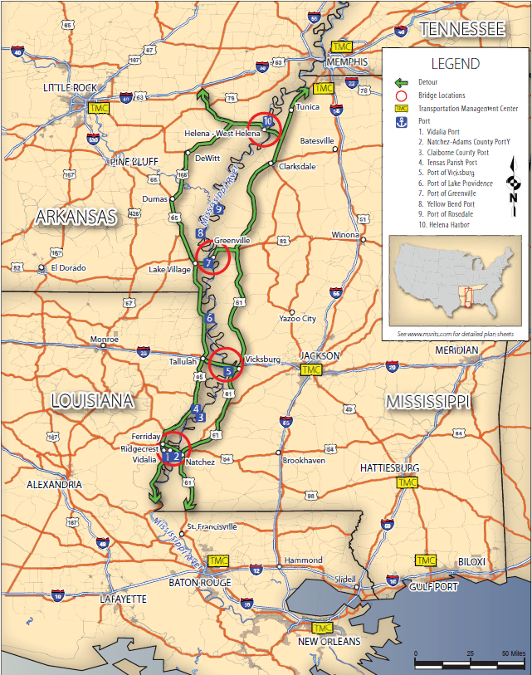

Map highlighting Mississippi River Bridges, Detour Routes, and Transportation Management Centers

Total Project: $10,760,658

TIGER Grant Contribution: $9,814,700 ($3,384,775 to Arkansas, $2,124,925 to Louisiana, $4,305,000 to Mississippi)

Recipient In-Kind Contribution: $945,958 donated by a private partner

***Location:***

Four bridges along Mississippi River in Arkansas, Mississippi, and Louisiana (see map).

***Project Type:***

Intelligent Transportation Systems (ITS) installation on four highway bridges – The purpose of this project was to create an integrated bridge, highway, and river monitoring and information dissemination system at and around four critical Mississippi River crossings within the states of Mississippi, Arkansas, and Louisiana: the Helena Bridge (US-49, MS and AR); the Greenville Bridge (US-82, MS and AR); the Vicksburg Bridge (I-20, MS and LA); and the Natchez-Vidalia Bridge (US-84, MS and LA). By implementing ITS technologies, the project sought to create a highly efficient multimodal transportation monitoring and management system to detect and support management of highway and river incidents, improve freight mobility, and enhance security for critical elements of the nation’s infrastructure. Each of the four rural highway bridges serves as a detour route for the other bridges (via the north/south US-61 and US-65 routes) and this project was intended to help prevent closures as well as better manage them when a closure does occur.

***Additional Project Background:***

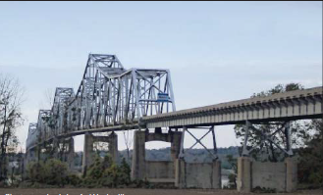

Helena Bridge across the Mississippi River

The improvements included dynamic messaging signs, vehicle detection systems, road weather information systems, Closed Circuit Television (CCTV), highway advisory radio, and other fiber optic connections that can coordinate communication across the bridges, as well as Real-Time River Current Sensors (RTRC) to provide information for barges traveling beneath the bridges. The project also includes the formation of a tri-state Traffic Incident Management (TIM) coalition to collaboratively operate and manage the system.

***Anticipated Benefits:***

The project was selected to meet the TIGER objectives of state of good repair, economic competitiveness, quality of life, sustainability, and safety. The following bullets describe how the project sponsor anticipated that the project would achieve these goals prior to project award.

**Safety**

The project sponsorassumed that the project would result in decreased time of response to crashes and other incidents; reduced congestion caused by incidents and recurring capacity bottlenecks; and active traffic demand management during times of restricted travel conditions. A few examples of the possible advantages of these results include:

* + Reduction of secondary incidents on approach routes and detour routes
  + Notification of river conditions warranting restriction of barge traffic
  + Documentation of “near misses” and “minor collisions” of barges and other commercial river traffic not otherwise reported
  + Early notification of barge-bridge collisions with structural damage necessitating roadway closures, weight restrictions and risk of catastrophic bridge failures
  + Active monitoring of bridge work zones or other lane restrictions on the bridges and the bridge approach routes for travelers and freight movements
  + Increased ability to manage critical resources when a bridge or bridges are out of service for extended periods

**Economic Competitiveness**

Locally, improving the safety and operations of the bridges could expand the economic opportunities available to communities, businesses, and individuals through greater mobility and access. At the national level, the region and the bridges serve as a key crossroad for both highway and waterway freight movement.

**State of Good Repair**

There are three ways in which the project sponsor believed this project would help maintain the bridges in a state of good repair. First, the bridge monitoring technology was expected to help bridge owners to detect deficiencies caused by damage to the structure. The detection and surveillance equipment to be installed would facilitate faster verification and response time to address events that pose hazards to the health of the bridge structures. Secondly, due to the ITS technology, better traffic management, and real time traveler information, it was expected that traffic demand would be reduced on these structures, thereby reducing wear and tear. Finally, the ITS equipment installed under this project could be used to inform asset management systems, leading to better investment decisions.

**Environmental Sustainability**

Prior to the project evaluation, the project sponsor estimated that, over the next 20 years,the reduction in traffic and idling due to the project should have the following air quality benefits: a 78,975 ton reduction in greenhouse gas emissions; and a 24 ton reduction in nitrogen oxide (precursor to ozone) emissions.

**Quality of Life**

The project was intended to advance quality of life goals. For example, the project was expected to provide consistent and reliable access to job markets for workers who live across the river from critical employment destinations, and access to medical services that may be on the other side of the river from a community.

In addition to these core TIGER goals, the project was anticipated to have three additional, unique benefits. First, the project promotes short and long-term job creation and additional near-term economic activity. Second, the project tests innovative ITS technologies that co-support the river and bridge traffic. Lastly, the project strengthens partnerships between the three participating State DOTs through the creation of the TIM, and implements the public-private collaboration.

## Analyzed Benefits:

The quantitative performance measure evaluation for this project focused on the safety and quality of life benefits. Specifically, it measured annual vehicle crash rates by severity; river traffic bridge collisions by severity; average crash clearance time by crash severity; average river incident clearance time; and vehicle delayed travel time per incident for all four bridges. Data for the project was summarized quarterly before the project began (2012), while it was under construction (2012-2014), and post project (2015). The data collection process is anticipated to run through 2017.

Measured Post-Project Benefits

|  |  |  |  |  |
| --- | --- | --- | --- | --- |
| **Performance Measure** | **Pre-Project (2012)** | **Post- Project**  **(2015)** | **Percentage Change** | **Strategic Goal Area** |
| Average crash clearance time (minutes) – Greenville | 210 | 102 | -51.3% | Safety, Quality of Life,  Economic Competitiveness |
| Average crash clearance time (minutes) – Helena | 106 | 74 | -30.6% | Safety, Quality of Life,  Economic Competitiveness |
| Average crash clearance time (minutes) – Vicksburg | 44 | 57 | +31.0% | Safety, Quality of Life,  Economic Competitiveness |
| Average crash clearance time (minutes) – Natchez | 27 | 34 | +24.9% | Safety, Quality of Life,  Economic Competitiveness |
| **Average crash clearance time (minutes) – Average** | **47** | **50** | **+5.8%** | Safety, Quality of Life,  Economic Competitiveness |
| Vehicle hours of delay - Greenville | 1,948 | 1,243 | -36% | Quality of Life,  Economic Competitiveness |
| Vehicle hours of delay - Helena | 620 | 224 | -64% | Quality of Life,  Economic Competitiveness |
| Vehicle hours of delay - Vicksburg | 89 | 620 | 600% | Quality of Life,  Economic Competitiveness |
| Vehicle hours of delay - Natchez | 36 | 234 | 543% | Quality of Life,  Economic Competitiveness |
| **Vehicle hours of delay - Average** | **195** | **444** | **127%** | Quality of Life,  Economic Competitiveness |
| River traffic bridge collisions | 0 | 0 | n/a | Safety |

**Safety**

The safety metrics associated with this project were: annual vehicle crash rates by severity; river traffic bridge collisions by severity; average crash clearance time by crash severity; and average river incident clearance time.

There were no river-bridge collisions during the pre- or post-project evaluation timeframes so MDOT was unable to complete an assessment of the river-bridge collision performance metrics. However, there were two major river flood events after the RTRC sensors were installed and there were no crashes during either of them. Lack of collisions during these flood events may have been a benefit of the project, but it is difficult to attribute this outcome directly to the project.

The annual vehicle crash rates on specific road or highway segments were differentiated by type (e.g., sideswipe, run off road) and severity (fatal, injury, property damage crashes). The data collected did not indicate that the project resulted in any reductions in crash rates; the number of crashes across all four bridges actually increased.

The clearance time performance metric was recorded as the time elapsed from the time an emergency official is notified until the crash site assignment is complete. As shown in the table below, crash clearance times decreased significantly for two of the four bridges; however, there were significant increases in crash clearance times at the other two. When averaged, the resulting overall crash clearance time increased by 6.4 percent.

Other factors may also have played a role in the reported increase in average crash clearance times. First, methodologies for determining the crash clearance time data across the bridges may have been inconsistent because the estimates are prepared by the individual police precincts that respond to the incidents. Second, it is unknown whether the protocol or operations of emergency responders has changed since the pre-project baseline data collection process. Obtaining actual videos of accidents and how they are being handled, or real-time speed and traffic information would help to verify the delay data.

**Economic Competitiveness**

Economic competitiveness was not directly measured as a performance metric; however, changes in vehicle delay (see Quality of Life) would also impact freight traffic on the bridges which could result in economic impacts. Although the project sponsor desired to measure the economic impacts of the project, there was insufficient baseline information on the economics of the port facilities and communities to enable a robust evaluation.

**State of Good Repair**

State of good repair was not directly measured as a performance metric for this project.

**Environmental Sustainability**

Environmental sustainability was not directly measured as a performance metric; however, changes in vehicle delay (see Quality of Life below) would result in changes in greenhouse gas and criteria air pollutant emissions. MDOT would have liked to have installed local air quality sensors but there would have been limited pre-project data for comparisons.

**Quality of Life**

The quality of life performance measure for this project is vehicle delay per incident. Vehicle delay was calculated by the project sponsor based on the methodology in “Estimation of Traffic Delays and Vehicle Queues at Freeway Work Zones” by Yi Jiang (TRB, 2001). Across all four bridges, vehicle delay increased between pre-project and post-project data collection time periods.

There are two factors that may have negatively skewed the vehicle-hours of delay performance metric results. First, due to a lack of more refined information, the project sponsor assumed that all lanes were blocked during incidents, which may have resulted in an overestimation of vehicle delay; it is likely that some crashes were off-road or that they only affected one lane of traffic. Also, vehicle-hours of delay is calculated from two input variables: clearance time and Average Annual Daily Traffic (AADT). AADT can change from year to year, but MDOT used a constant AADT number for each of the bridges throughout the evaluation time, which may have been inaccurate.

In terms of qualitative benefits, this project has allowed MDOT to provide more robust traffic information to travelers who, in turn, are able to make more informed choices about their route and travel time. MDOT reported that in stakeholder meetings, participants found significant value in this data, which is provided through 511 and changeable message signs.

## Success Factors, Lessons Learned, and Other Considerations:

Overall, the project evaluation to date has shown no barge-bridge collisions. Results have been mixed in regard to crash rates, crash clearance times, and vehicle hours of delay due to crashes. Due to many external factors, it is difficult to determine the causes of these changes and the role of the ITS project. Additionally, the project is less than halfway through the post project evaluation period, so the number of crashes that are providing data on clearance times and delay are relatively limited. This limited data set could allow a few outliers (e.g. severe crashes) to significantly skew the perceived effectiveness of the project. The performance measure outcomes may change over the course of the post-evaluation as the DOT’s, emergency responders, and the public become more adept at using the information provided the ITS technologies.

Two additional measures that would be valuable to analyze for a project of this type include traffic volumes and speed. These metrics would allow for more refined calculations of traffic volumes and delay and would limit the use of rough assumptions. Additionally, a standardized process or software for accurately calculating and recording clearance times would help to verify the results of the project.

Some lessons learned from the project relate to the RTRC sensors and automatic identification system (AIS) radio units. These technologies were welcomed by the US Army Corps of Engineers and the Coast Guard on navigable river bridge projects. The main benefit of the RTRC sensors is their ability to aid in navigation under the bridges by transmitting real-time river current information over the AIS radio system to vessels that are equipped to receive AIS transmissions. If these RTRC sensors are installed in other locations, it is recommended that they be placed further upstream from the bridges. For this project, it is possible that the RTRC sensors were not optimally located due to lack of available structures on which to attach them upstream of the bridges. Another consideration before installation of similar sensors in other locations is the high maintenance costs associated with the sensor network. These costs were not included in the TIGER grant and locating funding for the maintenance has proven difficult. MDOT and the Coast Guard are in the process of preparing a memorandum of understanding that outlines shared responsibilities for maintenance of the AIS radios, but a similar agreement has not been reached for the river sensors.

In addition to the positive feedback regarding traffic information, another qualitative benefit of this project was the enhanced collaboration between the three State DOTs. The road sensors allowed for enhanced detection and response capability with multi-state, multi-agency access, planning, and coordination. At the time of implementation, all three states were in different stages of deploying a commonly used Advanced Traffic Management System (ATMS) within their states. Rather than shifting the focus away from each state’s statewide deployment efforts, a shared ATMS server specific to these bridges permitted multi-state access to share field devices. Although Arkansas State Highway and Transportation Department has not implemented the operating software for all of the data, the agency is more likely to call and talk to MDOT during an incident. Additionally, working with the private partner (Delcan) to provide the ATMS systems with matching funds has largely been successful.

A benefit of the project that was not articulated in the initial application is the real-time information on road temperatures. This data allows the DOTs to more accurately determine when to conduct de-icing activities. They are less likely to be caught off guard by icing events and less likely to overuse resources when the temperatures are not dropping as significantly as forecast.

**CRESCENT CORRIDOR INTERMODAL FREIGHT RAIL TIGER 1 PROJECT –   
MEMPHIS AND BIRMINGHAM INTERMODAL FACILITIES—Case Study**

## Project Funding:

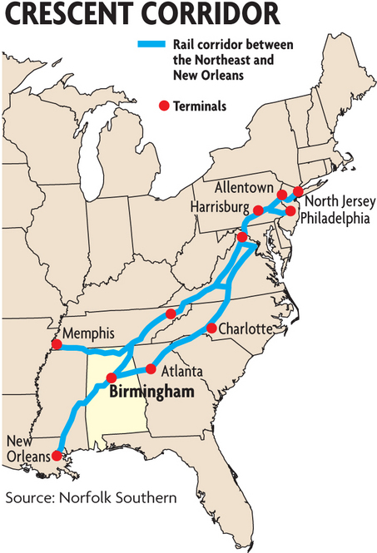The Birmingham Regional Intermodal Facility (BRIMF) and the Memphis Regional Intermodal Facility (MRIMF) are public-private partnerships to construct the facilities with adjacent infrastructure improvements. The TIGER Grant of $105 million is split evenly and applied toward the cost to construct these facilities. The remaining funding came from a combination of Norfolk Southern, CMAQ funds, and other local sources.



Figure 1: Map of the Crescent Corridor Rail Network

Total Project: $224,000,000

TIGER Contribution: $105,000,000

Recipient Contribution (includes $9,134,221.46 CMAQ funds, $6,372,000 STP funds): $119,000,000

***Location:***

Birmingham (McCalla), Alabama and Memphis (Rossville), Tennessee

## Project Type:

Intermodal Rail/Freight – The Crescent Corridor is a major intermodal freight program centered on the continued development of Norfolk Southern’s rail intermodal route from the Gulf Coast to the Mid-Atlantic. Two TIGER grants totaling $105 million supported construction of two new intermodal facilities in Birmingham (McCalla), Alabama and Memphis (Rossville), Tennessee —both critical components of the full corridor plan. Construction of these new facilities included pad and support tracks, trailer and container parking areas, lead tracks, roadway access, drainage improvements, and related ancillary buildings and features.

## Additional Project Background:

The Crescent Corridor freight rail improvement project is a multi-state rail development program undertaken by owner and operator Norfolk Southern Railway in partnership with the U.S. Department of Transportation and the States of Alabama, Pennsylvania, Virginia, Tennessee and Mississippi. The project will connect the existing rail lines with 11 intermodal facilities to enhance freight transportation and distribution services in the Southeast, Gulf Coast and Mid-Atlantic markets. It is intended to provide improved intermodal rail freight services along the Crescent Corridor, which has witnessed drastic growth in interstate freight volumes resulting in traffic congestion and heavy carbon emissions.

The construction of the two intermodal facilities in Alabama and Tennessee funded by TIGER are part of the larger corridor-wide facility improvement program, which, once fully developed, will improve domestic rail intermodal service between the Northeast and Southeast for the terminal host cities of Memphis, Birmingham, Atlanta, Charlotte, Knoxville, Roanoke, Greencastle, Harrisburg, Bethlehem, Philadelphia and the Northern New Jersey region. Connecting this 2,500-mile network of existing rail lines with regional intermodal freight distribution centers will strengthen domestic and international freight distribution in the Southeast, Gulf Coast and Mid-Atlantic markets. The Birmingham, AL and Memphis, TN facilities were completed in 2012.

## Anticipated Benefits:

The Crescent Corridor grant application covered the construction or upgrading of five intermodal facilities and track improvements across five states. While the grant application proffers potential benefits of the program in its entirety, it does not always break out these benefits by individual locations. That notwithstanding, the projected advantages of the Crescent Corridor Program included the following:

**State of Good Repair**

By diverting freight from truck to rail in the Crescent Corridor, public benefits for avoided costs of highway maintenance were estimated amount to $92 million annually through reduced roadway wear and tear.

**Economic Competitiveness, Job Creation/Economic Stimulus**

The applicants projected that the Crescent Corridor Program would have a positive economic impact on localities by financing the construction of new facilities and improving intermodal service for underserved major markets. Providing a new option for intermodal freight shippers in the Northeast and Southeast could decrease costs for producers and receivers and help insulate domestic production from recent trends to source from international markets. For 2011 to 2030, Cambridge Systematics estimated that $8.7 billion in long-term economic benefits, including $560 million in annual logistics savings for shippers and $480 million in additional annual capital (deriving from transportation efficiencies), could be made available for industries to expand facilities production or employment.

A study by Insight Research projected that the Crescent Corridor projects would collectively produce 3,663 direct, construction-related, Full-Time-Equivalent (FTE) jobs and 23,373 construction-related FTE jobs from at-risk and potentially secondarily benefited industrial expansions. Once the Intermodal Facilities reached an estimated 815,000 lifts annually, employment at the facilities was estimated to reach 1,484 jobs.

**Safety**

By reducing Vehicle Miles Traveled (VMT) on the highway, the number of crashes was also expected to decrease. A Cambridge Systematics study estimated that the Crescent Corridor Project at full build will help prevent 14 fatalities and 1,304 accidents annually, representing safety-related benefits valued at $146.5 million annually.

**Environmental Sustainability**

At full development, the Crescent Corridor Program each year will divert more than 1.3 billion vehicle miles traveled from the Nation’s highways. This will bring significant public benefits to states and communities estimated at $147 million annually. In terms of the environment, the reduced traffic would result in annual reductions of 1,874,997 tons of CO2, 3,353 tons of NOx and 80 tons of particulate matter.

**Quality of Life**

Diversion of freight from truck to rail, in the Crescent Corridor, was projected to help mitigate roadway congestion and reduce travel delays. The study estimated that this would reduce highway traffic by 1,312 million VMT (129.2 million VMT in AL and 208.5 million VMT in TN) and reduce travel times by 23.3 million hours in the Crescent Corridor (1.9 million and 3.2 million hour reductions in AL and TN, respectively).

## Analyzed Benefits:

No baseline figures were collected as these two projects represent new capacity. This notwithstanding, the benefits of the intermodal facilities were developed through operational records of cargo moved or handled as expressed in gross ton miles and number of lifts. The truck- and highway-related impacts—as expressed by average truck vehicle miles of travel avoided per quarter, average diesel fuel consumption saved per quarter (gallons), and average highway accidents avoided per quarter—were modeled based on freight flows across likely origin-destination locations that would be diverted from truck to rail as a result of the new facilities.

Benefits described in the grant proposal cannot always be directly compared to those measured or calculated for TIGER grants #31 and #32 for the Memphis, TN and Birmingham, AL facilities because the application encompassed all the proposed projects across the Crescent Corridor and not just the two locations. The grant application did provide factors relating expected impacts on VMT to roadway maintenance costs, emissions, and congestion and delays. These relationships could and were used along with the measured benefits to estimate impacts related to state of good repair, economic competitiveness, environmental sustainability and quality of life.

Within the scope of the grant agreement, post-project data collected reflect several project benefits. These are presented in the following text and summarized in the table below. A description of the project impacts by strategic goal area are as follows:

Table 1: Measured Post Project Benefits

|  |  |  |  |
| --- | --- | --- | --- |
| **Performance Measure** | **MRIMF-TIGER Grant #31** | **BRIMF TIGER Grant #32** | **Strategic Goal Area** |
| Average Daily Gross Ton-Miles | 3,382,545 | 989,886 | Economic Competitiveness, State of Good Repair |
| Average Daily Lifts (Containers or Trailers, Loads Only) | 201 | 47 | Economic Competitiveness |
| Average Truck Vehicle Miles of Travel Avoided Per Quarter | 17,164,141 | 5,025,161 | Economic Competitiveness, State of Good Repair |
| Average Diesel Fuel Consumption Saved Per Quarter (Gallons) | 2,358,862 | 690,606 | Environmental Sustainability, Economic Competitiveness |
| Average Highway Accidents Avoided Per Quarter | 17 | 5 | Safety |

**Economic Competitiveness**

The economic competitiveness metric represents the business impacts of freight movements. Such movements can result in more efficient freight operations (lower cost and reduced dwell times); direct, indirect, and induced job creation; and new, freight-dependent and freight supporting business development. The post-project data does not quantify these factors.

In the case of the two intermodal facilities, the strategic goal of economic competitiveness is captured in the metrics of increased gross-ton-miles, increased daily lifts, reduced Truck Vehicle Miles of Travel (TVMT), and reduced diesel fuel consumption associated with less truck traffic. The first two metrics were collected at the facilities. The TVMT, as mentioned previously, are estimated based on modeled freight movements between origin-destination pairs within the corridor and assumptions regarding proportion of such freight which could be diverted to rail. The estimated reductions in VMT were translated in diesel fuel savings using average fleet miles per gallon for trucking companies. This lower VMT also results in correspondingly reduced transportation costs.

Facility throughput as measured by average daily Gross Ton-Miles (GTM) originated or destined at facilities and average daily lifts (containers or trailers, loads only) represent new freight handling capacity, which increased significantly and steadily following completion of the projects. Average daily lifts increased by 21 percent (Memphis) and 122 percent (Birmingham) between May 2013 and January 2016.

The diversion of freight from highway to rail has annually reduced both TVMT—by an average of more than 88 million miles—and diesel consumption —by 12 million gallons per year—since the facilities opened. It is also estimated to have saved travelers an average of more than 1.8 million hours per year.

**Safety**

The safety benefits for the projects were expressed as reduced highway accidents. These were estimated based on modeled reductions in Vehicle Miles Traveled (VMT) due to diversion of truck freight to rail and published statistics for crash rates per VMT. The post-project reports estimate an average of 88 fewer highway accidents annually associated with the two facilities.

**State of Good Repair**

The state of good repair strategic goal is associated with reduced wear and tear on the region’s highways due to freight diverted from truck to rail. No data specific to the state of good repair was collected, but a dollar value of the impact on the state of good repair can be derived from the reductions in TVMT. The grant application estimated the public benefits for avoided costs of highway maintenance were approximately $0.07 per VMT. Using the TVMT reductions from the post-project reports, the public benefit of the facilities in terms of reduced highway maintenance costs exceeds   
$6 million per year at current diversion levels. Norfolk Southern agreed to pay all costs of maintaining the rail and intermodal facilities.

**Environmental Sustainability and Quality of Life**

No data specific to the environmental sustainability strategic goal was collected, but measures of environmental benefits can be estimated based on reductions in VMT and reduced fuel consumption, which correspond to reductions in emissions. Using the corridor-wide values presented in the grant application, carbon emissions are estimated to be reduced by .0014 tons and travel time would be lessened by .02 hours per reduced VMT. The diversion of freight from highway to rail has reduced TVMT an average of over 88 million miles annually as a result of the building on the two intermodal terminals, and thus carbon emissions have declined by 124 thousand tons and travelers have saved more than 1.8 million hours in travel time.

## Success Factors, Lessons Learned, and Other Considerations:

The two terminals (Rossville and McCalla) built using TIGER Grants #31 and #32 were part of a larger, corridor-wide effort to create a rail network that would provide a cost-effective alternative to shippers and trucking companies of intermodal transportation rather than long-haul trucking. Other advantages include flexibility and cost competitiveness in shipping and reduced truck traffic on highways, which has associated benefits that include reduced wear and tear on roadways, fewer truck-related crashes, and less air pollution. In addition, jobs were created due to the construction involved in the project and at surrounding the intermodal facilities.

The primary private-sector stakeholder, Norfolk Southern has and is currently expending significant funds for the construction and operation of the facilities, but the Crescent Corridor Project may not have been feasible without the cooperation and financial contributions of stakeholders ranging from local citizens and community leaders to representatives of State and Federal agencies. In terms of financial support, the project was enabled through the TIGER grants and by construction efforts of the States. For example, in Tennessee, the Tennessee Department of Transportation built an overpass to enable access to the intermodal facility.

On a local level, Norfolk Southern focused on outreach to the communities to educate the citizens and local decision makers about how intermodal facilities would operate, how they would affect the lives of the local population, and to address any potential development, nuisance, safety, or environmental concerns before they became difficult issues that could potentially stop the projects. Examples of how the recipient mitigated local concerns include relocating the Rossville, TN site because there were conflicting plans for development of the site and constructing an advanced storm water management system and retention ponds capable of handling runoff from 300-year floods in order to protect the Wolf River. At the McCalla location, the recipient constructed a berm along the property to hide the facility from a newly constructed neighboring elementary school and provided regular safety lectures to students.

The key lessons demonstrated by the project are to include a high degree of detail in planning, identifying, and obtaining available financial resources, including creating markets for intermodal services, involving local communities early in the process, and being flexible and innovative in executing the projects.

## US-395 North Spokane Corridor - Francis Ave. to Farwell Rd. Southbound TIGER 1 Project – Case study

## Project Funding:

Total Project: $210 million (for the Francis-Farwell component of the corridor[3],[4])

TIGER Grant Contribution: $35 million

Recipient Contribution: $175 million

***Location:*** Spokane, Washington

***Project Type and Purpose:***

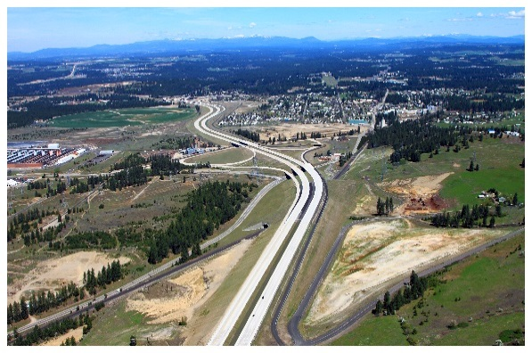

Design visualization for segment of North Spokane Corridor

New highway facility with multimodal components - The North Spokane Corridor addresses inadequate capacity for north/south traffic, including freight, from the northern part of the metro area to I-90 on the southern end. It also provides park and ride lots, space for future transit, and a bike/pedestrian trail.

***Additional Project Background:***

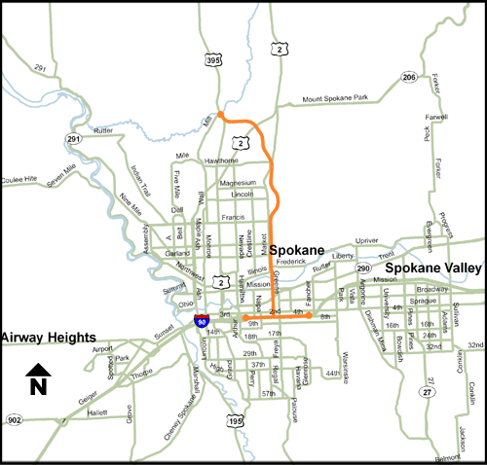The North Spokane Corridor provides a multi-modal transportation facility in the greater Spokane, Washington metropolitan area. To address inadequate capacity for North/South traffic through Spokane from I-90 north, it will eventually provide a highway link between I-90 and existing routes US-2 and US-395 at the north end of the metro area, along with several park and ride lots, reserved space for future high capacity transit, and a pedestrian/bicycle trail (the “Children of the Sun Trail”) that parallels the full length of the corridor. The design visualization for the proposed segment is shown in the first picture and the location of the proposed segment is shown the corridor map.

North Spokane Corridor Map

The TIGER-funded portion of the project included the completion of the 3.7 miles of southbound lanes between Francis Avenue and Farwell Road, with construction beginning in August 2009 and the southbound lanes opening to service by the end of 2012. The northbound lanes had been previously completed and used in a limited fashion for both northbound and southbound traffic prior to the TIGER-funded project. Construction elements for the TIGER-funded portion of the project included:

* Completion of the earthwork for the southbound alignment

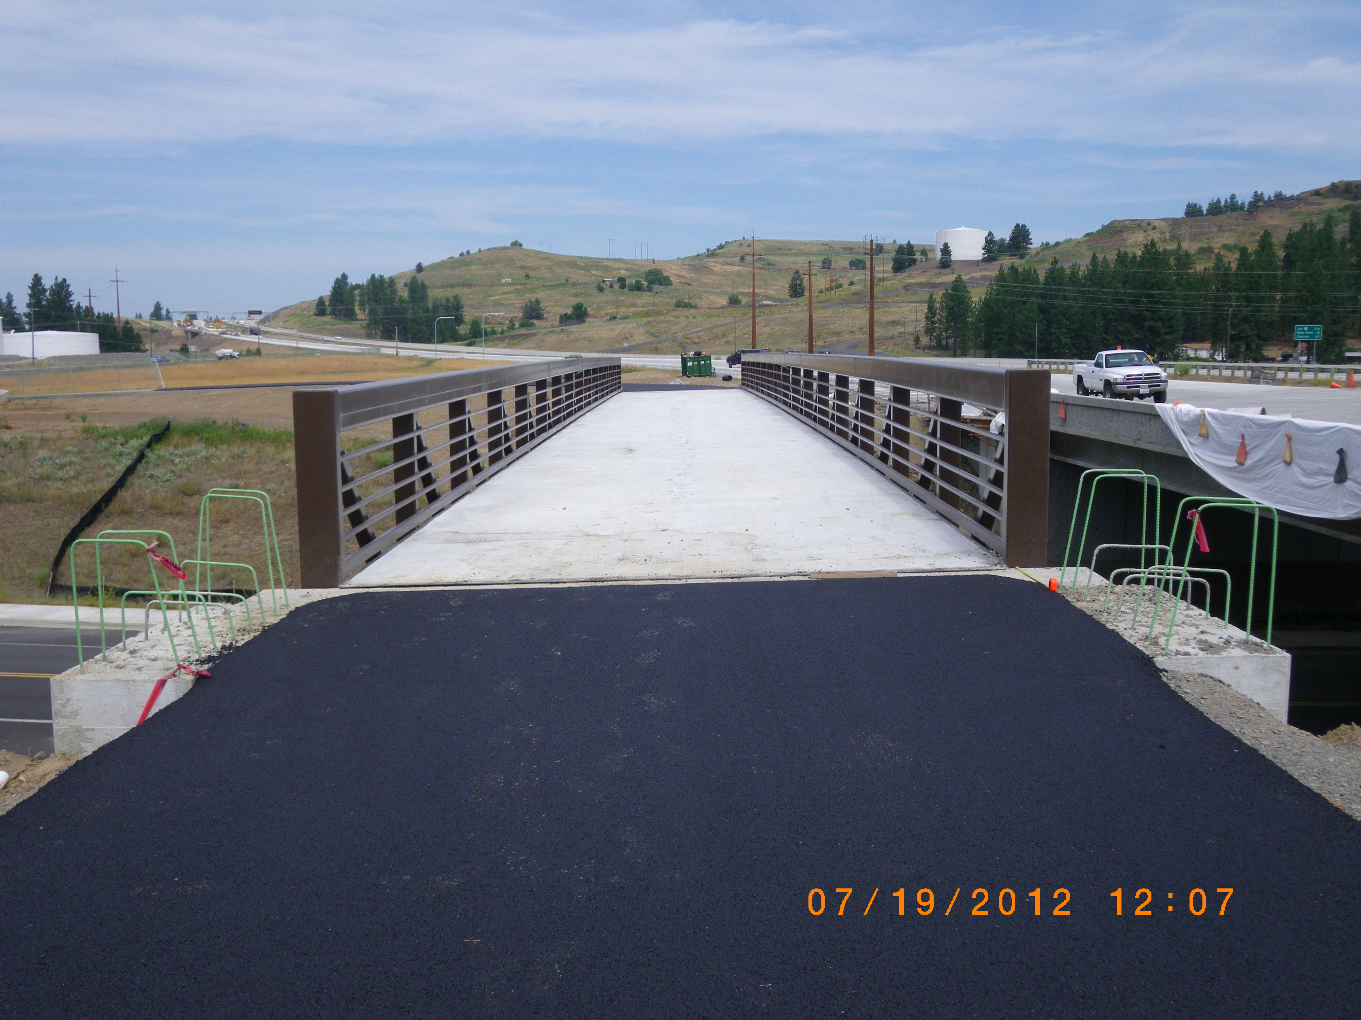

Grade separated crossing for Children of the Sun Trail

* Construction of five mainline bridges and a grade separated crossing for the bicycle/pedestrian Children of the Sun Trail (trail bridge shown at right)
* Construction of a concrete driving surface for the entire southbound lane alignment
* Construction of a roundabout at the southbound Freya Street off-ramp

The overarching purpose of the greater North Spokane Corridor project is to improve mobility and reduce travel time, reduce truck reliance on local arterials, improve safety, and support alternative transportation choices. Currently, trucks traveling from the northern part of the metro area (where US-2 and US-395 intersect) south to I-90 encounter 29 stoplights, which results in significant truck idling. This idling is a contributor to air pollutant emissions in the region, which has not consistently achieved National Ambient Air Quality Standards in the past. Truck idling and traffic delays also contribute to greenhouse gas emissions.

## Anticipated Benefits:

The project was envisioned to meet the TIGER objectives of:

* Safety (by reducing collisions and eliminating conflicting movements)
* Economic competitiveness (by improving travel times, increasing regional mobility, improving system efficiency, saving fuel, and creating jobs)
* Sustainability (by reducing emissions and congestion, and providing alternative transportation options)
* Livability (by improving travel times, and increasing neighborhood connectivity and mobility)

## Analyzed Benefits:

The performance measures selected for the project were:

* Average Annual Daily Traffic (ADT) (southbound lanes only)
* Average Annual Daily Truck Traffic (ADTT) (southbound lanes only)
* Average Bike/Pedestrian Trips
* Annual Average Hourly Vehicle Travel Time
* Annual Vehicle Crash Rates (per 100 million vehicle miles traveled, measured by type and severity)
* Annual Non-Vehicle (Bike and Pedestrian) Crash Rates (per 100 million vehicle miles traveled, by type and severity)
* Pavement Structural Condition (PSC), Pavement Rutting Condition (PRC), and Pavement Profile Condition (PPC)
* Bridge Sufficiency Rating (Scale 0 - 100) for the five constructed bridges

These measures were developed by WSDOT through a coordinated and cooperative process with FHWA. Because the project involved adding capacity and bridges, the agencies felt it was important to look at vehicle and truck volumes, delay, and bridge and pavement conditions. Safety and multimodal options were also part of the project, which led WSDOT to include crash rates (vehicle and non-vehicle) and bike/pedestrian trips. These measures were selected because they were generally consistent with the data collection capabilities and practices that WSDOT already had in place.

WSDOT collected data on performance results using these measures on a quarterly basis. Performance results showed some fluctuation across quarters. In a few cases, these were due to seasonal factors (e.g. bike/pedestrian trips were lower in the winter), while in others (e.g. delay) they were due to temporary construction activities. In yet other cases (e.g. traffic volumes), the fluctuations were the results of changes in methodologies for data collection. These factors are discussed below. It is also important to note that the baseline (pre-project) figures generally represent conditions during the interim period when the roadway provided one lane in each direction (one lane serving northbound traffic and one lane serving southbound traffic separated by a median lane on the northbound segment), while the post-project results are based on the ultimate six-lane mainline configuration (three northbound and three southbound lanes). The analyzed benefits are shown in the table below.

Measured Post-Project Benefits

|  |  |  |  |  |
| --- | --- | --- | --- | --- |
| **Performance Measure (per 100 million vehicle miles traveled)** | **Pre-Project (8/2009 to (8/2010)3** | | **Post-Project (6/2015)** | **Percentage Change** |
| Non-vehicle annual crash rates4 | 0 | | 0 | n/a |
| Annual vehicle crash rates - fatal | 0 | | 0 | n/a |
| Annual vehicle crash rates - injury | 0.25 | | 8.86 |  |
| Annual vehicle crash rates – property damage only | 1.25 | | 26.57 |  |
| Average Annual Daily Traffic (ADT) for southbound lanes | 2000 (8/2009) | | 6695 | +234.8% |
| Average Annual Daily Truck Traffic (ADTT) for the southbound lanes | 280 (8/2009) | | 570 | +103.6% |
| Annual Average Hourly Vehicle Travel Time (AHVTT), in minutes and seconds | 5:18 (10/2010) | | 5:35 | +5.3% |
| Pavement Condition5, 6 | n/a (all 99+) | | PSC:95  PRC: 91  PPC: 86 | -4.0%  -8.1%  -13.1% |
| Bridge Sufficiency Rating (0-100) | n/a (average of 99.64) | | 99.37 average | <.003% |
| Average daily bike trips | | 22 | 44 | 100% |
| Average daily pedestrian trips | | 6 | 14 | 133.3% |

3The pre-project period is associated with the time before the southbound segment was open, during the construction.

4Reported “non-vehicle” crashes are crashes involving pedestrians or bicyclists and a motor vehicle.

5 Pavement condition and bridge sufficiency baseline measures were taken after the new facility was completed. Therefore, the “pre-project” in this case refers to initial data after construction.

6 Pavement Structural Condition (PSC), Pavement Rutting Condition (PRC), and Pavement Profile Condition (PPC)

**Safety**

Annual vehicle crash rates and annual non-vehicle (bike and pedestrian) crash rates, each by type and severity, were the two metrics chosen to measure the safety improvements of the project.

Since the project segments of the Children of the Sun Trail were not open during the construction of the project in the vicinity of the counters, the baseline for bike/pedestrian crashes of all types was 0. For the vehicle crashes baseline, the crash rates reflect the portion of the corridor that was opened in August 2009, when the roadway provided one lane in each direction.

Bike and pedestrian crash rates of all types remained at 0 throughout the reporting period, likely due to the separation of bicyclists and pedestrians from the roadway. Similarly, annual fatal injury rates stayed at 0 throughout the post-project reporting. Injury and property damage only crash rates fluctuated on a quarterly basis. Each quarter typically saw between zero and two injury crashes, resulting in annual injury crash rates generally ranging between 0 and 18 per 100 million vehicle miles, although it rose to 35.19 in the fourth quarter of 2014, which may have been due to weather conditions. The annual property damage only rate also fluctuated significantly, generally ranging between 13 and 53 per 100 million vehicle miles across the various reporting quarters.

**Economic Competitiveness**

The project was expected to increase economic competitiveness by improving travel times, increasing regional mobility, improving system efficiency, saving fuel, and creating jobs. The measures selected for economic competitiveness were Average Annual Daily Traffic (ADT) for the southbound lanes, Average Annual Daily Truck Traffic (ADTT) for the southbound lanes, and Annual Average Hourly Vehicle Travel Time (AHVTT).

While traffic volumes on the roadway are not a direct indication of increased regional mobility, the figures do indicate increased usage of the facility after the completion of the additional capacity. The increase in traffic suggests that the project was likely supporting the project goal of decreasing truck traffic on arterials such as US-2. WSDOT did not directly measure truck traffic volumes on alternative routes in part because this would have required obtaining data from the city or county. Average vehicle travel time on the roadway itself increased slightly, however, associated with increased traffic on the segment.

Other economic competitiveness measures such as fuel savings and travel time savings (compared to travel on routes available before project completion) were not measured or calculated, due in part to limited resources for performance measurement. In addition, because the project did not involve construction of the entire facility, the desired outcomes of the broader corridor project could not be assessed at the time the TIGER portion of the project was completed. Once the entire facility is complete, it is likely that trucks and other vehicles will alter their routes to use the new highway; at present, it may not make sense for many of them seeking to reach I-90 to take the opened segment for only part of their journey, after which point they would be routed onto an urban roadway. WSDOT intends to calculate travel time and fuel savings measures upon completion of the entire North Spokane Corridor.

**State of Good Repair**

State of Good Repair (SGR) was addressed in WSDOT’s performance measures, using three measures of pavement condition and bridge sufficiency rating.7 Since the project involved new construction, however, the baseline conditions do not reflect “pre-project” conditions but instead conditions after construction was completed. Since the pavement and bridges were brand new at the beginning of the project, the post-project outcomes (conditions/ratings) were slightly lower by the end of the reporting period in the second quarter of 2015. Generally, however, all of the ratings remained high, indicating sustained SGR for these facilities, with decrease in pavement condition due to weather conditions and normal wear on roadway facilities.

**Environmental Sustainability**

Environmental sustainability was another key goal area for the project. There were no direct measures of environmental sustainability for the TIGER I component of the project, but a few of the measures addressed it indirectly. Depending on the extent that bicycle and pedestrian trips (which increased) replaced automobile trips, environmental benefits would be achieved in the form of reduced emissions. In addition, traffic that moved to the new segment from alternative routes with more stoplights would presumably result in reduced vehicle idling and, by extension, likely a reduction in Greenhouse Gas (GHG) emissions. Once the entire corridor is complete, WSDOT will have a better opportunity to quantify the environmental benefits of the project.

**Quality of Life**

Bike and pedestrian trip counts were used as performance measures supporting quality of life, since the new bicycle and pedestrian facility provided additional travel and recreational options for residents.

WSDOT has indicated that the trail seems to have been primarily used for recreational trips during the reporting period. Perhaps not surprisingly, the bike and pedestrian trip counts vary significantly depending on the season, with the counts being much lower in the first and fourth quarter of each year.

In the earlier stages of the project, WSDOT collected data on bike and pedestrian trips through video detection. During the project, WSDOT transitioned to using an ECHO system, which provided more consistent real-time data, thus improving the accuracy of measurement. WSDOT anticipates that bike and pedestrian trips will increase further in the future, once the entire trail is complete. At the moment, the trail’s usefulness for commuting by bike is somewhat limited because bicyclists still have to use the street network for significant portions of their trips.

## Success Factors, Lessons Learned, and Other Considerations:

This project demonstrates some of the challenges associated with measuring performance of a new transportation facility. For most performance metrics, the baseline figures represented conditions during an early stage of the project when only two lanes out of the eventual six-lane capacity highway were available. Reported changes in traffic, crashes, and pavement conditions do not address the overall benefits of the project from a regional perspective but represent changes on the road facility itself. Moreover, because the project involved construction of just one segment of what will eventually be a new multimodal corridor providing a critical high-speed, stoplight-free link to I-90, significantly greater benefits are likely to be realized once the full corridor is complete.

In the future, WSDOT plans to make a more concerted effort to develop meaningful performance measures at the time a project is developed, so that they are able to more accurately gauge the impacts of the project. Annual (instead of quarterly) reporting in subsequent TIGER rounds has reduced WSDOT’s expenses for tracking performance.

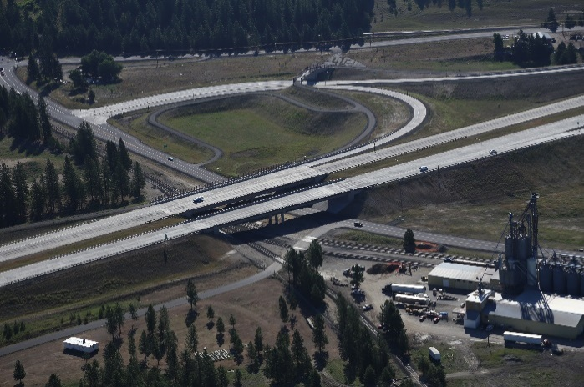

Parksmith Interchange Constructed with Remaining Funds due to Low Bids on Initial Project

An unexpected positive outcome of the project was that the final construction costs came in under budget, so WSDOT used the remaining TIGER funds toward construction of an interchange (shown right) that was previously expected to be completed in a later stage of the project.

***SADDLE ROAD IMPROVEMENT TIGER III PROJECT—CASE STUDY***

***Project Funding:***

Total Project: $33,500,000

TIGER Contribution: $13,500,000

Recipient Contribution: $15,000,000

Other Federal Funds: $5,000,000

## Location:

Hawaii, HI

***Project Type and Purpose:***

Highway Improvement – The Saddle Road Improvement Project is a rural highway project improving the most direct cross-island route (east to west) on the “Big Island” of Hawaii and the only paved access road to the U.S. Army’s Pohakuloa Training Area (PTA), Kaumana City, Hawaiian Homelands, Hakalau Forest National Wildlife Refuge, Mauna Kea State Park, and the Mauna Kea & Mauna Loa astronomical observatories. Although Saddle Road is the most direct cross-island route, many drivers avoid it because it is considered one of the state’s most hazardous highways. TIGER funded Section I of the project built off of work already completed on Sections II and III (see map below). Work on Section I included horizontal and vertical realignments, the addition of uphill passing lanes, truck escape ramps on 10 miles of the west side of Saddle Road from approximate mile post 52 to mile post 42, plus realignment of the western portion, making for a shorter and safer connection to Mamalahoa Highway Intersection. Work also included construction of a new bridge overpass and associated underpass approaches for military vehicles connecting the Pohakuloa Training Area to Ke'amuku Maneuver Area, reconfiguration of the Mamalahoa Highway Intersection, and several highway access approach roads providing connection to adjacent land.

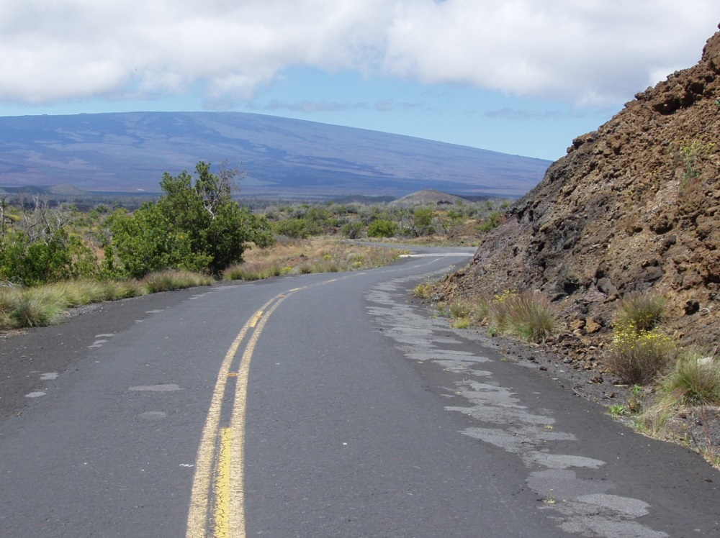

Saddle Rd, Hawaii, before improvements

***Additional Project Background:***

Although constructed as a two‐lane road, deterioration of the outer edges of the pavement had reduced much of Saddle Road to one asphalt lane approximately 12 to 15 feet wide with badly patched outer edges. The narrow width and poor pavement conditions caused motorists to drive in the center of the road, increasing the risk of head‐on collisions or “forced off the road” accidents. The road’s conditions and associated substandard sight distances made passing slow‐moving vehicles especially hazardous. Pavement markings and signage were inadequate or non‐existent. Drainage structures were undersized or, in many areas, non‐existent, resulting in periodic flooding of some roadway sections. Numerous other roadside hazards also marred the road, including:

* Narrow or structurally inadequate bridges
* Crumbling parapets or damaged guardrail
* Protruding concrete structures dangerously close to the road
* Jagged lava flows adjacent to the roadway
* Steep/deep drop‐offs at culvert inlets
* Many one-lane bridges that were built in the 1940s, some of which were structurally deficient.

Efforts to improve Saddle Road began in the mid-1990’s, with a multi-year planning effort between local stakeholders, the U.S. Army, and Federal Highway Administration. Since that time, two of the four sections (sections II and III, see map below) were improved, building on significant investments by the U.S. Army (which had already reconstructed 31 of the original 48 miles). The third segment, Section I in the map below, is the TIGER funded segment. The completion of the other 3 sections has allowed construction to begin on an additional phase of the project (Section IV on map).

TIGER funds were used on Section I, which included horizontal and vertical realignments, the addition of uphill passing lanes, truck escape ramps on the 10 miles of Saddle Road (SR200) from approximate MP 52 to MP 42, plus realignment of the western portion, making for a shorter and safer connection to the Mamalahoa Highway Intersection. Work also included construction of a new bridge overpass and associated underpass approaches (MP 43.5) for military vehicles and several highway access approach roads providing connection to adjacent land.

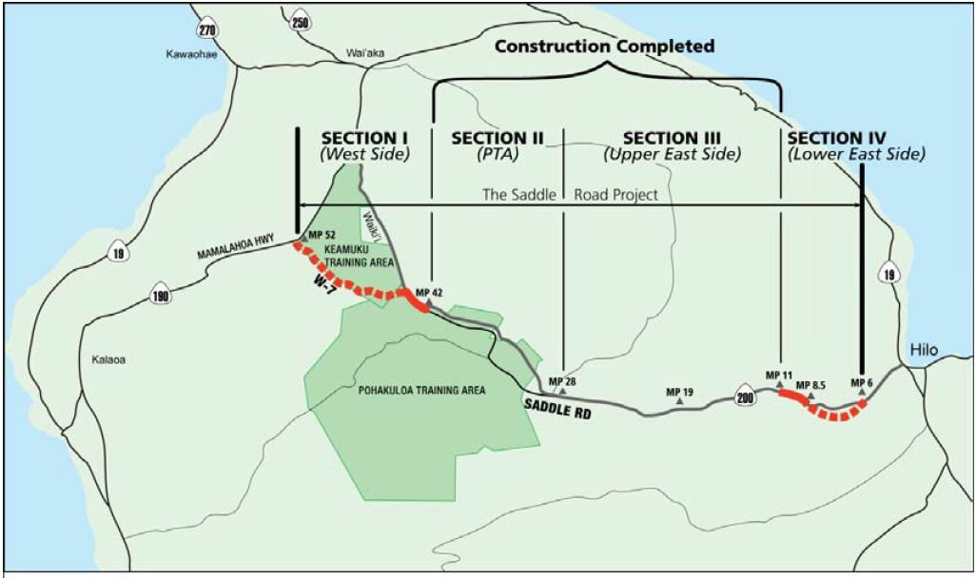

Location of Saddle Rd and West Side Improvements

## Anticipated Benefits:

Investments in Saddle Road were projected to boost commuter and freight travel and also reduce cross-island journey time while improving island mobility, connectivity, and accessibility. The prohibition by many auto rental companies of taking rental cars on Saddle Road would be lifted due to the safety improvements.

The initial TIGER grant request included reconstruction along the ‘Lower East Side” of Saddle Road, as well. With the size of the funding granted, only the west side project could be completed with TIGER funds.

Project sponsors projected that lifecycle maintenance costs would be reduced by 50 percent through the following improvements:

* Reconstruction will provide a more durable pavement surface with improved rideability
* The new roadway pavement has a design life of 20 years, at which time it would only need rehabilitation to extend the pavement life to 60 years
* One proposed bridge will have a design life of 75 years
* Improved drainage features will eliminate periodic flooding and roadway degradation
* Additional fire break will be constructed to reduce wildfire impacts

Economic benefits associated with increased cross‐island connectivity and time savings were expected to begin immediately after construction and increase over time, contributing to the area’s long‐term productivity by connecting affordable housing on the east to employment centers on the west as well as reduced cross island travel and shipping times.

The total average travel time savings for Section I and Section IV was estimated to be approximately 14.5 minutes after the improvements; however, the overall travel time savings once the entire route is improved would be approximately 30 minutes.

The project also notes enhanced modal connectivity and improved accessibility as potential benefits. Saddle Road has not been used extensively by bicyclists, pedestrians, or other nonmotorized modes due to unsafe conditions including inadequate shoulder width. The proposed project will accommodate bicyclists and pedestrians through a signed, shared route on the shoulder. Other projected livability benefits include significant reductions in traffic and noise levels for the communities of Waiki’i and Kaumana, the only communities within 5 miles of the east side and west side sections of Saddle Road.

With improved roadway features, speeds were expected to increase from between 25 and 30 mph up to between 45 and 57 mph. This will allow for more efficient fossil fuel consumption by vehicles. It is also estimated to save vehicles 157,000 to 319,000 gallons of fuel a year.

Improved safety was among the largest anticipated benefits of the Saddle Road Improvement project, as horizontal and vertical alignment deficiencies, narrow road width, lack of shoulders, and poor pavement conditions were corrected.

## Analyzed Benefits:

After completion, the west side of Saddle Road saw significant reductions in crash rates while use of the road (as measured in average daily traffic) increased considerably. The table below presents the overall quantified benefits of the project.

Measured Post-Project Benefits

|  |  |  |  |  |
| --- | --- | --- | --- | --- |
| **Performance Measure** | **Pre-Project**  **9/31/2012** | **Post-Project** | **Percentage Change** | **Strategic Goal Area** |
| Average Daily Traffic (ADT) | 1,881 | 3,4181 | 82% | Economic Competitiveness, Quality of Life |
| Average Daily Truck Traffic (ADTT) | 58 | 3902 | 572% | Economic Competitiveness, Quality of Life |
| Annual average vehicle travel time | 27 | 163 | -43% | Economic Competitiveness, Quality of Life |
| Annual crash rates measured by severity - Severe | 0.92 | 0.22† | -76% | Safety |
| Annual crash rates measured by severity - Total | 1.29 | 0.56† | -57% | Safety |
| Pavement condition rating (PCR) | 48 | 100‡ | 108.33% | State of Good Repair |
|
| *1Data is average of reports for 1/2014-8/2014.* | | | | |
| *2Data is average of reports for 1/2014-6/2014.* | | | | |
| *3Data is average for June 2014 and June 2015 Reports.* | | | | |
| *†Data is average of Q11 and Q14 reporting results* | | | | |
| *‡Data is only reported once, post project. Please see State of Good Repair discussion for further information* | | | | |

**Safety**

Annual Crash Rates were collected along Saddle Road. They were measured and reported as crashes per 100 million vehicle miles traveled and identified by severity categories: fatal, injury, and property damage only.

Results of the project indicate significant reduction in crash rates. The rate of severe crashes decreased by 57 percent, and the total crash rate declined by 76 percent. The new facility moved traffic off of one of the State’s most dangerous roads onto one designed for the capacity that is in use today.

**Economic Competitiveness**

Average vehicle travel time for the Saddle Road was collected before and after project completion. The method for collecting this data involved engineers travelling the roadway with a stop watch. The significant reduction in travel time is due to the bypass of the military facilities, connecting Saddle Road to Mamalahoa Highway in a more efficient manner.

Additionally, traffic volumes, with respect to Average Daily Traffic (ADT), and Average Daily Truck Traffic (ADTT) were collected. Since a portion of Section I was a new connection, it is hard to infer any specific meaning from the data currently reported.

While not quantified, interviews with stakeholders indicated an increase in cross‐island connectivity, as many people live on the east end of the island, while a large number of jobs are located on the west end.

**State of Good Repair**

Highway Pavement Condition Ratings (PCR) was selected as a performance metric.Pavement Condition rating is a physically measured and calculated rating using the roughness and surface condition (cracking) of the roadway pavement. The PCR is calculated and rated on a scale of 1-100 with 100 representing an undamaged, smooth surface. The PCR will be measured and compared using the before (baseline) and after construction measurements along the full length of the project

Stakeholders indicated this rating will not change for many years, and thus reporting on this metric after the initial post-project testing was suspended.

Other, non-quantified improvements include:

* Travel lane width improvements allowing for two way traffic and improved safety
* Creating eight-foot wide shoulders signed for shared route will accommodate bicyclist and pedestrian use
* Full adequate clear zones and improved guardrail and parapets
* Improved sight distance and passing opportunities
* Passing zones and/or pull-outs allow drivers the ability to safely pass slower moving vehicles or convoys
* Adding a climbing lane throughout most of the route, separating slower moving military convoys from the travelling public, reducing travel times and improving the functional and safety operations of the route.

**Environmental Sustainability**

While no specific metrics were selected, data on travel time savings and traffic could be used to determine any emissions reductions. Additionally, the new roadway was built in a context-sensitive manner, with minimal disruption to the native landscape.

**Quality of Life**

While no data was collected specifically for quality of life, interviews with stakeholders indicate the new road has positively impacted citizens across the island. This has come in the form of family members making more frequent visits to relatives who live on the other side of the island, now that a safe travel alternative is available.

## Success Factors, Lessons Learned, and Other Considerations:

The project was successful due to a number of factors, including high levels of local community participation. In interviews, local project stakeholders indicated a community committee to reconstruct Saddle Road had been active for 20 years. Discussion with FHWA project office indicated a positive working relationship as well. Local funding and military funding were important in demonstrating project readiness, and the project completion appeared to be a joint effort consisting of the community, state, local, and federal governments as well.

1. The buffer index represents the extra time (or time cushion) that travelers must add to their average travel time when planning trips to ensure on-time arrival. <http://ops.fhwa.dot.gov/publications/tt_reliability/brochure/>
2. Referred to as the degree of saturation, this is synonymous with vehicle level of service. This serves as an indication of the operational performance of the facility or structure by representing how sufficient it is to accommodate the vehicular demand. <https://www.fhwa.dot.gov/publications/research/safety/04091/07.cfm#chp711>
3. <http://www.transinfo.state.wa.us/Projects/frmProjectDetail.asp?projectdescid=69242669>
4. $625 million total has been allocated to date ($140 million Federal and $475 million from the State) for the larger North Spokane Corridor project with connection to I-90. The full build-out cost with the completed I-90 connected is estimated at $1.3 billion. <http://www.wsdot.wa.gov/Projects/US395/NorthSpokaneCorridor/>