DEPARTMENT OF TRANSPORTATION
ADVISORY COMMITTEE ON HUMAN TRAFFICKING
NON-ACHT PRESENTER BIOGRAPHY

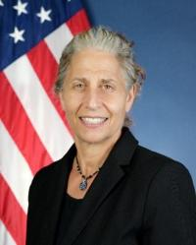
Carol A. (Annie) Petsonk, Assistant Secretary for Aviation and International Affairs,
Office of the Assistant Secretary for Aviation and International Affairs, U.S. Department of Transportation
Annie Petsonk serves as the Assistant Secretary for Aviation and International Affairs. A recognized expert on international aviation and climate change, she has previously served in the U.S. government, including the Office of the United States Trade Representative in the Executive Office of the President, and the Department of Justice; in the United Nations; as international counsel for the Environmental Defense Fund; in the private bar; and as an adjunct professor at the George Washington University Law School.

