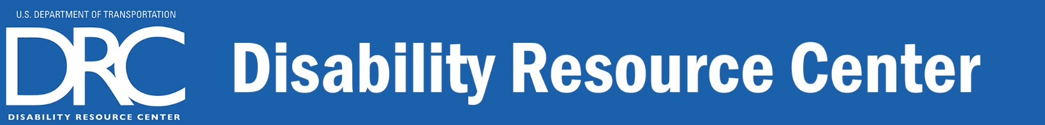

The DRC Team

DRC Manager
Michele Magana
Phone: 202-366-3221
Michele.Magana@dot.gov

Recruitment & Hiring
Duronne Walker
Phone: 202-366-5305
Duronne.Walker@dot.gov

Accommodations
Trish Day
Phone: 202-366-9122
Trish.Day@dot.gov
MarcusKeith Island
Phone: 202-366-6985
MarcusKeith.Island@dot.gov

Julia Wolhandler
Phone: 202-366-5316
Julia.Wolhandler@dot.gov

Join Our Mailing List!
Send an Email message to drc@dot.gov, with the words “mailing list” in the subject line.
The U.S. Department of Transportation’s Disability Resource Center (DRC) is a centrally funded national program, providing disability employment services and supports, to ensure applicants and employees with disabilities are included and have access throughout the DOT work experience. The DRC provides services in three key areas:

Recruitment & Hiring
- Coordinates the Department’s strategic planning and activities to improve recruitment, hiring, and advancement of people with disabilities.
- Identifies best practices, develops partnerships, and provides resources to Modal contacts for action.
- Partners with internal and external resources to increase awareness of hiring initiatives and to identify positions that need to be filled within the Department.

Reasonable Accommodations
- Facilitates the interactive accommodation process with managers and employees.
- Conducts individual needs assessments based on limitations and essential job functions.
- Recommends effective accommodation solutions.
- Procures products and services at no additional cost to mode
  - Assistive technology and software
  - Sign language interpreting and captioning
  - Personal attendants at work and on government travel
- Provides training and follow up to ensure accommodations are effective.

Consultation, Education & Training
- Provides technical assistance, information, referral, and resources to improve the employment and inclusion of people with disabilities in the DOT workforce
- Proactively engages with key decision makers regarding accessibility.
- Solicits customer feedback to drive DRC programs and services.
- Briefs managers, employees, and work groups on DRC services and disability topics to promote universal accessibility and inclusion of people with disabilities in the DOT workplace.

We look forward to working with you!
Phone: (202) 493-0625 - Email: DRC@dot.gov - Website: www.transportation.gov/drc
Interpreting Services: DRC.Interpreters@dot.gov - Captioning Services: DRC.CART@dot.gov

