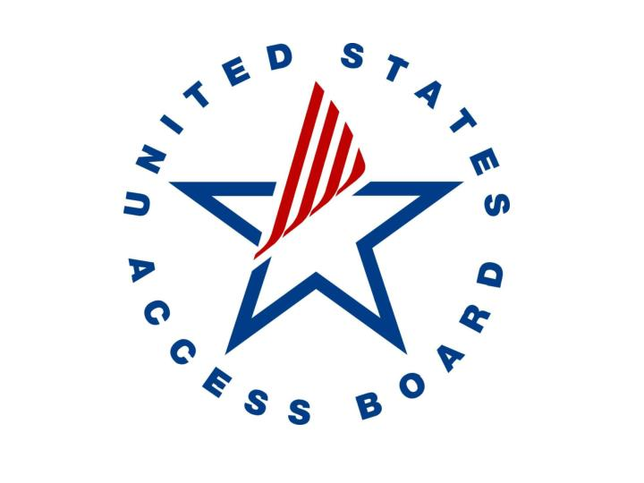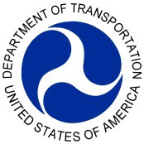

U.S. Department of Transportation

Architectural Transportation Barriers and Compliance Board

AGENDA

Joint Public Meeting: On-Board Wheelchair (OBW) Issues

*December 16, 2021*

9:30 to 9:45

9:45 to 10:45

10:45 to 11:30

11:30 to 1:00

1:00 to 2:10

2:10 to 2:50

2:50 to 3:00

Welcome, Introductions, Housekeeping

*Blane Workie,* DOT; *Sachin Pavithran*, Access Board

Background on DOT Rulemaking

*Rob Gorman,* DOT

Overview of Access Board Advisory Guidelines

*Bill Botten*, Access Board

Public Comment

Perspective of Air Travelers with Disabilities

*Shaun Castle*, Paralyzed Veterans of America

*Judith Heumann*, Disability Rights Advocate

Public Comment

Break

In-Flight Safety Considerations

*Graham Keithley*, A4A; *Linda Ristagno*, IATA

Public Comment

OBW Stowage Considerations

*Michelle Albert*, Boeing; *John Serafin*, Airbus

Public Comment

Design Cost Considerations

*Catherine Taylor,* Volpe Center

Public Comment

Wrap-up; Next Steps

*Blane Workie*, DOT; *Sachin Pavithran*, Access Board

# Meeting link: Provided by email

# Registration link: <https://usdot.zoomgov.com/webinar/register/WN_8PChAZcLQsmDm1xathLEjw>

Technical/Access Assistance: [webconferencing@dot.gov](mailto:webconferencing@dot.gov)

Dockets: [www.regulations.gov](http://www.regulations.gov)

DOT-OST-2019-0180 (DOT Docket)

ATBCB-2019-0002 (Access Board Docket)

DOT contact: OBWpublicmeeting@dot.gov